AGRICULTURAL SCIENCE
Strand 2: Sustainable Primary Production | Sub-strand 2.3: GLOBAL ISSUES AFFECTING PRIMARY PRODUCTION
LESSON ACTIVITY 4: Pollution

The Specific Learning Outcome (SLO) targeted in this activity are provided below.
SLO | Specific Learning Outcomes: Students are able to | Skill Level | SLO code
13 | Name the main types of pollution that affect local primary production. | 1 | agr2.3.1.4
14 | Describe how a specific type of pollution affects local primary production. | 2 | agr2.3.2.4
15 | Describe control mechanisms used to deal with specific pollution problems in local primary production. | 2 | agr2.3.2.5
16 | Analyse the advantages and disadvantages of each pollution control mechanisms. | 3 | agr2.3.3.4
17 | Recommend with reasons the most cost-effective pollution control for different pollution problems. | 4 | agr2.3.4.4

Pollution

What Is Agricultural Pollution?
Agricultural pollution is the contamination we release into the environment as a by-product of growing and raising livestock, food crops, animal feed, and biofuel crops.
Developing means of farming and agriculture is the reason humans live in the world they do today. It is a necessary means of survival, without which there would be famines all over the world. For thousands of years, agricultural was a natural process that did not harm the land it was done on. In fact, farmers were able to pass down their land for many generations and it would still be fertile as ever. However, modern agricultural practices have started the process of agricultural pollution. This process causes the degradation of the ecosystem, land, and environment due to the modern-day by-products of agriculture.
No single cause can be attributed to the widespread agricultural pollution we face today. Agriculture is a complex activity in which the growth of crops and livestock have to be balanced perfectly. The process of agricultural pollution stems from the many stages their growth goes through.

Causes of Agricultural Pollution

1. Pesticides and Fertilizers
To begin with, the earliest source of pollution has been pesticides and fertilizers. Modern-day pesticides & fertilizers have to deal with the local pests that have existed for hundreds of years along with the new invasive species. And so, they are laden with chemicals that are not found in nature.
Once they have been sprayed, it does not disappear completely. Some of it mixes with the water and seeps into the ground. The rest of is absorbed by the plant itself. As a result, the local streams that are supplied water from the ground become contaminated, as do the animals that eat these crops and plants.

2. Contaminated Water
Contaminated water used for irrigation is one further source of pollution. Much of the water we use comes from groundwater reservoirs, canals and through the rains. While plenty of it is clean and pure water, other sources are polluted with organic compounds and heavy metals. This happens due to the disposal of industrial and agricultural waste in local bodies of water.
As a result, the crops are exposed to water which has small amounts of mercury, arsenic, lead, and cadmium dissolved in it. The process of agricultural pollution becomes harder to fight when such water poisons livestock and causes crop failure.

3. Soil Erosion and Sedimentation
Further problems are caused by soil erosion and sedimentation. The soil is comprised of many layers and it is only the topmost layer that can support farming or grazing. Due to inefficient farming practices, this soil is left open for erosion and leads to declining fertility each year. Whether eroded by water or wind, all this soil has to be deposited somewhere or the other.
The resulting sedimentation causes the soil to build up in areas such as rivers, streams, ditches and surrounding fields. And so, the process of agricultural pollution prevents the natural movement of water, aquatic animals and nutrients to other fertile areas.

4. Livestock
In the olden days, farmers would keep as much livestock as their land could support. The cattle, sheep, pigs, chickens and other animals were fed natural diets, which was supplemented by the waste left over from the crops. As a result, the animals contributed to keeping the farm healthy as well.
As of now, livestock is grown in cramped conditions where it is fed unnatural diets and sent to slaughterhouses on a regular basis. As a result, they add to the process of agricultural pollution by way of emissions.

5. Pests and Weeds
Growing exotic crops and reducing the natural species in a certain area has become the norm for agriculture. However, it is simply adding to the process of agricultural pollution. With the arrival of new crops, the native population has to deal with new diseases, pests, and weeds that it is not capable of fighting.
As a result, the invasive species destroy the local vegetation and wildlife, altering the ecosystem permanently. This is especially the case with Genetically Modified foods, which create plant and animal species that can wipe out the existing species in a matter of years.

Air Pollution
Various gases from animal waste are all major sources of factory farm air pollution,and particulate matter and bacterial toxins found in high concentrations at and around industrialized animal facilities have caused serious respiratoryand cardiac disorders.The ammonia from waste slurry lagoons also breeds bacteria, which creates acid that evaporates and combines with nitrous oxide from fertilizers and industrial pollution to form nitric acid rain—which leaches nutrients from the soil, despoils forest habitats, and kills fish by releasing toxic minerals from the earth that flow into aquatic ecosystems. Air planes spraying on crops to control pests cause a lot of air pollution.
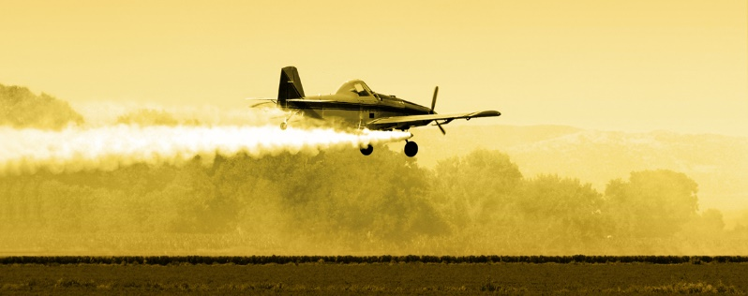

Effects of Agricultural Pollution

1. Health Related Issues
Agricultural pollution is the main source of pollution in water and lakes. Chemicals from fertilizers and pesticides make their way into the groundwater that ends up in drinking water. Oil, degreasing agents, metals and toxins from farm equipment cause health problems when they get into drinking water.

2. Effect on Aquatic Animals
Fertilizers, manure, waste, and ammonia turns into nitrate that reduces the amount of oxygen present in water which results in the death of many aquatic animals. Again, bacteria and parasites from animal waste can get into drinking water which can pose serious health hazards for various aquatic life and animals.
Keeping agricultural pollution in check is much harder than it seems. For the farms to become clean once again, levels of water, soil, and industrial pollution have to be kept in check. Over the last decade or so, governments have become stricter about enforcing regulations. Farmers are also becoming more aware of the damage and are looking for solutions.

Pollution Prevention, Best Management Practices, and Conservation

To be well thought-out a best management practice, an action is required which increase the crop production while reducing the impact on environment. This means that for healthy crop using the best management like reducing the pesticide treatment. Soil plays a very important role for healthy crops and its management is very necessary. Organic farming rely on the management of soil organic matter to increase the physical, biological and chemical properties of soil for optimization of crop production.

To be well thought-out a best management practice, an action is required which increase the crop production while reducing the impact on environment. Best management practices include practices like:

Organic farming
In organic farming, food is grown and processed using no synthetic fertilizers, but pesticides derived from natural sources may be used in producing organically grown food. Organic farms reduce some of the negative impacts of conventional farming such as soil erosion and leaching of carbon and nitrogen.

Green manures
A green manure is a crop worked into the soil to provide nutrients to the organisms and ultimately to the crops. To sustain a healthy soil, the use of green manure in crop rotation plays an important role. Green manure is a legume that fixes nitrogen into the soil; availability of nitrogen depends on the growing condition, and moisture.

Rotation of crops
Rotation is a planned sequence of crops, and organic producers consider it as the most important key in organic farming. Resources can be used more effectively by rotating the crops with different characteristics. As we know, crops differ in their requirements of water, nutrients, and susceptibility to pests and diseases. The sequence of crops must be cautiously selected, which is well adapted to the fertility level, to avoid the disease potential that builds in crops.

Tillage
In organic farming, soil erosion resulting from tillage is a major concern. Organic producers use more tillage; they use it for seed bed preparation, weed suppression, and for the incorporation of green manure. To prepare seed bed and to control weeds tillage, a harrow and cultivator is used; those who used disc seeders reported less cultivation because this method killed weeds.

Animal manure
Animal manure, such as livestock and poultry, provides not only nutrients to plants but also affects soil tilth and particle aggregation. Organic matter contained in manure act as binding agents in stabilizing soil structure. The addition of manure changes the soil structure and this surely affects water infiltration, water holding capacity, and aeration, as well as resistance to wind and water erosion.

Non-Biodegradable waste – Its impact & safe disposal

Waste is defined as discarded material which has no value in normal use or for ordinary use. Solid wastes are those undesirable, useless and unwanted materials and substances that come from human and animal activities. The solid waste can be classified into biodegradable and non - biodegradable waste. Biodegradable waste, that are completely decomposed by biological processes either in presence or in absence of air are called biodegradable. Non-biodegradable waste, which cannot be decomposed by biological processes is called non-biodegradable waste. These non-biodegradable waste should be buried.

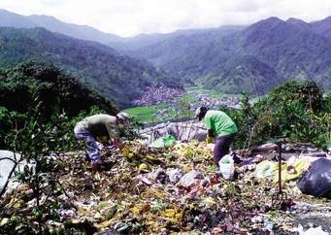Non-biodegradable waste
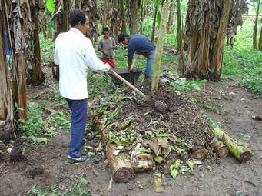Compost made of biodegradable waste

Exercise 4
- Name the main types of pollution that affect local primary production. L1 agr2.3.1.4

2.Describe how a specific type of pollution affects local primary production. L2 agr2.3.2.4

3. Describe control mechanisms used to deal with specific pollution problems in local primary production. L2 agr2.3.2.5

4.Analyse the advantages and disadvantages of each pollution control mechanisms. L3 agr2.3.3.4

5. Recommend with reasons the most cost-effective pollution control for different pollution problems Recommend with reasons the most cost-effective pollution control for different pollution problems. L4 agr2.3.4.4

