AGRICULTURAL SCIENCE
Strand 2: Sustainable Primary Production | Sub-strand 2.3: GLOBAL ISSUES AFFECTING PRIMARY PRODUCTION
LESSON ACTIVITY 3: Organic Husbandry

The Specific Learning Outcome (SLO) targeted in this activity are provided below.
SLO# | Specific Learning Outcomes: Students are able to | Skill level | SLO code
9 | State the features of organic husbandry in local primary production. | 1 | agr2.3.1.3
10 | Describe the features of organic husbandry in local primary production | 2 | agr2.3.2.3
11 | Explain how organic husbandry contributes to local primary production. | 3 | agr2.3.3.3
12 | Discuss the factors that influence the application of organic husbandry and suggest ways of maximising the benefits for local primary production. | 4 | agr2.3.4.3

What is organic farming?
“Organic farming is a system which avoids or largely excludes the use of synthetic inputs (such as fertilizers, pesticides, hormones, feed additives etc.) and to the maximum extent feasible rely upon crop rotations, crop residues, animal manures, off-farm organic waste, mineral grade rock additives and biological system of nutrient mobilization and plant protection”.
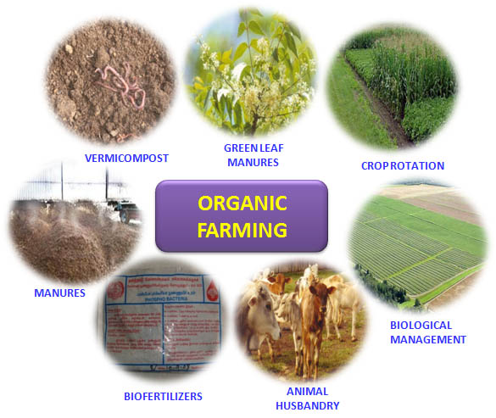

Aims of Organic Farming:
1. To produce crop with a high nutritional value
2. To maintain and improve long term fertility and sustainability of farm land.

Characteristics of Organic Farming include:
1. Protecting the long term fertility of soils by maintaining organic matter levels, encouraging soil biological activity, and careful mechanical intervention;
2. Providing crop nutrients indirectly using relatively insoluble nutrient sources which are made available to the plant by the action of soil microorganisms;
3. Nitrogen self-sufficiency through the use of legumes and biological nitrogen fixation, as well as effective recycling of organic materials including crop residues and livestock manures;
4. Weed, disease and pest control relying primarily on crop rotations, natural predators, diversity, organic manuring, resistant varieties and limited (preferably minimal) thermal, biological and chemical intervention.
5. The extensive management of livestock, paying full regard to their evolutionary adaptations, behavioral needs and animal welfare issues with respect to nutrition, housing, health, breeding and rearing.
How Organic Farming Benefits the Environment

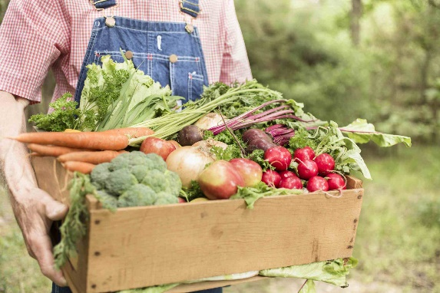
Reduced Exposure to Pesticides and Chemicals

- Pesticides allow disease resistance to build up in plants, weeds, plant-eating-insects, fungi, and bacteria.
- Pesticides and chemicals sprayed on plants contaminate the soil, water supply, and air. Sometimes these harmful pesticides stick around for decades (maybe longer).
- Synthetic chemicals also discourage smart farming practices such as cover crops and crop rotation, which in turn, may cause other harmful environmental problems like erosion.

Organic Farming Builds Healthy Soil
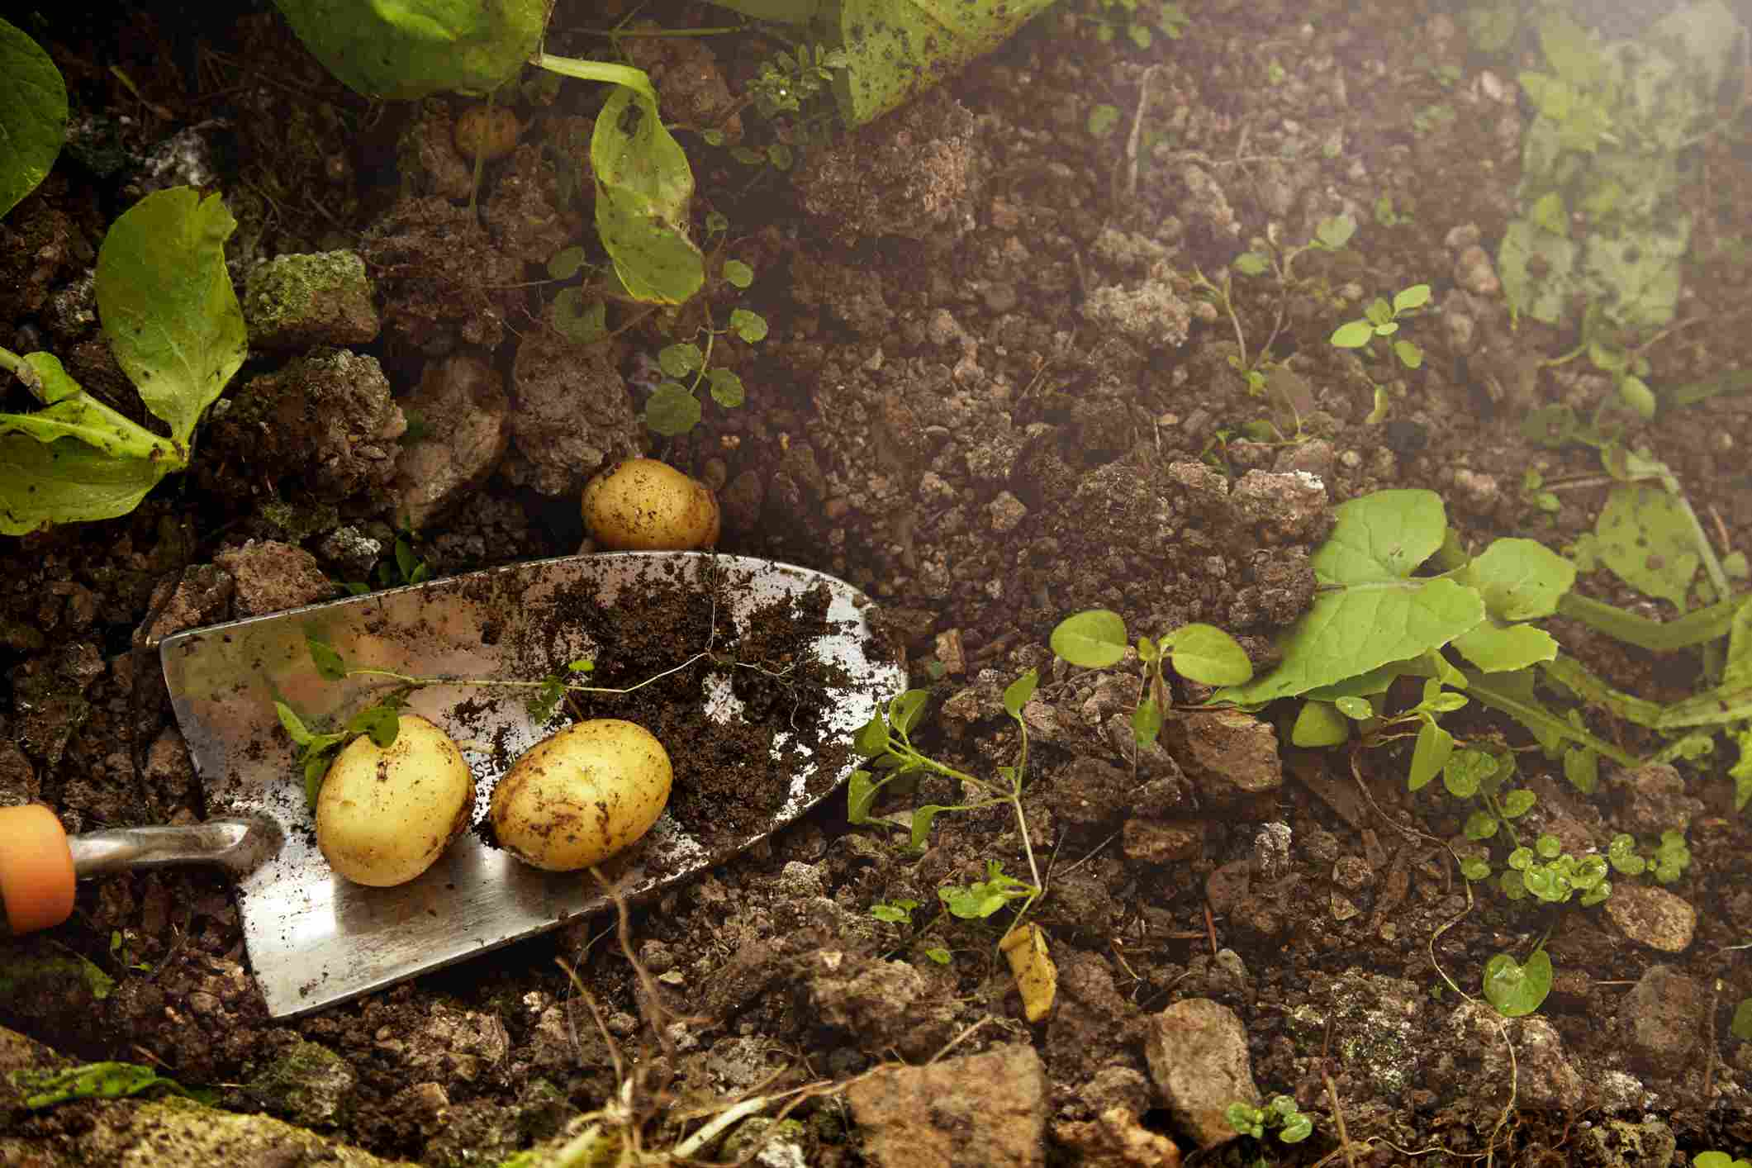

To grow healthy food, you must start with healthy soil. If you treat the soil with harmful pesticides and chemicals, you may end up with soil that cannot thrive on its own. Natural cultivation practices are far better than chemical soil management.

Combatting Erosion

Not only does organic farming build healthy soil, but it helps combat serious soil and land issues, such as erosion.

Fighting the Effects of Global Warming

Organic Farming Supports Water Conservation and Water Health
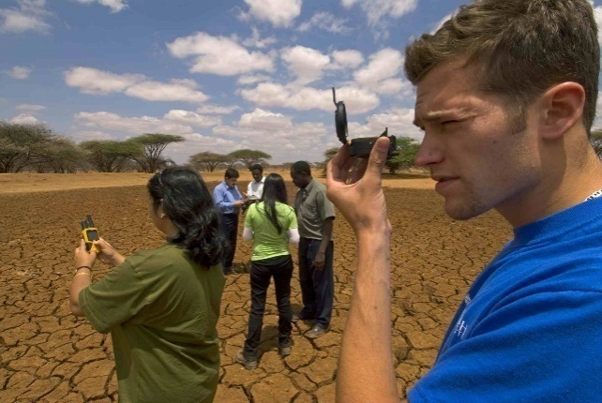

Organic farming also helps conserve water. Organic farmers, in general, tend to spend time amending soil correctly and using mulch - both of which help conserve water.

Supporting Animal Health and Welfare
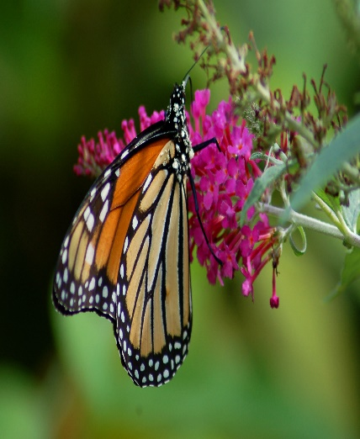

Insects, birds, fish and all sorts of other critters experience problems when humans swoop in and destroy their natural habitat. Organic farming not only helps preserve more natural habitat areas but also encourages birds and other natural predators to live happily on farmland, which assists in natural pest control.

Organic Farming Encourages Biodiversity

In general, the more biodiversity there is on a farm, the more stable the farm is. Organic farming encourages healthy biodiversity, which plays a critical role in how resilient, or not, a farm is to issues like bad weather, disease, and pests.

Exercise 3
  - State the features of organic husbandry in local primary production.

    - Describe the features of organic husbandry in local primary production.

    - Explain how organic husbandry contributes to local primary production.

    - Discuss the factors that influence the application of organic husbandry and suggest ways of maximising the benefits for local primary production.

