AGRICULTURAL SCIENCE
Strand 2: Sustainable Primary Production | Sub-strand 2.3: GLOBAL ISSUES AFFECTING PRIMARY PRODUCTION
LESSON ACTIVITY 2: Genetic Engineering

The Specific Learning Outcome (SLO) targeted in this activity are provided below.
SLO# | Specific Learning Outcomes: Students are able to | Skill level | SLO code
5 | Define genetic engineering as related to local primary production. | 1 | agr2.3.1.2
6 | Describe the features of genetic engineering used in local primary production. | 2 | agr2.3.2.2
7 | Assess the advantages and disadvantages of genetic engineering in local primary production. | 3 | agr2.3.3.2
8 | Discuss and recommend viable alternatives to genetic engineering in local primary production. | 4 | agr2.3.4.2

Genetic Engineering

What is it?
A set of genes is taken out of the DNA of one organism and inserted into the DNA of another organism. It has the potential to increase productivity without any increase demand on the environment; potential to breed disease – resistance reducing the reliance on sprays.

DNA (deoxyribonucleic acid), molecule that acts as the mechanism of biological inheritance in almost all living creatures. DNA is found in nearly all cells and contains the coded instructions that control the workings of the cell. DNA is passed from parents to offspring, and contains the coded instructions that enable the offspring to develop from a single cell into an adult body

Description of genetic engineering: Any alteration of an organism’s genes or genetic material. For example:
Scientists have created transgenic animals and plants by taking genes from one organism and placing them in the DNA of a different one. Animals have been genetically engineered to produce important, rare drugs, such as insulin, in their milk. Researchers gave genetically improved tomatoes to reduce the production of the gas ethylene that courses the ripening.When the gene is inserted into a tomato plant it slows the ripening process, allowing consumers to have tomatoes all year round.

Two positive effects:
- Can produce a cultivar/variety of plant or breed of animal that can resist diseases and effects of the environment such as drought, weeds, etc, hence farmers can still produce and get income.
- Are highly preferred and demanded in the market.

Two negative effects:
- Genetic engineering may produce cultivar/variety/breed that is too expensive to produce.
- If cultivar/variety/ breed produced is preferred and demanded by the market, local farmers may change to it losing production of the local strain, and possible loss of genetic diversity/cultural value.

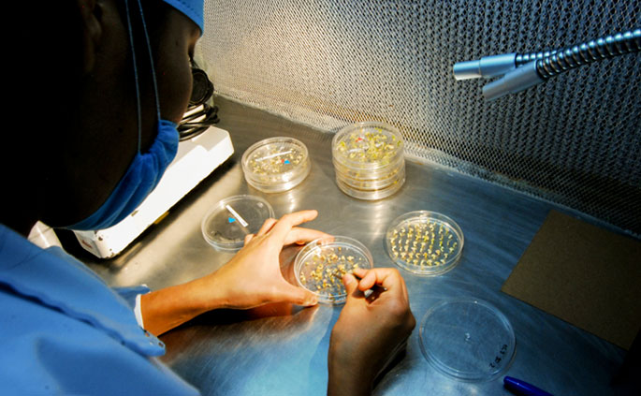

Exercise 2
- Define genetic engineering as related to local primary production.

- Describe the features of genetic engineering used in local primary production.

- Assess the advantages and disadvantages of genetic engineering in local primary production.

- Discuss and recommend viable alternatives to genetic engineering in local primary production.

