AGRICULTURAL SCIENCE
Strand 2: Sustainable Primary Production | Sub-strand 2.2: Husbandry/ Agronomy Practices
LESSON ACTIVITY 1: IMPORTANCE OF MANAGEMENT PRACTICES FOR SUSTAINABLE

The Specific Learning Outcome (SLO) targeted in this activity are provided below.
SLO# | Specific Learning Outcomes: Students are able to | Skill level | SLO code
1 | Name the key issues affecting long term primary production | 1 | agr2.2.1.1
2 | Describe the nature of pests, diseases and weeds that need to be controlled in long term primary production | 2 | agr2.2.2.1
3 | Describe the control mechanism used for each pest, disease and weeds in primary production | 2 | agr2.2.2.2
4 | Explain how pest, disease and weed control measures used are suited to the problems they are meant to deal with in enhancing long term primary production. | 3 | agr2.2.3.1
5 | Discuss the issues of pest, disease and weed control and recommend viable and sustainable alternatives that ensure the capability of long term primary production | 4 | agr2.2.4.1

The main factors that affect long term primary production can be grouped into:
- Environmental or ecological factors like:
- Abiotic factors (sunlight, wind, rain, water, soil)
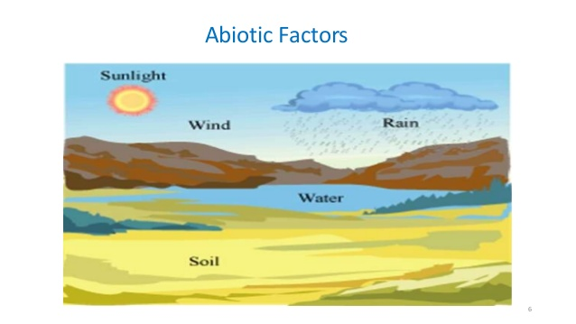

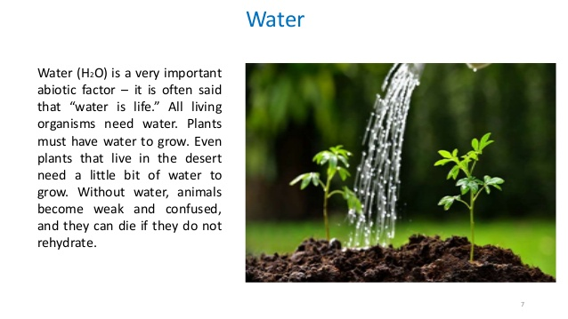
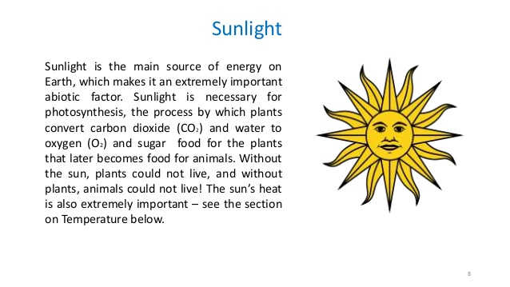
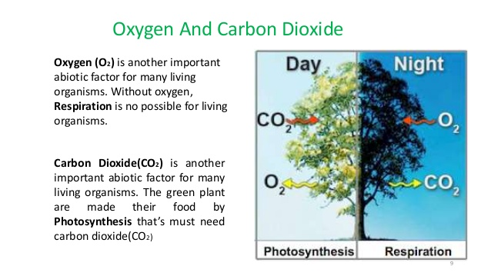
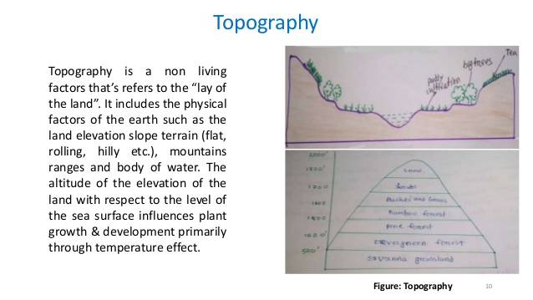
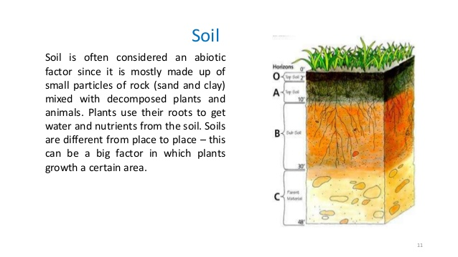
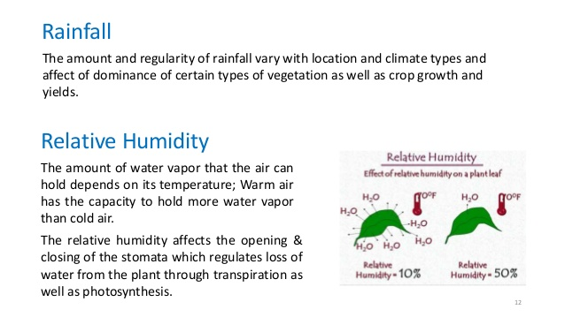

- Biotic factors (producers, consumers, decomposers)
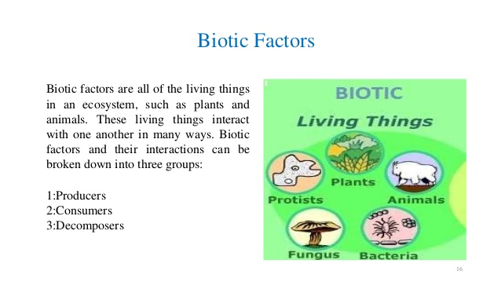
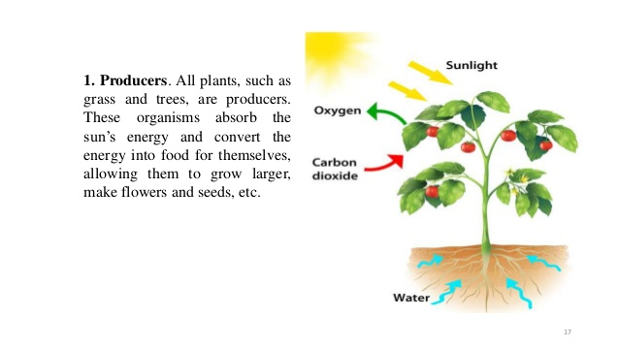
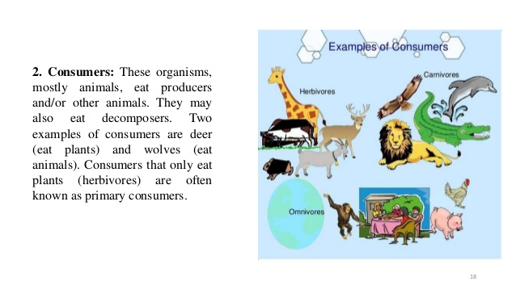
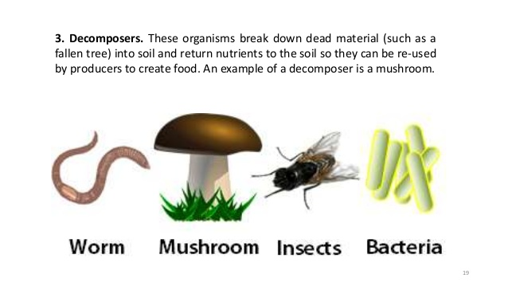

- Pests
- Diseases
- Weeds

What is a pest?
Plant pests refers to any organism – from the very small [e.g. a virus] to the large [e.g. rodent] – that causes damage to plants to plants that are used by humans or to plants in the natural environment that would not normally be affected by the organism.
An organism will only considered a pest when it interferes unfavorably with plants in a particular situation.
Pest causes damages or illness to crops, animals and people. In Agriculture the term pest may include insects, mites, fungi, bacteria, virus, nematodes, rodents, mollusc and weeds. Pest can cause damage directly and indirectly by:
- Damaging the whole plant
- Damaging the saleable part of a plant (fruits, corms, tuber, and nuts).
- Damaging the non-saleable part of a plant.
- Damaging the plant through injection of eggs and poisonous fluid into the plant.
- Damaging the plant through transmission of other pests’ e.g. virus.
- Encourage the growth of rooty moulds or insect secretion on plants.
- Causing yield loss due to competition (weeds compete for nutrients water and light).
- Interfering with managing practices.

Group of Pests.

Insect and Mites
This group of organisms or pests is classified according to their mouth of feeding or mouth part. Some have chewing mouth parts and bite piece of their food while some have piercing mouth part that they pierce an insert into their food to suck the juice of the food or plants.

Biting and Chewing Insect
These insects have mouth parts which are adapted for chewing and biting.
The types of damage they cause are:
- Bites and chew plant leaves which cause reduction in photosynthetic are of the plant leaves which may reduce growth and yield of plants.
- Bites and chew duds and shoots thus killing the growing point of the plant.
- Destruction of flowers, fruits and seeds.
- Boring and tunnelling into leaves, roots, fruits and seeds leading to breaking and transmitting of viral diseases.
- Destruction of seedlings or young plants.
- Damage stored products.
Members of this group of insects include locust, grass hopper, stick and leaf insects, cockroaches, mantis and termites.

Piercing and Sucking
The mouth part of members of this group has been modified to pierce plant tissues and suck the content. The secretion of slime from the mouth part into the tissues of the plant causes some physical damages when this is couple with the loss of cell sap. The growth rates of the plants are drastically reduced and part of the plant may be distorted. Some of these insects attack the reproductive organs of the plants thus fewer seeds are produced for reproduction.
Sucking insects insert toxic saliva or slime into plants which may cause lesions which in turn may lead to secondary infection such as attacks by fungi. Fruits may be blemished or the toxic substance may kill shoots.
Finally sucking insects can transmit diseases. They are vectors of most plant viruses.

Examples: -
- Plant aphids
- Scale insects
- Mealy bugs
- Melon flies
- White flies
- Fruit flies

Some major insects and mites of the South Pacific

Insects
- Diamond Back m0th
- Rhinoceros beetle
- Taro beetle
- Coconut stick insect
- Taro plant hopper
- Banana weevil borer
- Fruit flies
- Fruit piercing moth
- Citrus snow scale
- Onion thrip
- Serpentine leaf miner
- Sweet potato weevil

Mites:
- Broad mite
- Citrus red mite
- Spider mite

Slugs and snails
This group of pest attack crops /plants by biting and chewing, piercing and sucking and produce slime that they secrete on leaves and stems of crop plants. The slime may allow growth of sooty mould which will destroy the crop or plant product.
Snails and slugs can eat garden waste, house hold refuse including cupboard and even excreta. They appear on young and tender plants and damage them e.g. Seedlings in the nurseries.
The damage they can cause is through their rasping tongue (the radula) which can saw bits of plant tissue.

Vertebrate
This group of pest has biting and chewing mouth part that they use to destroy plants/crops. They damage crops by:
- Eating the whole plant (leaves, roots, stem etc…).
- Bores holes on stem and roots.
- Damage saleable parts of the plants.
This group of pest includes rats, bats and birds.

Diseases of Plants/Crops
Diseases are as the malfunction of host cells and tissue that results from their continuous irritation by pathogenic agent or environmental factor and leads to the development of symptoms. (Agrios 2005)
It can also be defined as a deviation (change) in the normal state of plants.
Plant diseases can be classified according to the agents (pathogens) which cause them.
These agents are:
- Fungi [fungal diseases]
- Bacteria [bacterial diseases]
- Virus [viral diseases]
- Nematodes [nematode diseases]
How diseases can damage plants/crops:
- Lesions
- Root rot, galls and root knots
- Excessive root branching
- Injured root tip
- Disruption to plant’s water system
- Leaf spots, galls, tambours
- Dwarfing

Fungi
Fungi are classified as plants because their protoplasm is enclosed in a cell wall. They have no roots, no stem and no leaves. Their bodies consist of a mass of interwoven branching threat like hyphae called mycelium.
They differ from green plants in that they do not contain chlorophyll and are unable to photosynthesize their own food from water (H2O) and carbon dioxide (O2).
Fungi lives either as parasite on other living organisms and cause diseases that develops from spores which are carried by wind and water. Their spores develop hypheae which penetrate the tissue where the mycelia are established. Some fungal diseases are:
- Damping off and seedling blight.
Seedlings are rich in food reserves that are converted into sugar early in the growth of plants. These sugars stimulate the germination of spores of soil fungi which later then penetrate the roots of the seedling causing the pre-emergence damping off.
- Rot.
Young roots are thin walled so that root rot fungi such as phythium can penetrate them and attack the roots causing root rot.
- Fruit rot.
E.g. Tomato fruit resting on the ground may have fruit rot. The infected part become soften and watery.
- Vascular wilt.
Some pathogens enter through roots and develop mainly in the xylem, disrupting the plant water transport system so that the entire plants suddenly collapse.

Bacterial Diseases.
Bacteria are microscopic unicellular (single celled) organism with a simple structure. They are found under both aerobic (require O₂) and anaerobic (does not require CO₂) condition and are especially in fertile soil, water, sewage, and various food product.
Most bacteria reproduce by simply dividing into two (2), a process known as FISSION and this allow them to multiply rapidly. Bacteria come in variety of shapes and some can move with the aid of flagella. Bacteria prefer warm and moisture conditions.
Examples of bacterial diseases:
- Bacterial wilt of tomatoes.
- Bacterial fruit and leaf sports.
- Stem Canker of tomatoes.
- Black rot of round cabbage.

Viral Diseases
Viruses are smaller than fungi and bacteria. They are so small that they can only be seen under powerful electron microscopes. Viruses are simple in structure consisting of a protein coat that encloses nucleic acid. Virus can pass through the pore of a filter through which bacteria can not pass, hence they are call Filtrate Viruses.
Viruses can pass from one organism to another by contact of pick up by contaminated materials.
Examples of viral diseases:
- Leaf molting
- Mosaics
- Leaf roll
- Dwarfing in plants

Nematode
This group of organism is also called eelworm, is found in almost every part of environment ranging in size from large animal parasites in livestock to tiny soil inhabiting species. The organism is found in most soils that have grown potatoes or root tuber crops. The proportion of their egg in the soil is stimulated by chemicals to hatch and produce in the potato roots.
The larvae invade the roots of potatoes, disrupting translocation in xylem and protein tissue and sucking up plant cell content.

Weeds
Weed is any group of plants growing on their own in any ecological medium. It is also defined as any plant or group of plants which grows where it is not wanted. Weeds compete with crop plants for sunlight energy, water and nutrients therefore reduces the yield of crops.

Weeds in pasture
The best way to control weeds in pasture is to have a healthy, vigorous species of grass of turf such as guinea grass, signal grass, koronivia grass.

Grassy weeds
Should be removed by hand or carefully treated with glyphosate, using a zero weeding brush.
Whenever herbicides are used make sure the following steps have to be respected:
- Read the label and follow all instructions.
- Protect yourself from absorbing the pesticides through skin (wear protective clothing), mouth (do not eat or smoke, using contaminated hands) and lungs (wear appropriate mask or respirator)

Keep pesticides in a locked cabinet or building
- Do not use herbicides if the conditions are not right(if it is windy then spray mist may be blown to inappropriate areas).

Control methods
- Cultural control – early planting, good crop cover, mulching, flooding, rotations.
- Mechanical control – cultivations (digging or ploughing), hand weeding.
- Chemical control – herbicides.

Stages of life cycle of an insect pest.
Incomplete Metamorphosis [egg, nymph, and adult]
In this stage of life cycle of typified by aphids, earwigs the eggs hatches to form a first stage [or instars] called nymph, which reassemble the adult in all but size, wing development and possession of sexual organs.
Successive nymph instars move closely resemble the adult. Two to seven instars [growth stages] occurs before the adult emerges.
Complete Metamorphosis [egg, larvae, pupa, adult]. This group of insects including the moths, butterflies, beetles undergoes a complete metamorphosis [complete change of form]. The egg hatch to form the instars called larvae which differ greatly in shape from the adult. E.g. the larvae [caterpillar] of the cabbage white bears little resemble of the adult butterfly. The great change [metamorphosis] is necessary to achieve this transformation to occur in the pupa stage.
eg.cabbage white bears.

Economic Reasons for Controlling Pests and Diseases in Relation to Product.
Insect pest are responsible for significant losses of Agricultural product and food stuff. The fact that they contaminate these food stuffs has ensured that they are generally disturbed globally because of transport and trade. Most storage insect pests prefer food stuff with high nutritive value such as grain and pulse. In the PIC, stored produce which are damage include rice, coffee, cocoa, copra, legumes, flour, maize, and tobacco.
E.g. Rice moth, copra beetle, rice weevil and tobacco beetle.
Plant disease like the insect pest also causes significant reduction in the quantity and quality of agricultural crops grown globally. They have been responsible for some of the most drastic failures and famines that have affected people all over the world. In some PICs taro leaf blight causes losses to the crops. Fortunately, this has not led to serious problem s of hunger through lack of food, although it has significantly try to affect the economy of Samoa for instance the export in 1993 at the early stages of the blight totaled WS $ 9.5 million. However, the first three month of 1994, when the blight was spread, saw only WS $ 56000 worth of taro export. Not only the country lost out in export earning; it had to import a considerable amount of substitutes, such as rice, flour and potatoes. Plant diseases can reduce the quality or market appearance of a number crop spots, scabs, cankers and other blemishes on fruits and vegetables will have little effect on quantity or yield but could possibly result in a total lost of the crop because it has lost its market value. E.g. in some market apples with as little as 5% scabs are only worth half as much as scab free apples.

Pest and Disease Control Measures
Due to the economic reasons and other products to be considered, such as food and human welfare, pest and diseases should be controlled to avoid such losses to agriculture products. Some of these control measures include:
- Crop Rotation
- Pesticides
- Cultural Practices
- Physical Control
- Biological Control
- Regulatory Control
- Integrated Pest Management. [IPM]

1. Crop Rotation
Crops are planted in sequential time. The most common rotation includes grasses and root crops. Rotation is most effective against those pests that have a limited host range and poor ability to disperse. If the pest cannot survive for a long period without a suitable host plant then it will die. Pests that are mostly vulnerable to this control method are poorly mobile [move]. Soil inhabiting with a restricted host range and a life cycle of one year or longer. Crop rotation is important for controlling a number of insects in PICs including sweet potato weevil.

2. Pesticides
Pesticides are pests killing agents. Pesticides may be classified in a variety of ways such as their mode of action, chemical nature, time of action or type of pest that they control.
Classification of pesticides according to the type of pest they control.
Classification of pesticides according to the type of pest they control.

Pesticides | Type of pest they control
- Acaricide  - Bactericide  - Fungicide  - Insecticide  - Nematicide  - Molluscide  - Rodenticide  - Herbicide | Mites, Ticks, Spider  Bacteria  Fungus  Insects and sometimes related to pests such as mites.  Nematodes  Snails and slugs  Rats and mice  Weeds

Choosing which pesticide to use.
It is important to make wise decision regarding which pesticide to use if you want to carry out effective chemical control. Failure to do so can lead to unnecessary expense and possible dangers your health and the environment.
Three [3] main important properties of pesticide that we can use to choose safer products are:
- Toxicity: - the toxicity of a pesticide gives us an indication of the danger that the pesticide possess to our health. Toxicity is the ability of a substance to cause poisoning.
It is mostly expressed as LD ₅₀ [Lethal Dosage for 50%] rating.
- Persistence: - this is the length of time that the pesticides persist in the environment for a relatively long time. This is more likely that it will cause danger to non-targeted organisms.
- Selectivity:- the wider range of species that a pesticide is able to control the less selective it is. Ideally you should choose a pesticide that is specific for the pest that you are trying to control.

There are three [3] broad categories of chemical used for plant disease control.
- Protestants [e.g. Fungal seed dressing]
- Systematic [Foliar spray or soil application]
- Soil fumigants [For controlling soil borne diseases such as nematodes]

The common soil fumigants are:
- Methyl bromide which is a gas at normal temperatures. It is placed on the soil surface [or injected a little way into it] under a light gas sheet. The fumigants strike into the soil as it is heavier than air.
- Dichloropropene and Dipromochloropropene, which are liquid at normal temperature. They have to be injected 20cm into the soil from where they gradually vaporize into the surrounding soil.

Advantages of pesticides:
- Kill the target pest directly
- Wipe out large population at once.

Disadvantages of pesticides:
- Expensive – use only on high value crops
- Extremely toxic- considerable care must be taken during their use. E.g. cause skin irritation, breathing problems and poison food for human consumption.

3. Cultural Control
Cultural control of pests and diseases is what we call a Preventative Treatment. This means taking steps to prevent a pest build-up at the beginning and mainly involves cultivation practices method we use. It is environmentally safe and is compatible with our control measures.

Cultural practices for pest control include:

- Time of planting.
The timing of seedlings and planting may be used to avoid the entry of migrant pests into crops reposition period of particular alternatively it may be used to ensure that pest attacks coincide [happen together] with the period of abundance of its natural enemies or with weather conditions that are unfavorable for the pest or a growth stage that is vulnerable [capable of causing damage].

- Use of pest free planting materials
Pest free planting materials are available for many crops. It will help delay the introduction of pests into the crops and also prevent initial colonization of a crop by a pest. eg. 1. When preparing planting material for sweet potato [kumala]. The cuttings should always be taken from the first 30cm to 50cm of vines from the tops. This help to avoid weevil, pest that damage kumala. E.g. larvae.
e.g. 2. The use of clean banana suckers is an important first step in the prevention of banana weevil.

- Drainage
The available of moisture affect the survival of some pest. When there is high amount of moisture, pets tend to spread really fast at the same time they also reproduce. Therefore drainage system is important in removing the amount of moisture thus destroying breeding site for pests and diseases.

- Burning
Burning an area before planting also helps in controlling pests and diseases because it kills or destroy the living organisms [pests /diseases] in that particular area. This will allow the crops to grow well without any pest and diseases infection or invasion at the beginning seasons.

- Roguing
This involves removing low level weeds to prevent a population build –up or removing and destroying infected plants [i.e. if known to be infected with virus]. Rouging may be infected in small plots. In large areas, it practical only in very valuable crops, and if the problem is recognized and does not spread rapidly.

- Mixed cropping
This involves the diversity of the cropping system which tends to reduce pest population. This technique is widely used by villager farmers and plantation groups Pacific Island countries.

- Irrigation system
This system disturbs, drown, or suffocate insects, fungi, nematodes, weeds, e.g in irrigated rice field.

Advantages of cultural control.
- They may be used as part of genera good practice in maintaining crops.
- Some types of cultural control may be fairly expensive.

Disadvantage
- On the other hand farmers usually decide at planting time what cultural practices to use. If pest infestation is developed during the season, the farmer cannot adopt another cultural control method.

3. Physical Control
Some of the physical control methods that can be used for pest control include:
- Heat treatment
This is applied to the planting material or the vegetative propagated crops to kill pests such as nematodes.
- Traps
These art used mainly against vertebrates. E.g. rat traps, light traps use of UV light to attract and kill insets at night.
- Hand Picking
This is frequently used to remove large insects and other pest in a garden e.g. By picking up eggs from taro leaves regularly, farmers can reduce the attack the of cluster caterpillar, lady bird.
- Barriers
Placing barriers around crop plants. E.g. using iron bands around coconut palm trunk to stop rats from attacking coconuts.
- Scaring devices.
Using devices that look like their enemies to scare them away. E.g. Scare crow or human figures placed in a field to frighten away pests.

Advantages
- Leave no residence
- Do not disturb the ecology of the crop system.

Disadvantages
- Only few pests can be control by this method.
- Labour intensive.

4. Biological Control
Biological control is the use of living organisms or virus to control other living organisms. It includes the introduction of parasites or predators or diseases [natural enemies of pests]. There is a great potential for the increase of natural enemies in pest control in the PICs. E.g. in the PICs the use of a virus called bacula virus to control the rhinoceros beetle on coconut palms. Another example is the use of snakes in cocoa trees to control rats in cocoa trees.

Advantages
- Cheap for farmers
- Environment friendly
- Once natural enemies are in place it continues to opera year after with need to import other organisms.

Disadvantages

- Although biological control is not expensive for farmers establishing a biological agent may be expensive for the government.
- Not all pests have effective predators and parasites.

5. Regulatory Control.
Regulatory control refers to control regulation which involves quarantine, eradication orders or certificates.
PICs have taken Measures such as:
- Routine quarantine inspection of plant materials to prevent the introduction of exotic plant pests.
- Placing quarantine restriction on the movement of fruits and vegetables in Solomon Islands to control melon fly [Bactroceriacucubitae]

Advantages
- Prevent the entry of pest into the country
- Successful eradication removes a pest entirely

Disadvantages
- Quarantine cannot control existing pests.
- Eradication is generally very expensive

6. Integrated Pest Management [IPM]
Integrated refers to a range of compatible methods of control used.
Management means the total elimination of the pest is not the objective.
Define as; the applications of the best mix of environmentally sound techniques to keep pest below the economic threshold.
When a pest occurs, a rational approach should involve the following stages;

- Identify the pest and define the area in which control should be applied – These facilitate choice of effective and economical measures.
- Asses the level of infestation and potential economic losses - This will indicate whether the loss cause by the pest is high enough to justify control actions.
- Study the life cycle and behavior of pest – This will reveal the most vulnerable stage in the pest life cycle.
- Consider the available option for controlling the pest in questions.
- Consider pesticides only after all other pest control methods have been considered. Pesticides should be included only when other available control measures cannot achieve a sufficient level of control.
- Apply the chosen measure[s].

The IPM approach involves the use of a combination of pest control methods. A Pest control option that may be included in an IPM program includes:
- Plant Resistance / varietal control
- Cultural Control
- Biological Control
- Interference method
- Physical Method
- Legislative / Regulatory Control
- Chemical Control
Name the key issues affecting long term primary production | 1 | agr2.2.1.1
Describe the nature of pests, diseases and weeds that need to be controlled in long term primary production | 2 | agr2.2.2.1
Describe the control mechanism used for each pest, disease and weeds in primary production | 2 | agr2.2.2.2
Explain how pest, disease and weed control measures used are suited to the problems they are meant to deal with in enhancing long term primary production. | 3 | agr2.2.3.1
Discuss the issues of pest, disease and weed control and recommend viable and sustainable alternatives that ensure the capability of long term primary production | 4 | agr2.2.4.1

Exercise 1
1. Name the key issues affecting long term primary production. L1 agr2.2.1.1

2. Describe the nature of pests, diseases and weeds that need to be controlled in long term primary production. L2 agr2.2.2.1
3.Describe the control mechanism used for each pest, disease and weeds in primary production. L2 agr2.2.2.2
4.Explain how pest, disease and weed control measures used are suited to the problems they are meant to deal with in enhancing long term primary production. L3 agr2.2.3.1
5.Discuss the issues of pest, disease and weed control and recommend viable and sustainable alternatives that ensure the capability of long term primary production. L4 agr2.2.4.1

