AGRICULTURAL SCIENCE
Strand 2: Sustainable Primary Production | Sub-strand 2.1: Analysis of Management Practices for Sustainable Primary Production
LESSON ACTIVITY 5: IMPORTANCE OF MANAGEMENT PRACTICES FOR SUSTAINABLE PRIMARY PRODUCTION

The Specific Learning Outcome (SLO) targeted in this activity are provided below.
SLO# | Specific Learning Outcomes: Students are able to | Skill level | SLO code
19 | Identify types of water management practices used to maintain sustainable primary production | 1 | agr2.1.1.6
20 | Describe the features of water management practices used to maintain sustainable primary production | 2 | agr2.1.2.5
21 | Describe how water management practices maintain sustainable primary production | 2 | agr2.1.2.6
22 | Explain how water management practices are used to maintain sustainable primary production | 3 | agr2.1.3.6
23 | Discuss ways to improve water management practices to enhance sustainable primary production | 4 | agr2.1.4.6

WATER MANAGEMENT PRACTICES

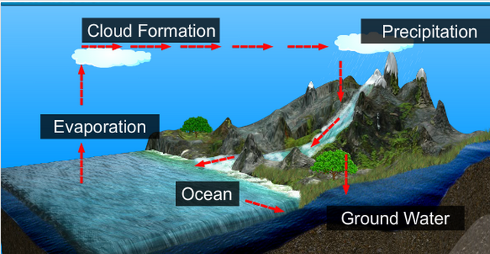

The importance of water management
Water management affects many aspects of our lives. Water is so common that we often do not think about where it comes from or where it is managed. But, bad water management can really hit us hard.

Water management
Water resource management is the activity of planning, developing, distributing and managing the optimum use of water resources.
Water is not an essential plant nutrient, but a solvent by means of which the nutrients in the soil and the fertilizers are dissolved and made available to plants. Without water all crop growth stops. Even if water is available, but in amounts less than the maximum a crop can use at a particular time, growth suffers and harvest is reduced.
Farmers must know how to manage their water to avoid shortage of water at root level, because this could have a detrimental effect on plant growth development and production.
Drainage is an important part of the management of water in the farm.
All excess water has to be drained out to avoid water logging situation and fungal disease.
All water management has a cost the farmer has to work out the best method he can afford and one that, will pay for itself by increasing crop yield and quality.
We then come to the problem of (1) water supply, (2) irrigation and (3) run off that farmer usually face in their farm productions

What is the importance of water management?

Water Management is important since it helps determine future Irrigation expectations. Water management is the management of water resources under set policies and regulations. Water, once an abundant natural resource, is becoming a more valuable commodity due to droughts and overuse.
How can we improve water management?
- Increase soil organic matter.
- Improve soil structure.
- Reduce soil erosion.
- Increase water filtration.
- Increase efficiency of water use.
- Replenish soil nutrients.
- Increase the efficiency of nutrient uptake.
What are the objectives of water management?

Improving productivity of irrigation water by efficient conveyance and its effective farm level use by adopting conservation agricultural practices. Production of more profitable crops through high efficiency irrigation systems for meeting increasing domestic demand and enhancing exports.

Water conversation practices

All plants need large amount of water for growth. It is also essential to microorganisms.
We now have the problem of (1) increasing water entry into the soil, (2) improving soil water movement and (3) increasing water storage capacity.
- Increasing water entry.
- Ploughing/cultivating is the common device for increasing water entry.
Cultivating will break the crust that often seals the surface of cultivated pores or air spaces which permit more rapid water entry.
- Contour ploughing is an extremely valuable water conservation device .
- Mulches also serves to break the crust-forming force of the rain drops and keep water clear and so it will penetrate more readily. Mulches help hold water on the soil.
- Early planting and contour planting are devices for increasing entry of rate of water.
- Cover crops planted after harvest of cash or feed crops will serve to prevent run off.
Green manure crops which have been ploughed under will help by increasing the number of pores.

- Improving soil water movement
Soil water movement is mainly controlled by soil texture, aeration and content of organic matter.
Little can be done to improve the movement of soil water in lands actually under cultivation and growing a crop.
Ploughing has a temporary effect but in the ploughing zone only.
In general this must be done before or after growing a crop. This usually accomplished by ploughing in animal and green manures, and by ploughing in crop residues. Grasses grown in rotation has a good effect on soil water management.
- Increasing water storage
The water storage capacity of the soil is determined by the size of soil particles and the organic matter content of the soil. As with water movement this capacity can only be improved before and after cropping with the use of green manures, animal manures and crop residues ploughed into the soil.
The devices used for increasing water entry will increase the amount of water a cultivated land can store.
The device for diminishing the amount of water evaporated from the surface of cultivated soil include fallow, mulches and weed control.

Water supply:
- Rainfall :
Crops and animals always rely on rainfall for most of their water needs. Unfortunately the rainfall cannot always satisfy their needs or even within a production period. Rainfall is really unreliable. The farmer always find ways to compensate for the shortfall of rain to make sure plants and livestock have their required amount of water for their development, growth or production.

- Water storage system (tank, dam, reservoir…)
The farmer has to capture water from the rainfall to store it in different devices such as:
- Water tank has limited quantity depending on the rainfall,
- River dam has large quantity to draw water from,
- Dam constructed in the gullies/farm ponds,
- Any type of water reservoir (natural lake, artificial lake, water hole….)
- Water supply system drawn from nearby river/stream.
The farmer has to install a pump to draw water from the river to the cultivated area, needing pipe system or water channel/furrows to take water to the plant roots.
In the case of paddy system such as rice and taro paddies huge quantity of water has to be drawn and channeled to the crops.
These devices have to be constructed close to the garden or cultivated area.
- Pumps: design to raise water can be in the form of a hand pump, a hydro pump, a motor driven pump.

Irrigation
What do you mean by irrigation?

A system of supplying (land) with water by means of artificial canals, ditches, etc, especially to promote the growth of food crops.

Make the most use of your water
- Water in the morning or evening to avoid much evaporation before it gets down.
- Train plants in good water habits. Less frequent, deep soakings will train the roots to grow deep.
- Light sprinkling create problem for the farmer as the plants develop superficial roots where they are more vulnerable to heating up and drying up.
- Water the roots of the plants, not the leaves where water will easily be evaporated. Use a soaker hose or a watering system that carries water directly into the root system.
- Mulch around your crops to conserve moisture in the soil. Make sure there is moisture in the soil before you mulch.
Make use of every drop of water. Rinse water from washing machine, “grey water” from bath can be mixed with soluble fertilizer such as Aquasol or Thrive-this to encourage the growth of healthy plants with vigorous root systems.

Irrigation systems
Basin irrigation or flood irrigation
Water from the main channels is allowed to flow into the basin that are carefully terraced and leveled. Siphon tubes are used. It has the advantages of even distribution of water, cheap to operate but it is easy to over use water, it needs quite a lot of work to construct basins and care must be taken to avoid erosion on steeper slopes by constructing stepped water channels, lined with concrete.

Why do we need irrigation?
- To make crops grow during dry season,
- To help plants through dry times,
- To extend the rainy season,
- To improve yield of crops,
- To improve quality of crops.

Methods of irrigation
- Dip tanks:
Water is collected in buckets to supply to plants.
- Furrow irrigation:
Water is guided along the surface of the ground by making furrows and dams on a gentle slope. Water is led along one row at a time until all the rows have been irrigated.
It is inexpensive where water is plentiful but it is easy to put on to much water (causing too much leaching and poor root development) and it is unsuitable for steep slope.

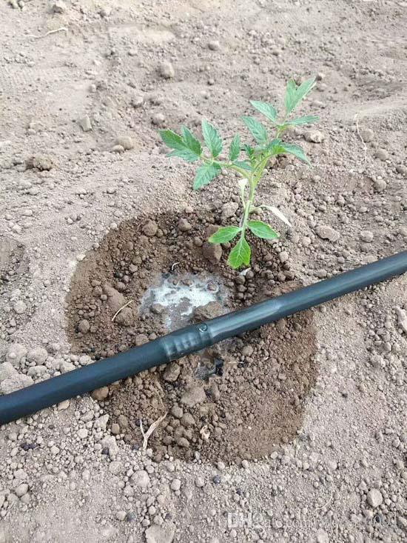Drip irrigation
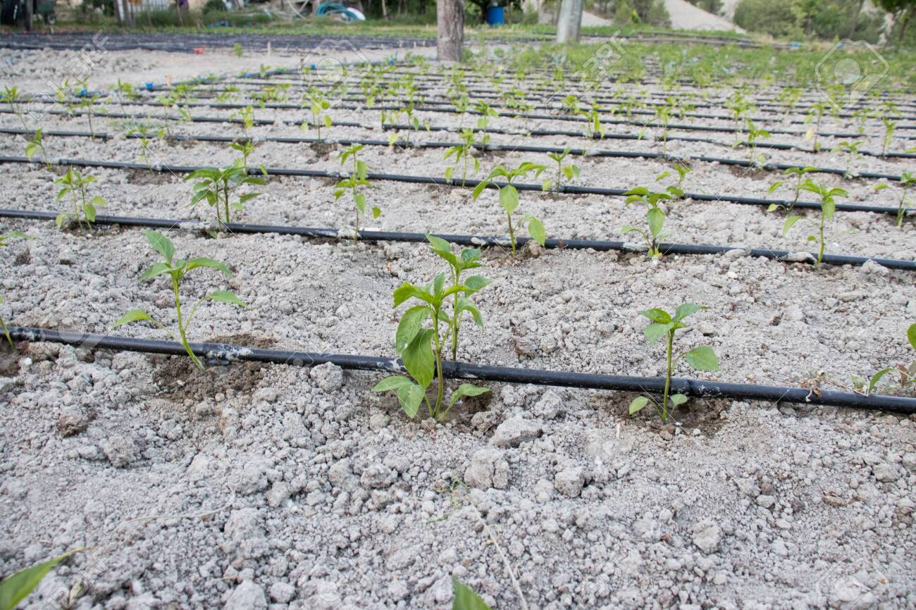
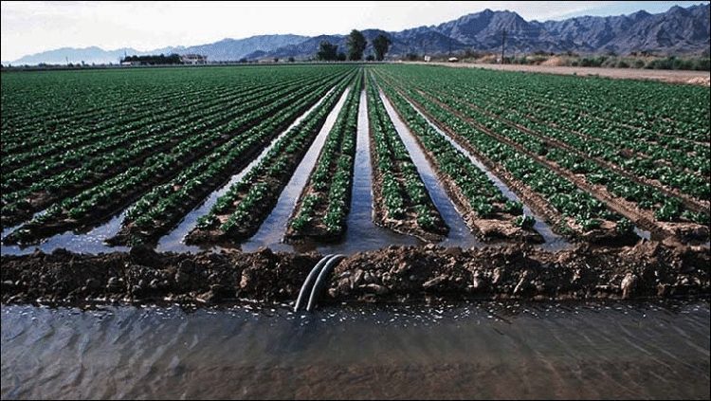Furrow irrigation
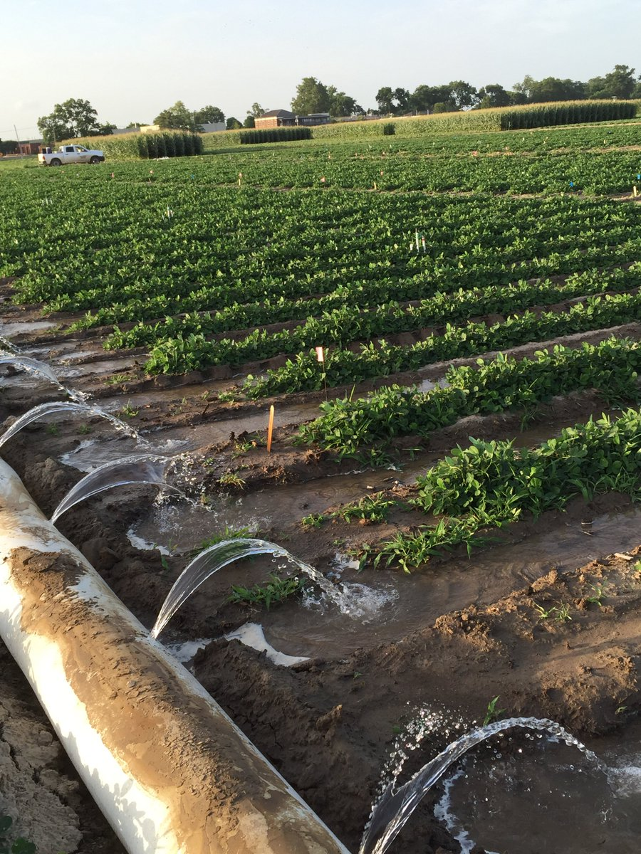Furrow irrigation

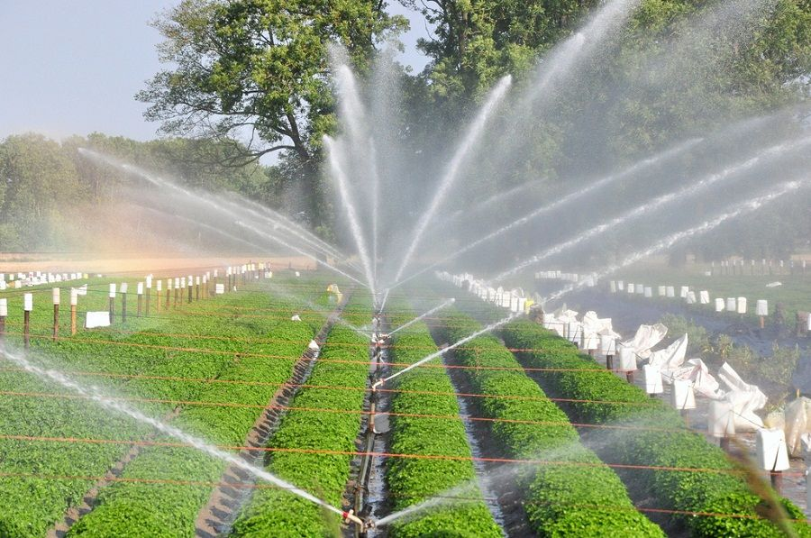Sprinkler irrigation
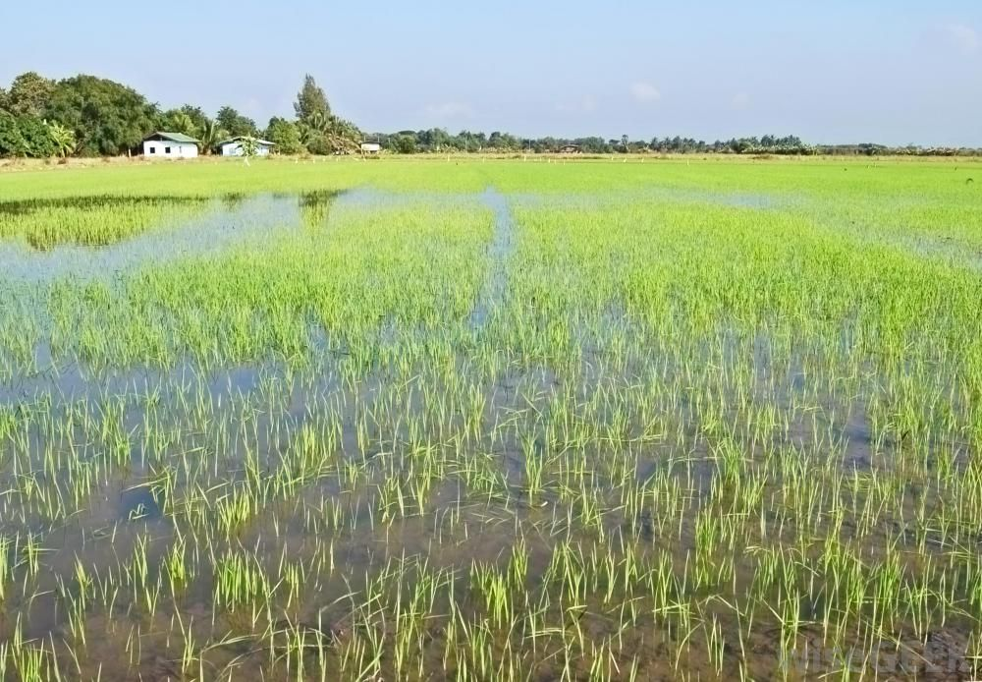Basin or Flood irrigation

- Sprinkler irrigation:
Water is pumped under pressure through pipes laid across the field-vertical pipes with sprinklers on top turn slowly round-water is forced out falls like rain.
This system can be used safely on sloping lad-there is no risk of erosion, water is well distributed, the rate of irrigation can be controlled, the amount of water can be controlled and less water is lost through drainage.
But it has the disadvantages of being too costly, needing fuel to run the pumps, labour is needed to move pipes, the wind can blow the sprinkled causing uneven distribution of water and the humidity caused can encourage fungal diseases.
- Trickle irrigation:
Plastic pipes are laid along the length of plant rows and are connected to the water supply. Small holes allow water to drip out slowly beside each plant – the soil beside the plants is near dug and never water logged.
Its advantages being that where water is scarce this is a good method because very little is needed. Also the spaces between the plants stay dry, reducing weeds chance to grow and causing less evaporation. Its disadvantages are the costs of labour to line up the plants and the trickle holes so each plant has its own supply of water.

Run off
It is a waste of water and a loss of valuable water
- Water runoff is the water that is not entering the soil but escape on the surface of the soil from a higher point to the lower point. It usually occur on the slopes as water run off to the lower point and can cause soil erosion.
- The farmer can effectively use this water if he uses some devices to catch the water such as dams constructed in the gullies or building a water holes at the lowest point of his farm and construct channels to divert the water to the hole during rainy season or rainy days.
- The farmer can also use mulches to trap water and conserve it or stop soil erosion.
- Farmer can also plant grasses on the waterways or between rows of tall crops to reduce the water run-off and encourage the water to enter the soil.
Water run-off is dangerous as it is the major cause of soil erosion on gentle slopes. It carries away valuable soil particles that make up the top soil.
- Farmers can dig ditches, holes or damps to catch water run-off to be used later for irrigation.
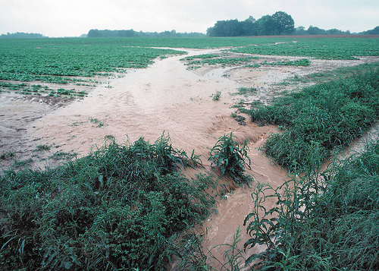Run-off

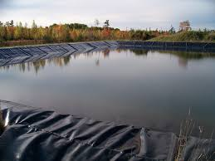Catchment of water run-off

Exercise 5
1. Identify types of water management practices used to maintain sustainable primary production.
-------------------------------------------------------------------------------------------------------------------------------------
2. Describe the features of water management practices used to maintain sustainable primary production.
---------------------------------------------------------------------------------------------------------------------------
3. Describe how water management practices maintain sustainable primary production.
--------------------------------------------------------------------------------------------------------------------------------------
4.Explain how water management practices are used to maintain sustainable primary production.
---------------------------------------------------------------------------------------------------------------------------
5. Discuss ways to improve water management practices to enhance sustainable primary production.
---------------------------------------------------------------------------------------------------------------------------

