AGRICULTURAL SCIENCE
Strand 2: Sustainable Primary Production | Sub-strand 2.1: Analysis of Management Practices for Sustainable Primary Production
LESSON ACTIVITY 4: IMPORTANCE OF MANAGEMENT PRACTICES FOR SUSTAINABLE PRIMARY PRODUCTION

The Specific Learning Outcome (SLO) targeted in this activity are provided below.
SLO# | Specific Learning Outcomes: Students are able to | Skill level | SLO code
14 | Identify the types of soil management practices used to maintain sustainable primary production | 1 | agr2.1.1.5
15 | Describe the features of soil management practices used in maintaining sustainable primary production | 2 | agr2.1.2.4
16 | Explain how soil management practices contribute to maintaining sustainable primary production | 3 | agr2.1.3.4
17 | Explain how soil management practices maintain sustainable primary production | 3 | agr2.1.3.5
18 | Discuss the advantages of soil management practices and suggest ways of improving sustainable primary production | 4 | agr2.1.4.4

- SOIL MANAGEMENT PRACTICES

CULTIVATION
Definition:
The process of growing plants on arable land. It is usually associated to large scale agriculture as opposed to small scale gardening. Crop cultivation requires fertile soil, water and seeds. Cultivation involves the sowing of seeds in the appropriate season. In the process of cultivation a farmer is often required to also initially till the land, weed control, and ultimately harvest the crops. Soil cultivation refers especially to the tilling of soil, such as ploughing, to prepare the soil for planting and to control weeds. Objectives of soil cultivation
- Seed preparation
- Water conservation
- Aeration
- Weed control
- Utilization and disposal of crop residues.

Advantages of soil cultivation:
- Cultivation or tillage leaves the soil temporarily looser than it was,
- In increase the size soil pores and thus aids air/water to penetrate,
- It helps to incorporate OM in the soil to increase nutrient content and improve the soil structure,
- It mixes the different layers of the soils,
- It facilitates the rooting system to develop,
- It allows seeds to germinate easily,
Cultivating soil a week or two before it stimulates the germination of those weeds which are inevitably present in the soil. By removing these weeds the farmer is then able to sow into a relatively weed free seed bed.

Types of soil cultivation that are sustainable
- Practices that include the incorporation of OM to increase water holding capacity and ability of soils such as digging in animal manure, dead leaves, compost, garden compost, green manure crops that are excellent additives when dug into the soils.
- Practices that do not encourage soil erosion to take place
- Practices that do not ruin soil properties (over cultivation, excess use of fertilizers incorporation, putting heavy pressure on soil when wet, use of heavy machinery on soil)
- Dig only top soil/do not dig so deeply as to bring up the subsoil to the surface.

Additives to use during soil cultivation
- Animal manure are probably the best because they contain useful quantities of nutrients as well.
- Green manure and compost are good source of organic matter and contain good quantity of nutrients
- All organic materials
- Adding OM to clay soil is beneficial as it improves the structure of clay soil by binding clay particles into crumbs
- By adding coarse sand to heavy clay soils you make a permanent improvement in the texture
- Chemical fertilizers are good source of nutrients but must be used with a lot of precaution because they can be a source of many problems to such, as toxicity, burning of roots or seedlings, pollution, health problem and breaking down of soil structure, increase in soil acidity or alkalinity linked to over use of fertilizers
- Use complete fertilizers to supply plants with all required major nutrients.

Types of cultivation
- Crop rotation: in the crop rotation system crop are grown in sequences and always involve a legume. The aim is to maintain the fertility of the soil by crop that can use up nutrients and others that can replenish the soil with nutrients (legumes).
- Intercropping: in the intercropping method different species crops are grown together while each one occupies a certain distance from the other. Usually legumes are intercropped with other crops to supply them with nitrates.
- Alley cropping: alley cropping with legume trees planted on the contour can serve as erosion control or trees used can serve as fodder for livestock.
- Fallowing: after each cultivation of a crop on a piece of land, that piece of land must be laid to rest for 1-2 years for the soil to regain its fertility before it can be reused again.
- Monoculture: this involves the cropping of a single crop on a large area of land.
- Mixed cropping: growing different crops in the same area at the same time, hence avoid depletion of any nutrient, because different crop need different soil nutrient.
- Agro forestry: this cultivation of land improves soil fertility, conserve soil, improve micro-climate and reduce weeds.

Fertility
- Definition: productive and inventive nutrient content in the soil. Degree/level of nutrients available to plant roots in any soil.
- Importance: nutrient elements are essential to growth and can be divided into 3 groups:

Major elements (nutrients)
Nitrogen (N), phosphorous (P). Potassium (K)

Secondary elements (nutrients)
Calcium (Ca), magnesium (Mg), sulphur (S)

Minor (trace) elements (nutrients)
Iron (Fe), manganese (mn), copper (Cu), zinc (Zn), boron (B), molybdenum (Mo)

Fertilizers and soil fertility
- The soil itself cannot keep on feeding plants eternally without being regularly supplemented or added with new nutrients or material rich in nutrients to replenish the soil. Good production only occurs when the fertility is high. As soon as the fertility becomes too low, produce crops with bad qualities. Therefore it is important to maintain or improve the fertility of the soil at all time to make sure quality of crops is always achieved.
- Fertilizers can be presented in two groups: organic fertilizers and inorganic fertilizers.
- Fertilizers supply the soil with the major nutrients, secondary nutrients and trace elements needed by the plants to grow, develop and produce good quality products.
- Some fertilizers are called simple fertilizers, others complete (compound) fertilizers.
- After every production in any plot the plot should be rested for the vegetation to repopulate the area and then later on the vegetation can be dug into the soil again to increase its organic matter and nutrients. If there is no rest the fertilizers must be used to compensate (Fallow period).

Additives one: Organic fertilizers
- Animal manure contains: nitrogen, phosphate, potash, as well as small quantities of other essential nutrients. The value of manure as a source of nutrients lies in the fact that it permits the farmer to receive double value from a considerable portion of nutrients-once when he first grows crops with them and again when he returns them in the soil in the form of manure.
Of even greater importance is the value of manure as a source of organic matter and micro-organisms. Manure improve soil tilth, structure and moisture retaining capacity. The richness of manure also varies with the amount and kind of bedding used. Rate to apply manure: “frequent” light application of manure are applications every two or three years.
2. Green manure (legumes)
Green manuring is another relatively inexpensive way of adding organic matter to soil. Legume crops which add nitrogen through nodules bacteria in their roots are usually preferred.
After digging them, keep the soil damp but not wet, then after three weeks dig the soil over again. It will take another 3-4 weeks for the organic matter to decompose. If there is any sign of yellowing in the following crops, give side dressing of a nitrogen fertilizer.
3. Compost (kitchen wastes)
Compost piles are a mixture of manure, soil, lime, fertilizer, straw, grass peat and similar materials. The addition of manure, soil, lime and fertilizer brings about quicker rotting of the straw and other organic materials.
4. Commercial organic fertilizers
Organic by-products of animal origin include bone dust, bone meal, blood and bone. Most of these fertilizers contain higher quantities of N and P than animal manure, but very little potassium. Spread 125g-250g per m² and sign into the top soil.

Where to apply:
- Soils most benefited: meaning poorest soils on the farm benefit best from manure. Also sandy and severely eroded soils benefit more from manure.
- Crops most benefited: meaning while all crops benefit from manure some crops respond especially well to manure such as row crops (corn, potatoes, garden crops).
- Top dressing of 2 to 4 tons per acre on fields.
- Spread during rainy season because rain works the more with soluble materials into the soils.
- During dry period, manures should be disked in or ploughed under to prevent ammonia losses.

Activities 2: Chemical fertilizers
- Before sowing or planting, apply a complete fertilizer with an approximate analysis N. P. K. 5:5:4. The high phosphorus content will ensure vigorous seedling growth.
- Fertilizers may be broadcasted at 1/3 of a cup per m² and raked into the topsoil for final leveling.
- Scatter fertilizer in band 15-20 cm wide at 1½ table spoon per m² where seed is to be sown in rows.
- Precautions
Fertilizer nutrients can leach into the soil and pollute waterways. The accumulation of these fertilizer nutrients can cause toxic effects on plant which can go through the food chain, thus intoxication any involved organisms (plants, animals and/or human being).
- Productivity
This refers to how well a soil can produce per unit area meaning yield per hectare, acre, square meter.
Without entering into much details, productivity of soils depends on how the farmer is using the land to grow his crops or animals.
Some farmers put pressure on the land, the soil to have high economic returns but forget about the sustainability of their production.
For example:
- Increasing plant density on land puts pressure on the reserve of nutrients in the soil
- Increasing animal stocking on the land can also cause problems to pasture, nutrients stock that could lead on to soil erosion, weeds invasion…..
- Farmers must find a balance between quantity and quality. They might go for more quantity and achieve poor quality.
- Use of a management system that is profitable without putting too much pressure on the land/soil resources.
- Draining land to make it become productive instead of being a wastage.
- Make efficient use of all land/soil to get the best out of them without much losses on erosion, pollution, crop failure.

6. Conservation
Losses of soil and water are greatest during the periods of planting, cultivation, harvest and when soil is left bare. During such periods fine particles that give topsoil its greatest value may be lost. The risk of losing valuable organic matter, manure, lime, and fertilizer exists.
Measures must be put in place to stabilize and conserve the soil and the precious water.

Soil conservation practices
- Do not crop a soil too intensively or too long resulting in the soil’s “exhaustion” or inability to grow a good ground cover.
- Mulching to reduce damage caused by rain drops on soil.
- Construct terraces.
- Planting grass on contour bands.
- Establish vegetative waterways.
- Add OM in the soil.
- Grow cover crops during wet season.
- Use strip cropping-planting closely-spaced or ground-contact crops between widely spaced, upright crops.
- Grazing land management to prevent animals from removing too much of the pasture’s plants.

Mulching
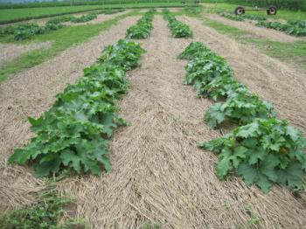

Planting on contour bands
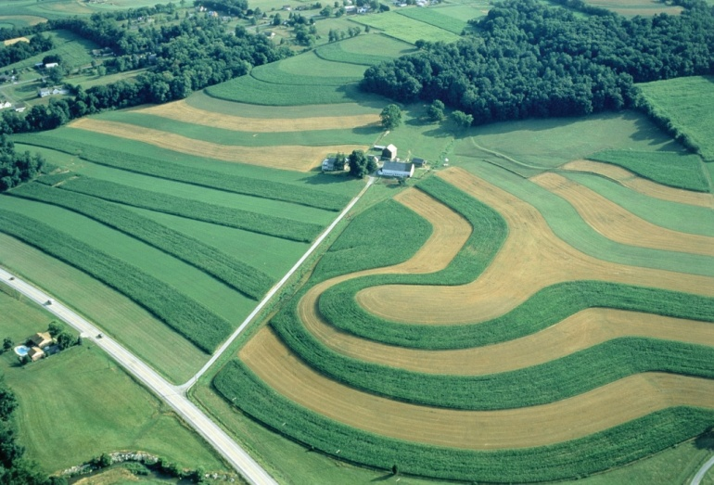

Alley cropping
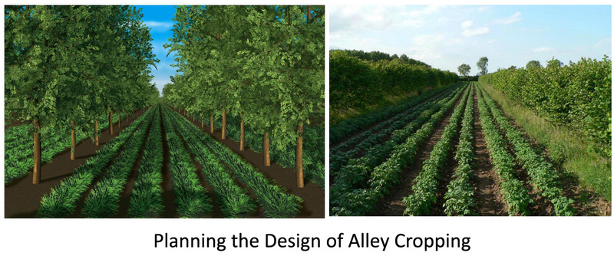

Mixed cropping
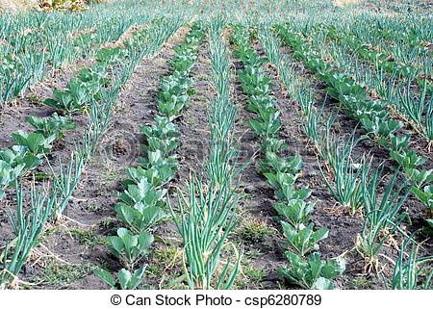

Crop rotation
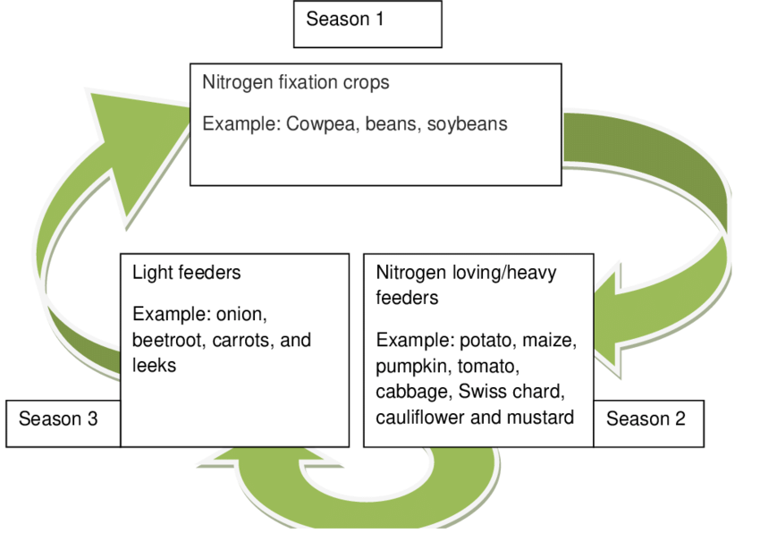
Identify the types of soil management practices used to maintain sustainable primary production | 1 | agr2.1.1.5
Describe the features of soil management practices used in maintaining sustainable primary production | 2 | agr2.1.2.4
Explain how soil management practices contribute to maintaining sustainable primary production | 3 | agr2.1.3.4
Explain how soil management practices maintain sustainable primary production | 3 | agr2.1.3.5
Discuss the advantages of soil management practices and suggest ways of improving sustainable primary production | 4 | agr2.1.4.4

Exercise 4
1. Identify the types of soil management practices used to maintain sustainable primary production L1 agr2.1.1.5

2. Describe the features of soil management practices used in maintaining sustainable primary production. L2 agr2.1.2.4
3. Explain how soil management practices contribute to maintaining sustainable primary production. L3 agr2.1.3.4
4.Explain how soil management practices maintain sustainable primary production. L3 agr2.1.3.5
5. Discuss the advantages of soil management practices and suggest ways of improving sustainable primary production. L4 agr2.1.4.4

