AGRICULTURAL SCIENCE
Strand 2: Sustainable Primary Production | Sub-strand 2.1: Analysis of Management Practices for Sustainable Primary Production
LESSON ACTIVITY 3: IMPORTANCE OF MANAGEMENT PRACTICES FOR SUSTAINABLE PRIMARY PRODUCTION

The Specific Learning Outcome (SLO) targeted in this activity are provided below.
SLO# | Specific Learning Outcomes: Students are able to | Skill level | SLO code
10 | Identify waste management practices used to maintain sustainable primary production | 1 | agr2.1.1.4
11 | Describe how waste management practices maintain sustainable primary production | 2 | agr2.1.2.3
12 | Explain how waste management practices used to maintain sustainable primary production | 3 | agr2.1.3.3
13 | Discuss the benefits of and suggest improvements to waste management practices used to maintain sustainable primary production | 4 | agr2.1.4.3

WASTE MANAGEMENT PRACTICES

What is Waste Management definition?
Waste management is the precise name for the collection, transportation, disposal or recycling and monitoring of waste. This term is assigned to the material, waste material that is produced through human being activity. This material is managed to avoid its adverse effect over human health and environment.

What is waste management and why it is so important?
The most important reason for waste collection is the protection of the environment and the health of the population. Rubbish and waste can cause air and water pollution. Rotting garbage is also known to produce harmful gases that mix with the air and can cause breathing problems in people.

What are the effects of waste management?
Here are some of the effects of the improper removal and disposal of waste.
- Soil contamination.
- Air contamination.
- Water contamination.
- Bad impact on human health.
- Impact on animals and marine life.
- Disease-carrying pests.
Organic waste must recycled back into the system by any means. The waste management helps to protect the communities, the water quality, airquality and property values.
Recycling: Among many recycling examples happening in the farm it is important to point out one main one: when the farmer is using the animal waste to re-enrich his soils. The nutrients in the grass ingested by the animals are re-entering the soil by means of waste decomposition. As such the nutrients are recycled into the system. Also the organic matter in the form of grass eaten by animals are re-entering the soil to improve its structure and re-enrich it with humus and nutrients. There is hardly a waste unless the farmer is selling off his livestock and crops to the market.
Reusing: The farmer can re-use old hard wood from the fallen trees to make fence posts with them. All other farm equipment that can be re-used must be kept in the farm for that purpose. The farmer has to allocate one area for waste storage.
Disposal: All items which are not useful such as plastic containers rusty metals/parts of engine, must be disposed of from the farm on an area allocated by the community that is safe from possible pollution of air/water. Chemical containers must be buried or disposed off farm
.

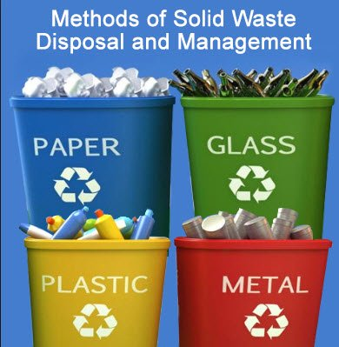
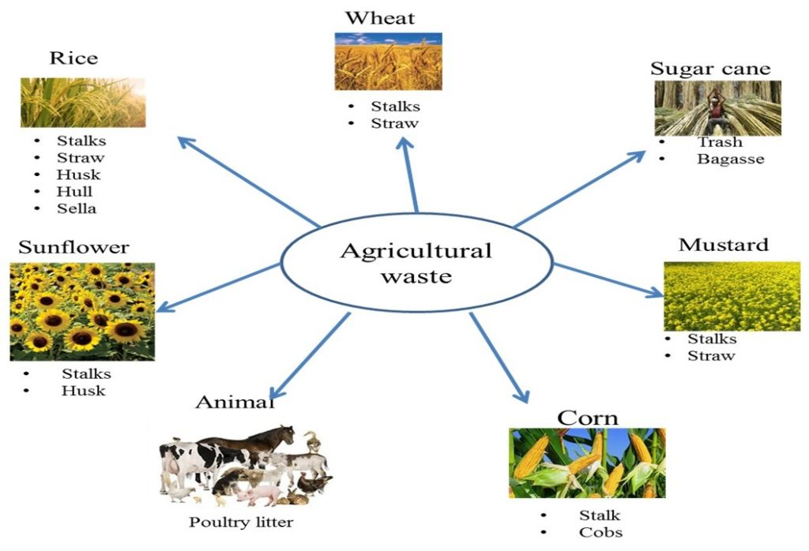
Management of crop waste: All crop waste must return back to the soil, so compost heaps/boxes should be built on farm and encourage worm to multiply in the compost or in the pasture area to fast tract the process of decomposition.
Crop residues ploughed back into the soil | Compost
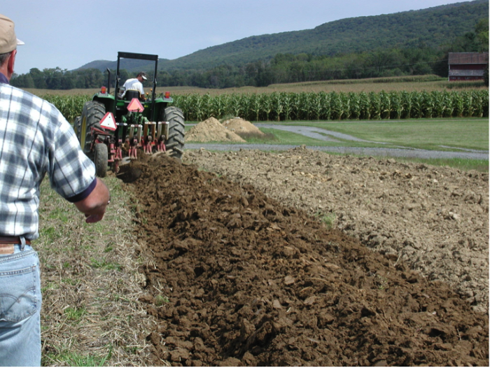 | 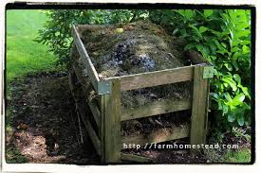
Animal manure  Animal manures are the solid, semisolid, and liquid by-products generated by animals grown to produce meat, milk, eggs, and other agricultural products for human use and consumption. | 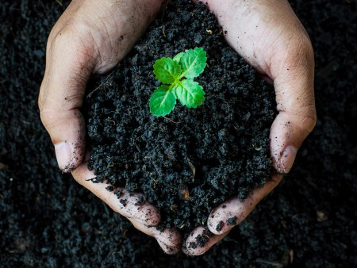
Spreading chicken manure around a growing crop  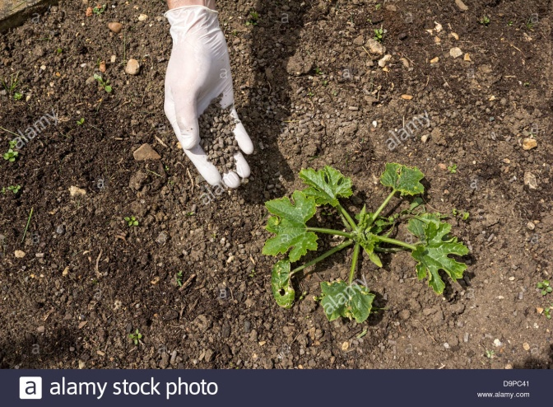 | Compost chicken manure  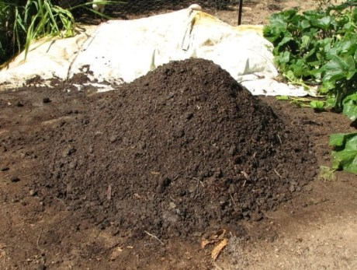

All substances with strong smell need to be placed away from main activity area and in area with good aeration

Exercise 3
1. Identify waste management practices used to maintain sustainable primary production from the above information given. L1 agr2.1.1.4

2. Describe giving two (2) examples how waste management practices maintain sustainable primary production. L2 agr2.1.2.3

3. Explain how waste management practices used to maintain sustainable primary production. L3 agr2.1.3.3

4. Discuss the benefits of and suggest improvements to waste management practices used to

