AGRICULTURAL SCIENCE
Strand 2: Sustainable Primary Production | Sub-strand 2.1: Analysis of Management Practices for Sustainable Primary Production
LESSON ACTIVITY 2: IMPORTANCE OF MANAGEMENT PRACTICES FOR SUSTAINABLE PRIMARY PRODUCTION
The Specific Learning Outcome (SLO) targeted in this activity are provided below.
SLO# | Specific Learning Outcomes: Students are able to | Skill level | SLO code
6 | Identify genetic resource management practices used to maintain sustainable primary production | 1 | agr2.1.1.3
7 | Describe the features of genetic resource management practices used to maintain sustainable primary production | 2 | agr2.1.2.2
8 | Explain how genetic resource management is used to maintain sustainable primary production | 3 | agr2.1.3.2
9 | Discuss the advantages and disadvantages of genetic resource management and propose a sustainable primary production plan that is suited to the situation. | 4 | agr2.1.4.2

GENETIC RESOURCE MANAGEMENT PRACTICES
What is meant by genetic resources?

Genetic resources (GRs) refer to the genetic material of actual or potential value. Genetic material is any material of plant, animal, microbial or other origin containing functional units of heredity.

What is the conservation of genetic resources?

The fundamental objective of genetic resources conservation is the maintenance of broad-based genetic diversity within each of the species with a known or potential value in order to ensure availability for exploitation by present and future generations.

When the level of management and husbandry are good, it is possible to improve the yield and performance (Kg of milk, growth rate, number of eggs, feed conversion ratio….) of animal and crop through culling and selection. Slow genetic improvement can be brought about by removing poor performing animals and crops from the herd and garden and replace them with better-producing crops and animals.
The degree to which improvement by this method can be achieved depends on the heritability (a measure of how much an animal/plant can pass on its characteristics of each offspring/new generation) for example:
- Traits and aspects of economic value. Genetic improvement of herds or crops is slow.
- The farmer has to keep a record to use for the purpose of selection. Without records, improvement is difficult to achieve.
- Selection indices should be based on production.
How does genetic selection affect primary production?
- Every performance must be recorded for culling/selection purposes.
- Replace old/poor productive crops and animals with better-producing crops and animals.
These are sources of new planting materials for plants or new animals produced by local expert farmers and/or researchers. These can be multiplied and grown or raised to maintain the required needs of farmers and market opportunities. Taro, banana, manioc and sweet potato, for example, are widely grown in the South Pacific Islands. Researches have been carried out on these crops whereby the new cultivars have been tested in the market. Each variety has particular characteristics, requirements, advantages and disadvantages. Some are needed for traditional ceremonies.
The long-term nutritional security, health, incomes and cultural identity of communities in the South Pacific region depend on conserving and making the most of these differences. We need this diversity to overcome current production problems and new ones as they arise in the future, and thus ensure the sustainability of agriculture.
OR
Maintaining diversity helps to ensure genetic variety of resource in case conditions change or market demand changes – if all the crop is genetically the same then it is more at risk of being widely affected by a pest or disease.
Advantages and disadvantages of genetic resource management practices
Advantages
- high yield
- fast growth rate
- resistant to pests and diseases
- high demand in the market
Disadvantages
- expensive
- susceptible to diseases
- need high knowledge and skills to perform
- low demand in the market
- local varieties/species are at risk
Here are more examples of genetic resource management practices used to maintain sustainable primary production.
Breeding
This is an application of genetic principles to improving hereditary for economically important traits in domestic animals. For example;
- Improving milk production in dairy animals.
- Egg production in chickens.
Advantages
- Produce individuals with superior merits.
- Improvement of characteristics.
- Production of new traits.

- Hand mating – male and female of known good characteristics are brought together for mating.
- Inbreeding – the crossing of closely related family members of known desirable characteristics.
- Crossing breeding –the mating of two different breeds.
- Linebreeding – the crossing of animals that share common ancestors but are not closely related.
- Outbreeding –the crossing of distantly related animals.
- Artificial Insemination (AI) - Artificial insemination is the deliberate introduction of sperm into a female's cervix or uterine cavity for the purpose of achieving a pregnancy through in vivo fertilization by means other than sexual intercourse.

The diagram below shows an example of crossing breeding of two different breeds.
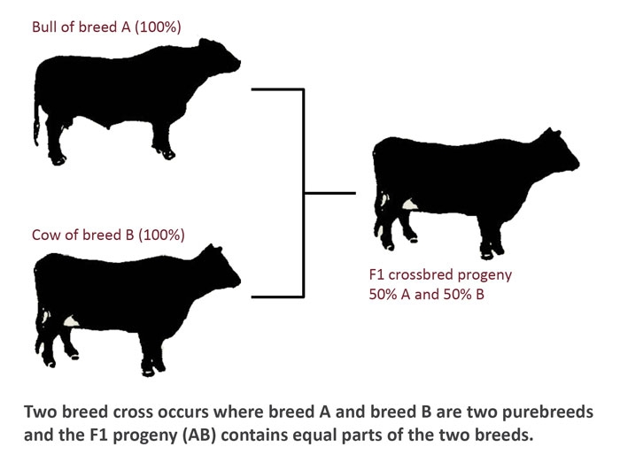

Artificial Insemination
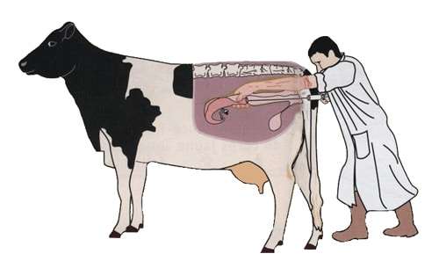
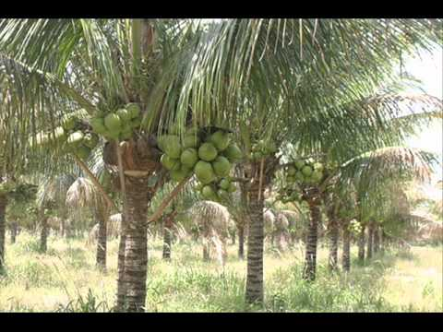
Hybrid coconut (cross between Vanuatu Green Tall and Vanuatu Green Dwarf)

Exercise 2
1. Name two (2) genetic resource management practices used to maintain sustainable primary production. L1 agr2.1.1.3
-------------------------------------------------------------------------------------------------------------------------------------

2. Describe two features of genetic resource management practices used to maintain sustainable primary production. L2 agr2.1.2.2
-------------------------------------------------------------------------------------------------------------------------------------
3. Explain how genetic resource management is used to maintain sustainable primary production. L3 agr2.1.3.2
--------------------------------------------------------------------------------------------------------------------------------------
4. Using the diagrams above discuss the advantages and disadvantages of genetic resource management and propose a sustainable primary production plan that is suited to the situation. L3 agr2.1.3.2
--------------------------------------------------------------------------------------------------------------------------------------

