AGRICULTURAL SCIENCE
Strand 2: Sustainable Primary Production | Sub-strand 2.1: Analysis of Management Practices for Sustainable Primary Production
LESSON ACTIVITY 1: IMPORTANCE OF MANAGEMENT PRACTICES FOR SUSTAINABLE PRIMARY PRODUCTION

The Specific Learning Outcome (SLO) targeted in this activity are provided below.
SLO# | Specific Learning Outcomes: Students are able to | Skill level | SLO code
1 | Define the term sustainable production | 1 | Agr2.1.1.1
2 | Name management practices that are used in primary production | 1 | Agr2.1.1.2
3 | Describe the sustainable agriculture practices that contribute to maintaining primary production | 2 | Agr2.1.2.1
4 | Explain the sustainable agriculture practices that contribute to maintaining primary production | 3 | Agr2.1.3.1
5 | Evaluate how a particular management practice contributes to maintaining sustainable production and suggest ways of improvement. | 4 | Agr2.1.4.1

SUSTAINABLE MANAGEMENT PRACTICES
What is sustainable production?
According to a dictionary definition, ‘sustainability’ refers to ‘keeping an effort going continuously, the ability to last out and keep from falling’. In terms of agriculture, ‘sustainability’ refers to the capacity to remain productive while maintaining the resource base. However many people in the Pacific island countries use a more comprehensive definition, insisting agriculture must have the following features if it is sustainable:

Ecologically sound, which means that the quality of natural resources is maintained and the vitality of the entire agroecosystem - from humans, crops and animals to soil organisms – is enhanced. This is best ensured when the soil is managed and the health of crops, animals and people is maintained through biological processes (self- regulation). Local resources are used in a way that minimises losses of nutrients, biomass and energy, and avoids pollution. Emphasis is on the use of renewable resources.

Economically viable, which means that farmers can produce enough for self-sufficiency and/or income, and gain sufficient returns to warrant the labour and costs involved. Economic viability is measured not only in terms of direct farm produce (yield) but also in terms of functions such as conserving resources and minimising risks.

Socially just, which means that resources and power are distributed in such a way that the basic needs of all members of society are met and their rights to land use, adequate capital, technical assistance and market opportunities are assured. All people have the opportunity to participate in decision-making, in the field and in the society.

Humane means that all forms of life (plant, animal, human) are respected. The fundamental dignity of all human beings is recognised, and relationships show such basic human values as trust, honesty, self-respect, cooperation and compassion. The cultural and spiritual integrity of society is preserved and nurtured.

Adaptable means that rural communities are capable of adjusting to the constantly changing conditions for farming: population growth, policies, and market demand.

Management practices that are used in primary production.
AgriculturalManagement Practices. ... A variety of management practices exist, including practices such as cover crops, conservation tillage, irrigation efficiency, and contour farming. Management practices are primarily used to modify land management practices on croplands, specifically those focused on reducing erosion and nutrient runoff.

Sustainable agriculture practices that contribute to maintaining primary production
The sustainable agriculture practices that contribute to maintaining primary production would include practices as: crop rotation, intercropping, pest and disease control, composting, mulching, selection of seeds and planting materials, dig the soil well, fallow period, mixed farming, agroforestry, green manure, commercial fertilisers, alley cropping and use of organic fertilizer
Sustainable ways of farming
There are many ways we can adapt farming systems to fit the needs of our changing nation. We should be aware that there are many parts to a farming system - cultural and economic as well as agricultural factors are involved.
This guide should help you to explore some ideas and techniques for improving and sustaining food production. These ideas, methods and techniques are discussed here so that you can select from them what best fits your own particular changing condition(s).
Improving our farming
There are many easy rules to follow in farming that can prevent the damage to our soils.
They can be followed by farmers who can understand the problems of slash and burn, and who wish to keep their soil fertile and continue farming in the same place for a longer time. Often these changes can only happen if people first change their attitudes.
Do not burn the ground
Cut the grass, under wood and trees and allow it to dry on the ground. This will protect the soil as mulch until you are ready to plant crops. When grasses and leaves are dry, collect them for mulch and compost.

Crop rotation
Different kinds of crops take different kinds of foods from the soil. Because of this, we should change the place where we plant our crops after each harvest. For example, if we grow a crop of corn, we should plant a crop there that can put plant food back into the soil, e.g. beans.
Three main groups of crops used in a rotation are:
Heavy feeders e.g. corn, lettuce; Light feeders e.g. sweet potato, taro; Nutrient givers (legumes) e.g. wing bean, peanuts, beans.
Intercropping
Intercropping means planting of many different kinds of crops in one area at the same time.
Another name for it is mixed cropping. This method was first practiced in traditional gardens.
There are many advantages to this method of growing crops. Some of them are:
Crops help each other. For example, when corn and bean are grown together, the corn shades the beans from the hot sun. The bean in return put nitrogen in the soil that helps the corn to grow well. This is called companion planting.
Pest and disease control. If one type of crop is grown on a piece of land, you make it easy for insects and disease to destroy your crop. Intercropping makes the spread of pest and disease harder.
Composting
In nature all living things die and rot. They supply the organic subsistence that the soil needs to feed other plants. This is how nature maintains a balance between life and death. Farming should follow natures’ balance. Leaves, grass, animal manure and plants should be returned to the soil and used again…. NOT THROWN AWAY or burnt.

Mulch
Dry grass or other dry materials placed on top of the garden beds, ridges or mounds, protects the soil from drying out and being cooked. Mulch protects the soil from heavy rain, it prevents weeds from coming up too quickly in the garden, it helps the ground to stay cool and wet during the dry season, and it provides plant nutrients to the growing crops.

Selecting of seeds and planting materials
To make sure you have healthy and productive crops you should select your planting materials well. You should encourage people to save the best of their harvest for seeds and store them well.

Dig the soil well
When we dig the soil well, we allow air, water and nutrients to go deep into the soil. This digging also makes our soil softer and lets the roots of our crops go down deeper where they can get the food and water they need to grow strong and resist disease.

Improved use of fallow time
The traditional approach has been to allow nature to provide the regrowth. However, as fallow times get shorter due to a variety of pressures, planting desirable fallow crops will improve soil condition quicker.

Evaluate how a particular management practice contributes to maintaining sustainable production and suggest ways of improvement.
Soil Tillage

What is soil tillage?
Tillage is the agricultural preparation of soil by mechanical stirring up of various types, such as digging, and overturning. Examples of human-powered tilling methods using hand tools include shovelling, picking, mattock work, hoeing, and raking.

What are the advantages of tilling the soil?
Turning your soil twice a year is a good defence against weeds and other insects from invading and damaging your plants. Tilling also helps break down weed roots, along with the homes of other insects, helping to prevent these pests from intruding your garden.

How does tillage affect soil?
The effect of tillage on soil however, tillage has all along been contributing negatively to soil quality. Since tillage fractures the soil, it disrupts soil structure, accelerating surface runoff and soil erosion. Tillage also reduces crop residue, which help cushion the force of pounding raindrops.

Why Cultivating Soil Is Important
Helps to break up the dry crust on the surface of the soil, allowing air, nutrients, and water to get deeper into the ground where the plant roots can access them. Makes it easier for new seeds to sprout through the surface of the soil.

What are the advantages of tillage?
- Reduces labour, saves time.
- Improves soil tilth.
- Increases organic matter.
- Traps soil moisture to improve water availability.
- Reduces soil erosion.

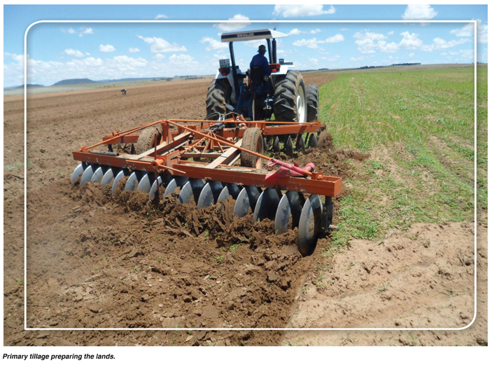

Negative Effects of Soil Tillage

1. Soil Erosion
Tillage causes the soil to break down into smaller particles. The Wind easily blows away these particles. Again, heavy rains wash the particles as topsoil to lower elevation. In these instances, nutrients are either blown away or washed away and easily leached away from the reach of roots. Then, you would need more fertilizer to get consistent yields.

2. Reduction of amount of soil organisms
Soil organisms are very vital to organic matter decomposition and their activities are vital to soil improvements. In very simple terms, tillage displaces and exposes soil organism to air and direct sunlight. Soils with low of soil organisms experience low rates of decomposition and therefore reduced amounts of soil nutrients.

3. Loss of nitrogen
Microorganisms, during the breakdown of organic matter, release nitrogen, an essential plant nutrient for plant growth. Tillage releases the accumulated nitrogen in the soil whiles exposing the microorganisms. The farmer would then need more fertilizer to make up for the loss, increasing the cost of production.

4. Soil compaction
After continuous tillage and exposure to several impacts, the soil forms a hardpan just below the depth of tillage. This hardpan prevents soil water drainage and root development. Moreover, soil compaction impedes root development and decreases the plant’s ability to take up nutrients and water. Without adequate and timely rains and correct fertilizer application, it reduces yield. In wet seasons, it reduces soil aeration resulting in loss of nitrate-nitrogen to the atmosphere. Besides, soil compaction can induce nitrogen and potassium deficiency.

5. Additional cost of production
Soil tillage is an additional cost to farmers and is expensive. Consider the cost of fuel and maintenance of machinery and if manual, the cost of labour. All these instances would need extra fertilizer in addition to other costs.
Exercise 1
1. Define the term “sustainable production.” L1 (Agr2.1.1.1)

2. Name a sustainable activity that is taking place in farming sector in your country? L1 Agr2.1.1.2

3. Describe two sustainable agricultural practices that contribute to maintaining primary production. L2 Agr2.1.2.1

4. Explain three (3) named sustainable agriculture practices you know of that contributes to maintaining primary production. L3 Agr2.1.3.1

5. Select four items from the list in the box below and evaluate how a particular management practice contributes to maintaining sustainable production and suggest ways of improvement to each practice selected. L4 Agr2.1.4.1

Crop rotation Tillage
Fallow Mulching
Compost Pest and disease control
Inter-cropping Alley cropping
Fertilizer Seed selection
Mixed cropping Organic fertiliser
Commercial fertilisers Green manure

