3.1 Seed Production
TYPES OF SEED:
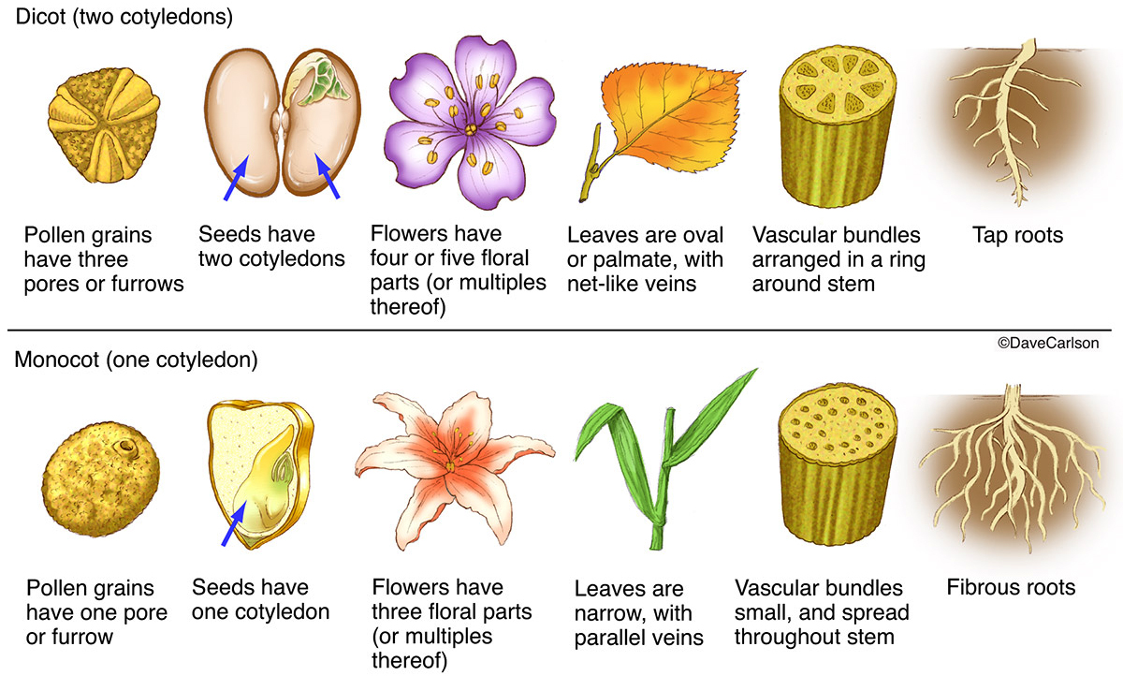

The selection of the best planting material is basic to good crop production practices. The role of seedling is crucial for the advancement of agriculture. Good seeds have a high growing ability, can grow simultaneously, and are of a good quality and always available as well. The use of good seeds is essential to promote the food security program and also develop agro-industries. Good seeds must be consistently used and its supply in the community should be guaranteed in both quality and continuity. In order to produce quality seed, a good drying is needed. Although the sun light is available abundantly, in the rainy season, a drying machine is still required to maintain the quality, quantity and continuity of good seeds.

Quality seed must be high in germination, relatively free from insect or mechanical damage, pure for the crop variety, and contain little or no inert matter or weed seeds. For maximum profit quality seed must be used in conjunction with good cultural practices, correct fertilizer rates, and adequate control of plant pests.
There are several factors to consider when selecting the seed type to plant in the crop production unit as follows:
- Fertilizer requirements on improved seed will be higher than for native lines
- Save their own seed shall be the one saved from cropping season to next by the farmer
- Seed storage and handling.

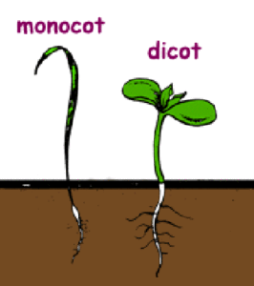
  - Replanting - plant (a tree or plant which has been dug up) to be planted again, especially in a larger pot or new site.

  - Seed harvesting
During harvest mature and good quality seeds are removed and selected to be stored for the next planting season
Selecting plants /fruits for seeding
- Appropriate cultivar
- Genetic purity
- Physical purity
- High germination and good seedling vigor
- Low frequency of seed borne diseases or insects

Methods of seed harvesting
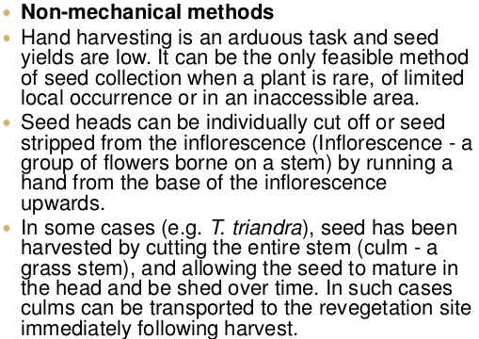
Trough, beater and brush harvesting
Refer to Additional handout 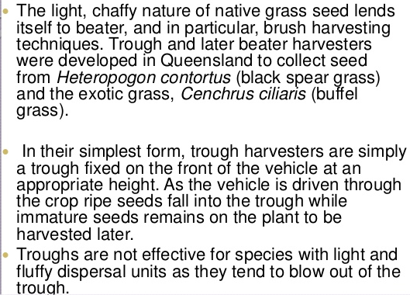
Collecting seed
Steps:
- Collect ripe seed on a dry day, as soon as the seed heads (e.g. capsules or pods) ripen. This is often indicated by a color change from green to brown, black or red, but must be before they open and shed their contents
- Pick the seed heads, either singly or on stalks, and lay them out to dry on a greenhouse bench, warm windowsill or in an airing cupboard. This enables seed to be more easily extracted from pods, cones or capsules
- If they don’t open when dry, gently crush pods and capsules to release the seed
- Collect seed from fleshy fruits and berries by mashing them in a fine sieve and then rinsing away the pulp in cold water. Leave the seed to dry for a few days on paper towels
- Exploding seed heads need checking every few days. Place a bag over them and shake – this will usually cause the ripe seed heads to explode into the bag. Alternatively, remove the seed heads on their stems as they turn brown and place in a labelled paper bag
- Nuts should be collected around the time they would naturally fall either by hand-picking, or by placing a sheet at the base of the tree and shaking the branches until they fall
- After extracting the seed, clean off any surrounding material (chaff) attached to them, as this material could rot and lead to the seed damping off. Chaff can harbor moulds, pests and diseases

c) Storing seeds

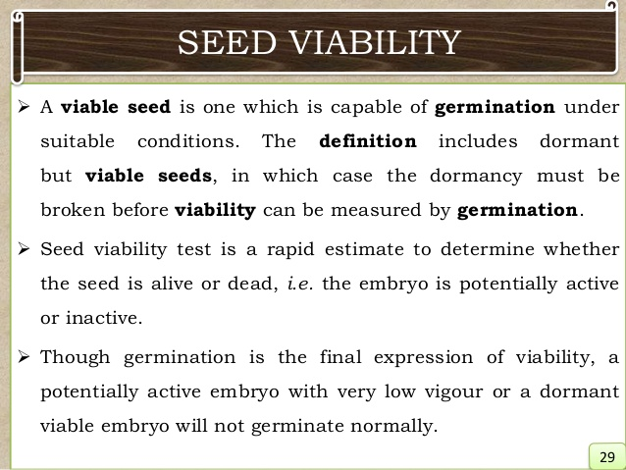
Some seeds (`e.g. hellebore) are best sown immediately as their viability reduces with storage. However, for many species, sowing is best delayed until a more suitable time of the year, such as autumn or spring, so the harvested seed will need to be safely stored until sowing. Storing is also required if surplus seed has been collected.

- Place dry seed in labelled paper packets or envelopes in an airtight container with some desiccant to remove excess moisture. Suitable materials include calcium chloride (sold in DIY stores for use in dehumidifiers) or silica gel
- Excess humidity or warmth can cause seed to deteriorate or die from fungal disease or rotting
- Certain seed must not be allowed to dry out as they cannot then take up water necessary for germination. Examples are walnuts, oaks and magnolias. These seed can be stored in a plastic bag of damp vermiculite, sand, or a mix of moist coir and sand for several months
- Store in a refrigerator at 5°C (41°F) until required. Most seed will remain viable in this way for many years

Problems
- Lack of collectable seed: Some plants are sterile and cannot set seed.
- Seed production can be exhausting for a plant so it is also not uncommon for seed production to be cyclical – some years will be good for harvesting, others bad – or it may simply be that weather conditions for that season were not favourable, perhaps due to a late frost or drought.
- Poor viability (the length of time that seed stays alive and able to germinate): If seed is sown but fails to germinate, it suggests it was not viable. Seed viability depends on the condition of the seed when first stored, how long it is stored and what seed is being kept.

d) Seed dormancy –

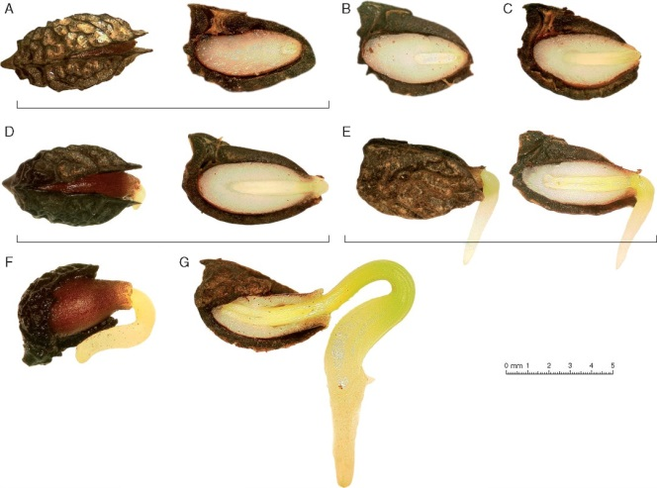
Seed is alive but not growing, however metabolic reactions occur

e) Dormancy period – time from which the seed dries up and is picked until the time the seed is able or allowed to germinate or grow into a plant of its own kind.

Common causes of seed dormancy

- Impermeability of the seed coat
- Chemicals with the seed
- Dormancy of the embryo, physiological requirements
- Temperature

Practices to break dormancy

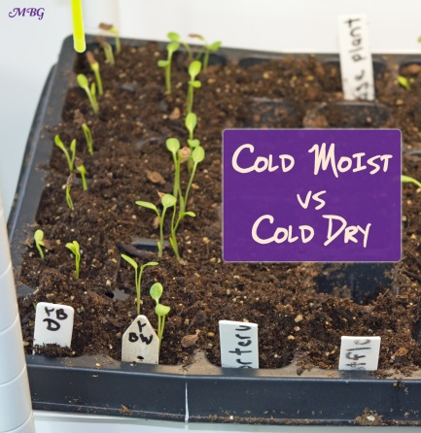
- Scarification
  - treating in concentrated sulfuric acid
  - making cuts
  - mechanical abrasion of the seed coat

- Seed stratification - process of treating seeds to simulate natural conditions that the seeds must experience before germination can occur. Many seed species have an embryonic dormancy phase, and generally will not sprout until this dormancy is broken.

f) Seed cleaning
This is the removal of any debris or low quality, infested or infected seeds and seeds of different species (weeds) that are foreign to the sample.

This is important because the cost of maintaining an accession in a genebank is high and space is limited. Debris and damaged seeds can spread infection. Therefore only good quality viable seeds should occupy space in the store and damaged or non-viable seeds should be destroyed to prevent the spread of infection.

Seeds should be cleaned immediately after registration or harvest. If the seeds are very moist and cleaning is done by machines, it may be necessary to dry the seeds within the fruits to within 12 - 16% moisture content before cleaning to prevent damage. Seeds donated by other institutes often arrive already cleaned.

g) Seed treatment - the application of fungicide , insecticide or both to the seeds to disinfect (deep seated ) and disinfest ( over seed coat ) them from seed borne or soil borne pathogenic organisms and storage insects.
Benefits of seed treatment:
- Prevention of spread of plant diseases both systemic and non systemic
- Protects seed from seed rot and seedling blights
- Improves germination
- Provides protection from storage insects and pests.
Dates back to 17th century when salt water was accidently discovered to control bunt and stinking smut of wheat seed. In 1755, M.D Tillet, a french botanist recommended the use of lye and lime as a chemical treatment for wheat seed. Some 50 years later, Prevost a Swiss botanist, discovered the use of copper fungicides as seed treatment.

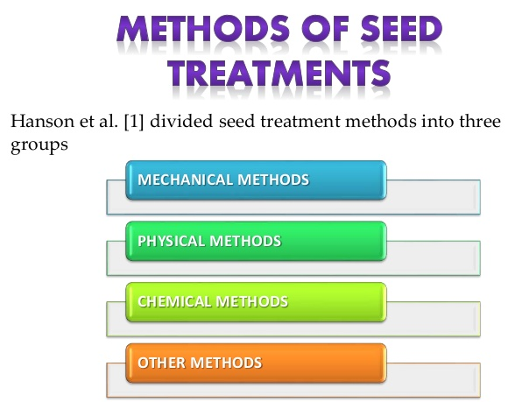
- MECHANICAL METHODS - These are designed to remove infectious materials mixed with seeds. ¬Seeds can be mechanically cleaned thoroughly before seeding to remove pathogenic organisms from the seed surfaces. ¬This often requires further treatment.
- PHYSICAL METHODS - Physical methods include hot-water and water-soak treatments and ultraviolet, infrared, X-ray and other types of irradiation. Do not protect seeds from soil borne organisms
  - Seed is exposed to temperature which should kill pathogen not the seed. Heat applied as hot water, dry air or steam. E.g. Celery, cauliflower, cabbage – 48 – 49C for 30 minutes; Potato and sweet corn – 56 – 57C for 30 minutes
- CHEMICAL METHODS - Chemicals are used to eradicate bacterial and fungal disease pathogen from seeds. E.g. Acetic acid – 0.5 – 0.8 % over night on vegetables.

Most commonly used method because of its effectiveness and ease of handling.
IDEAL CHEMICAL would be:
  - Highly effective in controlling the pathogen
  - Harmless to the seed, animals and non- toxic to people
  - Economic to use ⎫Easy to apply ⎫Non corrosive to machinery
  - Stable for long periods
  - Seed treated with fungicides up to seedling stages

3.2 Crop Management
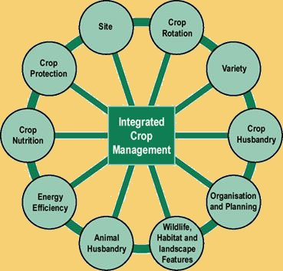
Crop management defined as “the various processes applied toward the effective cultivation and harvesting of crops”
Crop management begins with the sowing of seeds, continues with crop maintenance during growth and development, and ends with crop harvest, storage, and distribution (Tivy, 1990).
During seed sowing, a mechanized planter often opens a furrow in the prepared soil seed bed, places the seed in the exposed moist soil, covers the planted seed, and then often packs the soil down to assure firm seed-soil contact. In no-till systems, the crop is planted (“drilled”) directly into the soil through residue from the previous crop.
Soil fertilization is an essential component of crop management to assure nutritional sufficiency for plant growth. The selection of type, amount, timing, and method of fertilizer application is determined by a variety of considerations including the crop type, the nature of the fertilizer, soil conditions, and weather. A generalized listing of common fertilizer applications follows (after Briggs and Courtney, 1985): (1) broadcast [application of fertilizer (often pelletized) to the soil surface before the crop emerges]; (2) plowing in (application of fertilizer to the surface followed by mixing into the topsoil by plowing); (3) sideband (fertilizer application in bands adjacent to the seed); (4) contact placement (fertilizer application in direct contact with the seed); (5) side-dressing (fertilizer placement in narrow rows at the surface after crop emergence); and (6) top-dressing (general application of fertilizer to the crop after emergence).
During crop growth, a variety of crop and soil maintenance as well as weed removal practices may be undertaken. Again, the specific type of farm machinery actually used and overall management practices are site, farmer, and climate specific. But overall, weed control can be accomplished through several types of soil cultivation practices (see earlier). These include dense arrays of small spring tines, rotary hoes, and tractor-mounted arrays of spear- or sweep-pointed shanks designed to till in between crop rows (Loomis and Connor, 1992). Herbicides are also used widely for weed control (see the following discussion).
In essence, crop management practices influence the subsurface habitat by two independent mechanisms. First, the physical structure of soil (hence the infiltration rates of water) is altered by farm machinery traffic passing over the soil, by cultivation implements, and by the penetration of soil by roots and shoots of the growing crop plants. Second, the solutes in soil that may be conveyed to the subsurface by infiltrating water are determined by the organic and inorganic compounds present in the soil as a result of fertilizer amendments and crop growth and decay.

Such a management system usually includes considerations regarding:
- The selection of the crop to plant - One of the first considerations in crop production management is of the determination of the type of crop to be planted in the designated land.
The reason why this is important is because different crops require specific growing conditions, meaning that crops that do well in certain types of soil will not prosper when they are cultivated in other types of soil. Also, the climate plays an important role in the growth of crops, dictating the type of crops that can be successfully cultivated in different geographical areas. There are a large and diverse number of crop management practices used by grain growers to alleviate the effects of waterlogging. These include:
- crop choice,
- waterlogging tolerant crop varieties,
- bio-drainage, and
- different agronomic practices such as
  - sowing time,
  - nutrient application and
  - plant growth regulators (PGRs).

- The preparation of the land where the crop will be planted - After the crop has been selected and the land has been prepared by tilling, the crop will be planted according to the specifications for planting such a crop, including the observation of the proper spacing between individual plants.
  - Soil tillage – knife, hoe, spade, pic, plough
Agricultural preparation of soil by mechanical agitation of various types, such as digging, stirring, and overturning. Examples of human-powered tilling methods using hand tools include shoveling, picking, mattock work, hoeing, and raking. Examples of draft-animal-powered or mechanized work include ploughing (overturning with moldboards or chiseling with chisel shanks), rototilling, rolling with culti-packers or other rollers, harrowing, and cultivating with cultivator shanks (teeth). Small-scale gardening and farming, for household food production or small business production, tends to use the smaller-scale methods, whereas medium- to large-scale farming tends to use the larger-scale methods.
Tillage that is deeper and more thorough is classified as primary, and tillage that is shallower and sometimes more selective of location is secondary. Primary tillage such as ploughing tends to produce a rough surface finish, whereas secondary tillage tends to produce a smoother surface finish, such as that required to make a good seedbed for many crops. Harrowing and rototilling often combine primary and secondary tillage into one operation.

Positive
Plowing:
- Loosens and aerates the top layer of soil or horizon A, which facilitates planting the crop.
- Helps mix harvest residue, organic matter (humus), and nutrients evenly into the soil.
- Mechanically destroys weeds.
- Dries the soil before seeding (in wetter climates tillage aids in keeping the soil drier).
- When done in autumn, helps exposed soil crumble over winter through frosting and defrosting, which helps prepare a smooth surface for spring planting.

Negative
- Dries the soil before seeding.
- Soil loses nutrients, like nitrogen and fertilizer, and its ability to store water.
- Decreases the water infiltration rate of soil. (Results in more runoff and erosion since the soil absorbs water more slowly than before)[
- Tilling the soil results in dislodging the cohesiveness of the soil particles thereby inducing erosion.
- Chemical runoff.
- Reduces organic matter in the soil.
- Reduces microbes, earthworms, ants, etc.
- Destroys soil aggregates.
- Compaction of the soil, also known as a tillage pan.
- Eutrophication (nutrient runoff into a body of water).
- Can attract slugs, cut worms, army worms, and harmful insects to the leftover residues.
- Crop diseases can be harbored in surface residues.

- Crop Maintenance during growth and development - the application of fertilizers and pesticides
Other practices aimed at improving crop yields like irrigation. These practices may be vary slightly depending on the type of crop under consideration due to the fact that different types of crops grow at different rates and are subject to different growing conditions and attacks by insects and diseases. These may include:
  - Pest, disease and weed control
  - Cultivation/ crop rotation and intercropping
  - Fertilizer and feed application
  - Hygiene e.g. certified seeds
  - Genetic selection
  - Production methods

3.3 Value adding products
- POST – HARVEST HANDLING

Value added - Value added describes the enhancement a company gives its product or service before offering the product to customers.

This can be raw agricultural products that have been modified or enhanced to have a higher market value and/or a longer shelf life. Some examples include fruits made into pies or jams, meats made into jerky, and tomatoes and peppers made into salsa.

Postharvest Handling Systems: Fruit vegetables

j) Post – harvest handling

Post- harvest handling is the stage of crop production immediately following harvest, including cooling, cleaning, sorting and packing. The instant a crop is removed from the ground, or separated from its parent plant, it begins to deteriorate. Postharvest treatment largely determines final quality, whether a crop is sold for fresh consumption, or used as an ingredient in a processed food product.
With the exceptions of peas and broad beans, fruit vegetables are warm-season crops, and with the exception of sweet corn and peas, all are subject to chilling injury. Fruit vegetables are not generally adaptable to long-term storage. Exceptions are the hard rind (winter) squashes and pumpkin. A useful classification for postharvest discussion of the fruit vegetables is based on the stage of maturity at harvest. This presents an overview of the general postharvest requirements and handling systems for this group of commodities.

Immature fruit vegetables
Legumes: snap, lima, and other beans, snow pea, sugar snap and garden peas
Cucurbits: cucumber, soft rind squashes, chayote, bitter melon, luffa
Solanaceous vegetables: eggplant, peppers, tomatillo
Others such as okra and sweet corn

Mature fruit vegetables
Cucurbits: cantaloupe, honeydew, and other muskmelons; watermelon, pumpkin, hard-rind squashes
Solanaceous vegetables: mature green and vine-ripe tomatoes, ripe peppers

Field Operations
Harvesting
The harvest index for most immature fruit vegetables is based principally on size and color. Immature soft-rind squashes, for example, may be harvested at several sizes or stages of development, depending upon market needs. Fruit that are too developed are of interior internal quality and show undesirable color change after harvest. This also applies to other immature fruit vegetables such as cucumber and bell peppers.
The harvest index for mature fruit vegetables depends on several characteristics, and proper harvest maturity is the key to adequate shelf life and good quality of the ripened fruit. For cantaloupe, the principal harvest indices are surface color and the development of the abscission zone.
Most fruit vegetables are harvested by hand. Some harvest aids may be used, including pickup machines and conveyors for melons. Cantaloupe is also harvested with "sack" crews who empty the melons into bulk trailers. Crenshaw and other specialty melons are easily damaged and require special care in handling and transport to the packing area. Mature green tomatoes are usually hand harvested into buckets and emptied into field bins or gondolas. Almost all fresh market tomatoes grown in California are bush type, and the plants are typically harvested only once or twice. At the time of harvest, 5 to 10 percent of the tomatoes have pink and yellow color and are separated out later on the packing line as vine-ripest
Immature fruit vegetables generally have very tender skins that are easily damaged in harvest and handling. Special care must be taken in all handling operations to prevent product damage and subsequent decay. Sweet corn, snap beans, and peas may be harvested mechanically or by hand.
Many of the mature fruit vegetables are hauled to packinghouses, storage, or loading facilities in bulk bins (hard rind squashes, peppers, pink tomatoes), gondolas (mature green tomatoes and peppers), or bulk field trailers or trucks (muskmelons, hard rind squashes).
Harvesting at night, when products are the coolest, is common for sweet corn and is gaining in use for cantaloupe. Products reach their lowest temperature near daybreak. Night harvest may reduce the time and costs of cooling products, may result in better and more uniform cooling, and helps maintain product quality. Fluorescent lights attached to mobile packing units have permitted successful night harvesting of cantaloupe in California.
Field packing
The trend is increasing toward field packing of fruit vegetables. Grading, sorting, sizing, packing, and palletizing are carried out in the field. The products are then transported to a central cooling facility. Mobile packing facilities are commonly towed through the fields for cantaloupe, honeydew melon, eggplant, cucumber, summer squashes, and peppers. Field-pack operations entail much less handling of products than in packinghouses. This reduces product damage and, therefore, increases packout yield of products. In melons, for example, field packing means less rolling, dumping, and dropping and thus helps reduce the "shaker" problem, in which the seed cavity loosens from the pericarp wall. It also reduces scuffing of the net which reduces subsequent water loss. Handling costs are also reduced in field pack operations. One difficulty with field packing, however, is the need for increased supervision to maintain consistent quality in the packed product. Field packing is not used for commodities that require classification for both color and size, such as tomato.

Packinghouse Operations
Receiving
Loaded field vehicles should be parked in shade to prevent product warming and sunburning. Products may be unloaded by hand (soft rind squashes, eggplant, some muskmelons, cucumber, watermelon), dry-dumped onto sloping, padded ramps (cantaloupe, honeydew melon, sweet peppers) or onto moving conveyor belts (tomatoes), or wet-dumped into tanks of moving water to reduce physical injury (honeydew melon, tomatoes, and peppers). Considerable mechanical damage occurs in dry-dumping operations; bruising, scratching, abrading and splitting are common examples. The water temperature in wet-dump tanks for tomatoes should be slightly warmer than the product temperature to prevent uptake of water and decay-causing organisms into the fruits. The dump tank water needs to be chlorinated. An operation may have two tanks separated by a clean water spray to improve overall handling sanitation.

Preliminary operations
Presizing. For many commodities, fruit below a certain size are eliminated manually or mechanically by a presizing belt or chain. Undersize fruit are diverted to a cull conveyor or used for processing.
Sorting or selection. The sorting process eliminates cull, overripe, misshapen, and otherwise defective fruit and separates products by color, maturity, and ripeness classes (e.g. tomato and muskmelons). Electronic color sorters are used in some tomato operations.
Grading. Fruit are sorted by quality into two or more grades according to U.S. standards, California grade standards, or a shipper's own Trade standards.
Waxing. Food grade waxes are commonly applied to cucumber, eggplant, sweet peppers, cantaloupe, and tomato, and occasionally to some summer squashes. The purpose is to replace some of the natural waxes removed in the washing and cleaning operations, to reduce water loss, and to improve appearance. Waxing may be done before or after sizing, and fungicides may be added to the wax. Application of wax and postharvest fungicides must be indicated on each shipping container. Waxing and fungicides are used only in packinghouse handling of fruit vegetables. European cucumbers are frequently shrink-wrapped rather than waxed.
Sizing. After sorting for defects and color differences, the fruit vegetables are segregated into several size categories. Sizing is done manually for many of the fruit vegetables, including the legumes, soft and hard rind squashes, cucumber, eggplant, chili peppers, okra, pumpkin, rnuskmelons, and watermelon. Cantaloupes may be sized by volumetric weights, or diverging roll sizers, sweet peppers are sized commonly by diverging bar sizers, and tomatoes are sized by diameter with belt sizers or by weight.
Packing. Mature green and pink tomatoes, sweet and chili peppers, okra, cucumber, and legumes are commonly weight- or volume-filled into shipping containers. All other fruit type vegetables and many of the above are place-packed into shipping containers by count, bulk bins (hard rind squashes. pumpkin, muskmelons, and watermelon) or bulk trucks (watermelon). Fruit type vegetables that are place-packed are often sized during the same operation.
Palletizing. Packed shipping containers of most fruit vegetables in large-volume operations are palletized for shipment. This is a common practice with cantaloupe, muskmelons, sweet peppers, and tomato. Except for sweet corn, the immature fruit vegetables are often handled in low volume operations, where palletizing is not common because of lack of forklifts. In these cases, the products are palletized at a centralized cooling facility or as they are loaded for transport. Palletizing is usually done after hydrocooling or package-ice cooling, but before forced-air cooling. In field-pack operations, palletizing is generally done in the field.

Cooling
Various methods are used for cooling fruit vegetables. The most common methods are discussed here.
Forced-air cooling is used for beans, cantaloupe, cucumbers, muskmelons, peas, peppers, soft rind squashes, and tomato. Forced-air evaporative cooling is used to a limited extent on chilling-sensitive commodities such as squashes, peppers, eggplant, and cherry tomato.
Hydrocooling is used before grading, sizing, and packing of beans, cantaloupe, sweet corn, and okra. Sorting of defective products is done both before and after cooling. Hydrocooling cycles are rarely long enough during hot weather. The need to maintain a continuous, adequate supply of cantaloupes to the packers often results in the melons being incompletely cooled. This can be remedied if, after packing and palletizing, enough time is allowed in the cold room to cool the product to recommended temperatures before loading for transport to markets.
Package icing and liquid-icing are used to a limited extent for cooling cantaloupe and routinely as a supplement to hydrocooling for sweet corn.
Temporary cold storage. In large-volume operations, most fruit vegetables are placed in cold storage rooms after cooling and before shipment. Cold rooms are less used in small farm operations; the products are often transported to central cooperatively owned or distributor-owned facilities for cooling and short-term storage.
Loading for transport. Some tomatoes, cantaloupe, and other muskmelons are shipped in refrigerated railcars, but most fruit vegetables are shipped in refrigerated trucks or container vans. Except for the major volume products such as cantaloupe and tomato, most are shipped in mixed loads, sometimes with ethylene-sensitive commodities. Among the immature fruit type vegetables, products such as cucumber, legumes, bitter melon, and eggplant are sensitive to ethylene exposure. Among the mature fruit types, watermelon is detrimentally affected by ethylene, resulting in softening of the whole fruit, flesh mealiness, and rind separation.

Special Treatments
Ripening
For uniform and controlled ripening, ethylene is often applied to mature green tomatoes and sometimes to honeydew, casaba, and Crenshaw melons. Ethylene treatments may be done at the shipping point or the destination, although final fruit quality is generally considered best if the treatment is applied at the shipping point soon after harvest. Satisfactory ripening occurs at 12.5° to 25°C (55° to 77°F), the higher the temperature, the faster the ripening (table 29.3). Above 30°C (86°F), red color development of tomato is inhibited. An ethylene concentration of about 100 ppm is commonly used. Honeydew melons (usually class 12 melons) are sometimes held in ethylene up to 24 hours; tomatoes are usually held at 20°C (68°F) and treated for up to 3 days.
Tomatoes may be ethylene-treated before or after packing, but most are treated after packing. An advantage of treating before packing is that the warmer conditions favor development of any decay-causing pathogens on the fruit, so infected fruit can be eliminated before final packout. Packing after ethylene treatment also permits a more uniform packout. Because most of the mature green tomatoes produced in California are packed and then treated with ethylene, "checkerboarding" may still occur and make a repack operation necessary.
Modified atmospheres
Modified atmospheres are seldom used commercially for these commodities, although shipments of melons and tomato under modified atmospheres are being tested for long-distance markets. Consumer packaging of vine-ripe tomatoes may also involve the use of modified atmospheres. For tomatoes held at recommended temperatures, oxygen levels of 3 to 5 percent slow ripening, with carbon dioxide levels held below 5 percent to avoid injury. Muskmelons have been less studied, but recommended atmospheres under normal storage conditions are 3 to 5 percent oxygen and 10 to 20 percent carbon dioxide.
Recommended storage/transit conditions
For mature fruit type vegetables temperature can effectively control the rate of ripening. Most mature-harvested fruit vegetables are sensitive to chilling injury when held below the recommended storage temperature. Chilling injury is cumulative, and its severity depends on the temperature and the duration of exposure. In the case of tomato, exposure to chilling temperatures below 10°C (50° F) results in lack of color development decreased flavor, and increased decay
The optimum temperatures for short-term storage and transport are:
Mature green tomatoes, pumpkin, and hard rind squashes: 12.5° to 15° C (55° to 60° F)
Partially to fully ripe tomatoes, muskmelons (except cantaloupe): 10° to 12.5° C (50° to 55° F).
Honeydew melons that are ripening naturally or have been induced with ethylene are best held at 5° to 7.5° C (41° to 45° F).
Watermelon: 7° to 10° C (45° to 50° F)
Cantaloupe: 2.5° to 5° C (36° to 41° F)
The optimum relative humidity range is 85 to 90 percent for tomato and muskmelons (except cantaloupe), 90 to 95 percent for cantaloupe, and 60 to 70 percent for pumpkin and hard rind squashes.
Immature fruit vegetables
All fruit vegetables harvested immature are sensitive to chilling injury. Exceptions are the peas and sweet corn, which are stored best at 0° C (32° F) and 95 percent RH.
The optimum product temperatures with RH at 90 to 95 percent for short-term storage and transport are as follows:
Eggplant, cucumber, soft rind squashes, okra: 10° to 12.5° C (50° to 55° F)
Peppers: 5° to 7° C (41° to 45° F)
Lima beans, snap beans: 5° to 8° C (41° to 46° F)

3.4 Production of livestock offspring

Animal breeding

  - Addresses the evaluation of the genetic value of livestock
  - Selecting for breeding animals with superior EBV in growth rate, egg, meat, milk, or wool production, or with other desirable traits has revolutionized livestock production throughout the entire world

- BREEDING METHODS

- In breeding

Inbreeding is the production of offspring from the mating or breeding of individuals or organisms that are closely related genetically.

Inbreeding is the mating of related individuals that have one or more relatives in common. Linebreeding is a form of inbreeding.
ADVANTAGES  - increased uniformity  - increased prepotency (ability to pass on traits to offspring)  - “fixing” of desired traits and breed type | DISADVANTAGES  - lower fertility  - lower “vigor”  - birth defects  - smaller size  - fewer offspring  - slower growth  - higher offspring mortality  - shorter lifespan  - increase in genetic diseases  - reduced “genetic potential” (ability to improve a trait)

- Cross breeding

A crossbreed is an animal with purebred parents of two different breeds, varieties, or populations. Crossbreeding, sometimes called "designer crossbreeding", is the process of breeding such an animal, often with the intention to create offspring that share the traits of both parent lineages, or producing an organism with hybrid vigor.
Advantages | Disadvantages
- more vigorous and faster growing  - more resistant to many diseases and afflictions  - Selective breeding is done for the purpose of creating strains that are more disease-resistant.  - Less susceptible to problematic growing conditions. Plants can be bred to be more tolerant of little water or extremes of temperature  - Useful in creating uniformity. The plants will, therefore, be perceived as more attractive.  - safer way of manipulating plants | - contribute to loss of variety  - can only maximize good traits, rather than removing bad.  - genetic mutation

- Line breeding

Linebreeding is a term commonly used to describe milder forms of inbreeding. Typically it involves arranging mating so that one or more relatives occur more than once in a pedigree, while avoiding close inbreeding.

Selective breeding of animals for a desired feature by mating them within a closely related line.

- Selective breeding

Selective breeding is the process by which humans use animal breeding and plant breeding to selectively develop particular phenotypic traits by choosing which typically animal or plant males and females will sexually reproduce and have offspring together.

Advantages |  | Disadvantages
- It can result to more produce and agricultural products.  - It can eliminate control diseases in plants  and animals.  - It can result to superior breed |  | - There is the possibility of genetic mutation  - This can result to the lost of genes from the genetic pool  - This can result to risks of having diseases

Breeding methods for cattle, Goat and pig

1. Cattle (Bos indicus):

Selection:
Mature cattle having more than 3 years of age should be used for breeding.

Methods of Breeding:
There are two methods of cattle breeding: natural breeding and artificial insemination.
1. Natural Breeding:
It may be random or controlled.
Heat:
The oestrus (heat period) in the female lasts for 12-24 hours. The average gestation period for the cow is 280 days.
2. Artificial Insemination (AI):
It involves the insemination of the semen of superior bulls of exotic or indigenous breeds into the native cows. The inseminating pipette is carefully inserted into the cervix through vagina.
The semen should be deposited either deep in the cervix or at the beginning of the body of the uterus. Semen from desired bull located at distant places can be used. The spread of certain diseases can be controlled by this method.
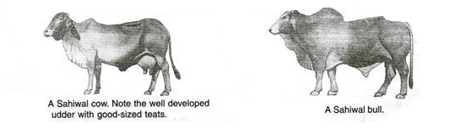
Artificial insemination was first introduced in India at Indian Veterinary Research Institute, Izatnagar, near Bareilly, Uttar Pradesh.
Super Ovulation and Embryo Transplantation:
Generally one ovum is released from each ovary at the time of ovulation. But by hormone injection, more ova can be produced from the ovary. After artificial insemination 4 to 10 embryos are collected at a time. Then each embryo is transplanted into a surrogate mother “carrier cow”. At very low temperature foetuses can be preserved for several days.

Breeds of Cattle:
The cattle breeds are classified into three groups.
(i) Milch Breeds:
The cows of these breeds are good milk producing, however, bullocks are of poor quality.
(ii) Drought Breeds:
The bullocks of these breeds are good for working but cows are poor milk producers.
(iii) General utility Breeds (Dual-purpose Breeds):
The cows of these breeds are good milk producers and the bullocks are good draught animals. They are intermediate between milch and drought breeds.
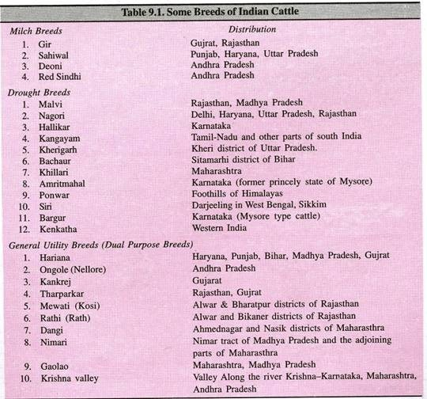
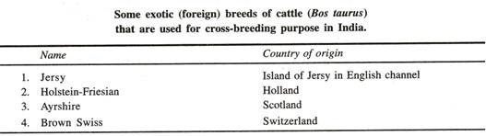
Lactation in sterle cows is induced by stibesterol.

2. Goat (Capra capra):
Goat is called the poor man’s cow. The goat is usually hollow-horned and bearded ruminant mammal. It has strong smelling power. It can readily adopt to almost any climate.
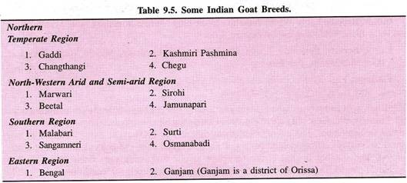

Exotic Breeds of Goats:

(1) Alpine.
(2) Toggenberg.
(3) Saanen.
(4) Nubian and
(5) Angora.

Breeding of Goats:
For getting good results, goats should be bred at the age from 14 to 18 months. The duration of oestrus or heat period is usually 24 to 28 hours but it may differ in certain breeds. The gestation period is from 145-153 days (5 months). Indian goat commonly kid twice in one year and usually three times in two years.
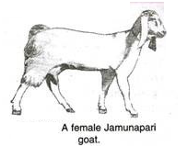
In does, a peculiar behaviour has been observed where occasionally accept the male even when they are pregnant. The goat gives birth while lying down. Male kids, not required for breeding, should be castrated before 10 to 12 weeks old. Under ordinary conditions, the average life of goat is about 12 years.

Pashmina wool is obtained from the mountain goat. This animal is found in Ladakh and Tibet.

3. Pigs (Sus scrofa):
Pig is also called swine or hog. It is an omnivorous, non-ruminant, gregarious mammal. The European breeds of domestic swine were derived from the local wild pig, Sus scrofa, whereas the breeds in the far Eastern parts of the globe were derived from another wild pig. Sus vittatus. The modern breeds of pig evolved from different crossings between the two original types. The present day domestic pig, Sus domesticus is the result of several years of evolution through gradual domestication.

Breeds of Pig:
There are about 60 recognised breeds of domestic pigs in the world.
Indian Breeds:
Large-White Yorkshire Boar, Large-White Yorkshire Sow, Middle White Yorkshire Boar, Middle White Yorkshire Sow.
Exotic Breeds:
Berkshire, Large White Yorkshire, Landrace, Middle White Yorkshire, Hampshire, Tamworth and Wessex.
Wallows:
Pigs have poor heat-regulating mechanism as they sweat only on the snout, because they have very few sweat glands.
Boar is fit for service when it is 1 year old. A gill becomes ready for breeding when it is 9 months old. Generally there are two seasons for breeding pigs. February to March and August to September. The average length of the oestrus cycle is 21 days.
Duration of heat period is 2-3 days. The gestation period of pig averages about 114 days (3 months, 3 weeks, 3 days). The number of piglets they produce at one birth may vary from 10 to 12. It is capable of producing two litters per year under good management conditions.
FARM MANAGEMENT SYSTEMS

A) System of management of chickens

1. Extensive

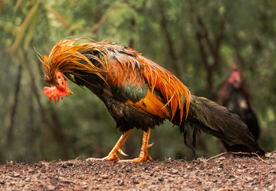
• The chickens are not restricted in any way.
• They can wonder in the field as they like. There should be a house for
roosting at night and for laying-eggs
• These are common in villages in Vanuatu.
Advantage
a. No overcrowding
b. No expensive wing etc...
c. Chickens have plenty of exercise
d. Smaller food cost as they obtain grass, weeds, kitchen wastes freely
Disadvantage
a. Close supervision is not easy
b. Eggs may be laid all over the place
c. Chicken may get into crops and spoil them
d. Easy prey to wild animals (dogs, cats and pigs)
e. A breeding policy is not easy unless roaming cocks are kept away
f. Disease can be easily caught from other flocks
.

2. Semi-Intensive
Advantage –
  - The birds are restricted in movement.
  - Chickens can be better manged
Disadvantage
  - Fencing and wire may be expensive

3. Intensive method
a. Deep litter house
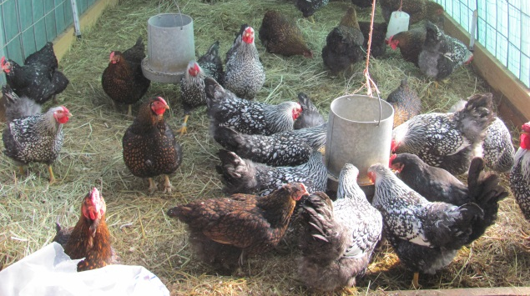

1. Many birds are kept in a house
2. House equipped with feeders, drinkers, laying boxed and roosts
3. Chickens move in the house
4. The floor is covered with litter made of dried grass; saw dust, wood shaving etc.
5. The litter is stirred regularly and more is added on top. The litter heats up as a compost heap and destroys disease organisms
6. Once a year the litter is removed and used as compost, fresh litter is then put

b. Battery system
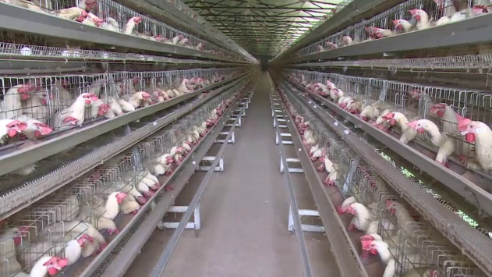
1. Each bird has a little rage for itself for the whole laying period.
2. The floor is sloping slightly so that when the egg is laid, it rolls down into a wire trough.
3. Food is given in feeding troughs fitted outside the cages. The chicken can take their heads out and feed.
4. Water and medicine are given automatically to the chickens
* In a house about 500 chickens can be kept.

B) System of management for cattle/pig/goat

According to FAO there are three main livestock management systems:
- mixed production
- intensive farming systems “landless”
- extensive production system
  - Mixed livestock production
It includes both agriculture and livestock and it can be either intensive or extensive. Generally these systems exploit both irrigated and non-irrigated land and they are common in some parts of America, Europe and Asia.
  - Intensive farming
It applies mainly to livestock. Intensive breeding farms look more like factories to breed pigs, chickens, laying hens, cattle and even fish. These farms “landless” are common in North America, Europe and Asia and in heavy populated areas in general, where, for instance, the demand for meat and proteins is very high.
  - Extensive farming
It is a livestock management system used on large non-cultivated land where animals can graze freely. Extensive farming is mainly chosen for cattle, to produce meat and milk, sheep and goats. It is more common in Central and South America (Mexico, Argentina, Brazil and Peru), and in some Southern Africa countries (South Africa, Namibia and Botswana), Australia, but even in Europe.
3.5 Livestock Management

