Central School
Home School Package

Year :11ECO

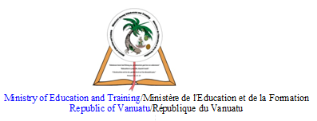

HOME SCHOOL PACKAGE CONTENT

LESSON Plan

Teacher | Name : Charlie Gihiala  Subject : Economics
Date  Date | Week FOUR  TERM TWO
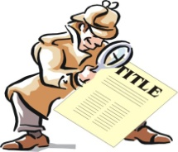 | Topic :  RESOURCE ALLOCATION THROUGH THE STATE SECTOR  Lesson number : 4
Learning outcomes | 11ECO2.1.1.4  Identify the sources of Government revenue and major areas of Government expenditure  1
Introduction | Government Budget. What are the sources of revenue and expenditure for the Central government? Big percentage of government revenue comes from various forms of government taxes. The rest comes from a mix of sources. The expenditure is all the various action for which government must pay for, such as providing public goods and services.  This tabled information shows Vanuatu Government major areas of Expenditure and Revenue. (Source: Budget Appropriation 2020)  https://doft.gov.vu/images/2020/Budget/2020_Volume_1__2_Budget_Book_English.pdf
Catch phrase for the lesson

Government budget.
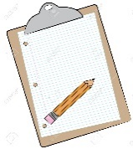  Learners notes | Summary  Government revenue is the money received by a government from taxes and non-tax sources to enable it to undertake government expenditures. Government revenue as well as government spending are components of the government budget and important tools of the government's fiscal policy.  Follow this link  https://ec.europa.eu/eurostat/statistics-explained/index.php/Glossary:Government_revenue_and_expenditure  https://www150.statcan.gc.ca/n1/pub/68f0023x/2006001/chap/chap6-eng.htm
https://youtu.be/idi3H400HlQ

Also read the comments from previous viewers.

 | - List the first six government objectives in the video or the written material on the link : https://www.nationalpriorities.org/budget-basics/federal-budget-101/revenues/
Assignment | Reflect on the video you have watched.  https://youtu.be/idi3H400HlQ
Assessment | Open book Test that you can download and complete from Central School Website
References | - https://doft.gov.vu/images/2020/Budget/2020_Volume_1__2_Budget_Book_English.pdf  - https://www.nationalpriorities.org/budget-basics/federal-budget-101/revenues/  - https://youtu.be/idi3H400HlQ  - https://ec.europa.eu/eurostat/statistics-explained/index.php/Glossary:Government_revenue_and_expenditure  - https://www150.statcan.gc.ca/n1/pub/68f0023x/2006001/chap/chap6-eng.htm

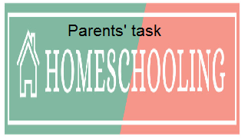

WEEKLY CHECKLIST For Parents:

Term: 2 Week number 1 Date…… to…… Month: …………

Subject | Number of lessons | Days | Tick when activity is complete | Parents comment | Signature
 | 1
 | 2
 | 3
 | 4
 | 5
 | 6

Term: 2 Week number 2 Date…… to…… Month: …………

Subject | Number of lessons | Days | Tick when activity is complete | Parents comment | Signature
 | 1
 | 2
 | 3
 | 4
 | 5
 | 6

Term: 2 Week number 3 Date…… to…… Month: …………

Subject | Number of lessons | Days | Tick when activity is complete | Parents comment | Signature
 | 1
 | 2
 | 3
 | 4
 | 5
 | 6

Term: 2 Week number 4 Date…… to…… Month: …………

Subject | Number of lessons | Days | Tick when activity is complete | Parents comment | Signature
 | 1
 | 2
 | 3
 | 4
 | 5
 | 6

Term: 2 Week number 5 Date…… to…… Month: …………

Subject | Number of lessons | Days | Tick when activity is complete | Parents comment | Signature
 | 1
 | 2
 | 3
 | 4
 | 5
 | 6

Term: 2 Week number 6 Date…… to…… Month: …………

Subject | Number of lessons | Days | Tick when activity is complete | Parents comment | Signature
 | 1
 | 2
 | 3
 | 4
 | 5
 | 6

Term: 2 Week number 7 Date…… to…… Month: …………

Subject | Number of lessons | Days | Tick when activity is complete | Parents comment | Signature
 | 1
 | 2
 | 3
 | 4
 | 5
 | 6

Term: 2 Week number 8 Date…… to…… Month: …………

Subject | Number of lessons | Days | Tick when activity is complete | Parents comment | Signature
 | 1
 | 2
 | 3
 | 4
 | 5
 | 6

Term: 2 Week number 9 Date…… to…… Month: …………

Subject | Number of lessons | Days | Tick when activity is complete | Parents comment | Signature
 | 1
 | 2
 | 3
 | 4
 | 5
 | 6

Term: 2 Week number 10 Date…… to…… Month: …………

Subject | Number of lessons | Days | Tick when activity is complete | Parents comment | Signature
 | 1
 | 2
 | 3
 | 4
 | 5
 | 6

Term: 2 Week number 11 Date…… to…… Month: …………

Subject | Number of lessons | Days | Tick when activity is complete | Parents comment | Signature
 | 1
 | 2
 | 3
 | 4
 | 5
 | 6

Term: 2 Week number 12 Date…… to…… Month: …………

Subject | Number of lessons | Days | Tick when activity is complete | Parents comment | Signature
 | 1
 | 2
 | 3
 | 4
 | 5
 | 6

Term: 2 Week number 13 Date…… to…… Month: …………

Subject | Number of lessons | Days | Tick when activity is complete | Parents comment | Signature
 | 1
 | 2
 | 3
 | 4
 | 5
 | 6

