Central School
Home School Package

Year : 3

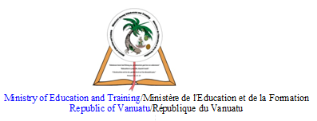

HOME SCHOOL PACKAGE CONTENT

Term 2 : Grade 3 : Mathematic Overview (Week 6, 7,8)
Lesson Page
Lesson Plan Content………………………………. 2
Week 1..Lesson Plan……………………………… 3-5
Reference……………………………………………. 5
Week 2..Lesson Plan……………………………….6-9 Reference…………………………………………….. 9
Week 3..Lesson Plan……………………………….. 10-12
Reference …………………………………………… 12
Week 4..Lesson Plan………………………………… 13-15
Reference…………………………………………….. 15
Week 5..Lesson Plan………………………………… 16-18
Reference…………………………………………….. 18
Week 6..Lesson Plan………………………………… 19-22
Référence…………………………………………….. 22
Week 7.. Lesson Plan………………………………… 23-26
Référence……………………………………………… 26
Week 8.. ………………………………………………. 27-30
Référencé ………………………………………………. 30
Week 9 …………………………………………………. 31-33
Reference ……………………………………………… 33
Week 10 ……………………………………………….. 34-38
Reference ……………………………………………… 38
Week 11 …………………………………………………. 39-41
Reference ……………………………………………….. 41
Week 12 ………………………………………………... 42 – 45
Reference ……………………………………………… 45
Week 13 ………………………………………………. 46-50
Reference ……………………………………………..50
Week 14 ………………………………………………. 51-54
Reference ……………………………………………… 54
Week 15 ………………………………………………. 55-58
Reference …………………………………………….. 58

Weekly Checklist for Parents………………………… 59-65

LESSON Plan

Teacher | Name : Mrs Barth & Ms Willie  Subject : Mathematic

Date
Topic : Time
Lesson number : 1 (week 6)

Learning outcomes | Students will identify the hour and minute hands in an analog clock.They will tell time to the hour and define the characteristics of an analog clock time. Read and undersatand time in one minute intervals.
Introduction | Form a family to stand in a circle. Explain your Left side is TO… Right side is…PAST. Tell how the clock turn
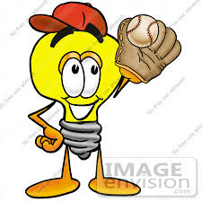 | Catch phrase for the lesson  Life is measured in minutes
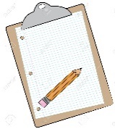  Learners notes | Summary  A clockis a device to measure, keep and indicate time. The clockis one of the oldesthuman  inventions, meeting the need to measure.
 | 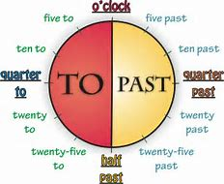
 | 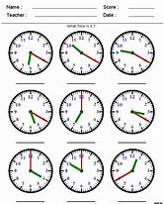
Assignment
Assessment
References | Mental Maths 3 : Unit 19 : Activity A, pg 56

LESSON PLAN 2

Teacher | Name : Mrs Barth & Ms Willie  Subject : Mathematic

Date
Topic : Mass : Using the gram
Lesson number : 2 ( week 6 )

Learning outcomes | Students should be able to:  - Estimates, measures, compares and records masses using kilograms and grams.  - Identify objects that have a mass of more than, less than or about the same as one kilogram.  - measures mass using a given measuring device.  - explain the need for a unit smaller than a kilogram to measure mass.  - estimate and check the number of similar objects which have a total mass of one kilogram.
Introduction | Provide students with different types of measuring device, eg. kitchen scales. Have students use 1-kg standard masses on both the equal arms balance and kitchen scale. Find objects that have the mass of more than , less than or about the same as one kilogram.
Catch phrase for the lesson
We go up light, we go down heavy.
Learners notes | Summary  We can use grams to measure parts of a kilogram.  Using formular ; 1,000 grams = 1 kilogram  500 grams = ½
 | 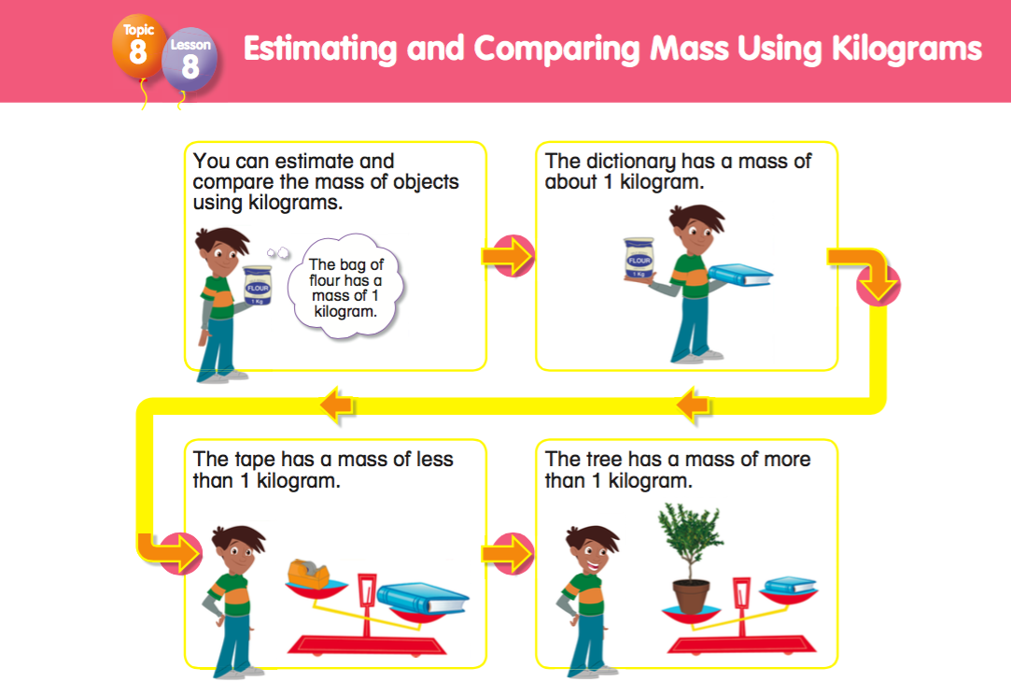
Experiment :

Slowly fill a plstic bag with sand until it balances a 100 gram mass. Seal the bag and label it 100g. Prepare eleven more 100 g bags of sand. Find how many
- 100g bags balance a 500g bag ____
- 100g bags balance two 500g bags ____
- 500g bags balance a 1 kg mass ____
- 100g bags balance a 1kg mass ____

Activities :
1. Use the short form to write :
- Forty grams ____
- One hundred grams ____
- Six hundred grams _____
- Three hundred grams ____
- Eighty grams ____
- Fifty grams _____
- Twenty grams ____
- Seventy grams ___
- Four hundred grams ____

Assignment | -Encourage students to explain the need for a unit smaller than the kilogram to measure mass.
Assessment
References | Mental Maths 3 : Activity B pg 54

LESSON PLAN 3

Teacher | Name : Mrs Barth & Ms Willie  Subject : Mathematic

Date
Topic : Mass : Using gram
Lesson number : 3 (week 6)

Learning outcomes | Students should be able to:  - Estimates, measures, compares and records masses using kilograms and grams.  - Identify objects that have a mass of more than, less than or about the same as one kilogram.  - measures mass using a given measuring device.  - explain the need for a unit smaller than a kilogram to measure mass.  - estimate and check the number of similar objects which have a total mass of one kilogram.
Introduction | Provide students with different types of measuring device, eg. kitchen scales. Have students use 1-kg standard masses on both the equal arms balance and kitchen scale. Find objects that have the mass of more than , less than or about the same as one kilogram.
Catch phrase for the lesson
We go up light, we go down heavy.
Learners notes | Summary  We can use grams to measure parts of a kilogram.  Using formular ; 1,000 grams = 1 kilogram  500 grams = ½
Experiment : Order three objects from lighest to heaviest, by hefting. Use balance scale to check your estimates.
- Five items lighter than 500g
- Five items with a mass between 500g and 1kg
- Five items heavier than 1kg.

Activities:

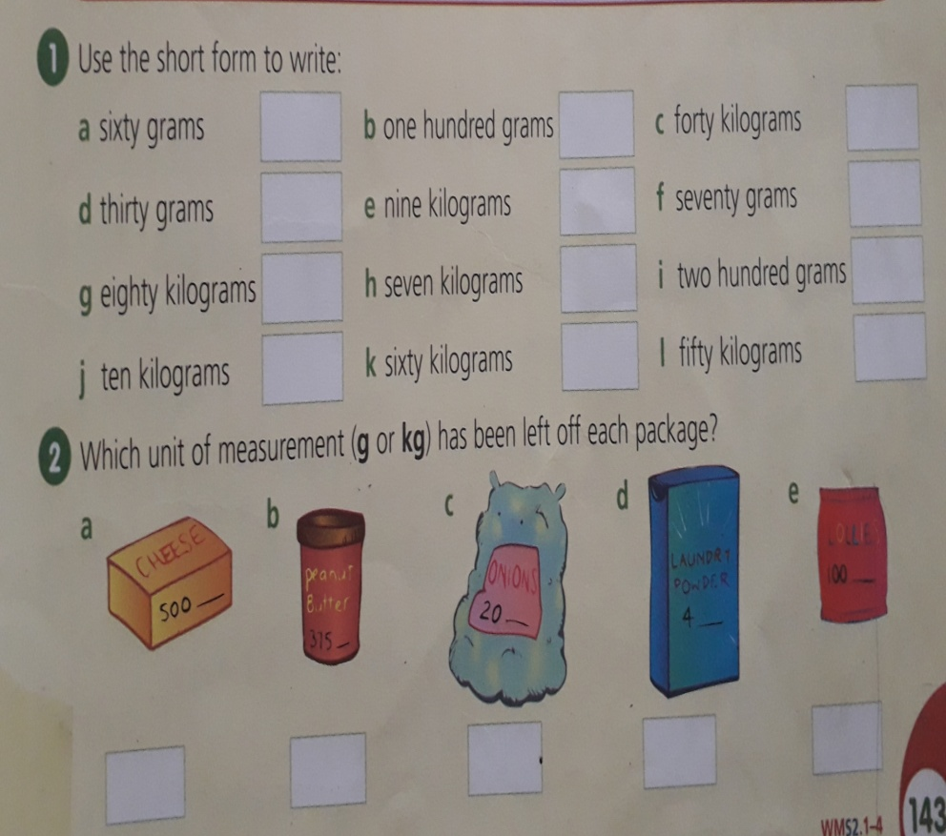

Assignment | -Encourage students to explain the need for a unit smaller than the kilogram to measure mass.
Assessment
References | Mental Maths 3 : Unit 18, Activity C pg 55

LESSON PLAN 4

Teacher | Name : Mrs Barth & Ms Willie  Subject : Mathematic

Date
Topic : Comparing Masses
Lesson number : 4 ( week 6 )

Learning outcomes | Students should be able to:  - Estimates, measures, compares and records masses using kilograms and grams.  - Identify objects that have a mass of more than, less than or about the same as one kilogram.  - measures mass using a given measuring device.  - explain the need for a unit smaller than a kilogram to measure mass.  - estimate and check the number of similar objects which have a total mass of one kilogram.
Introduction | Provide students with different types of measuring device, eg. kitchen scales. Have students use 1-kg standard masses on both the equal arms balance and kitchen scale. Find objects that have the mass of more than , less than or about the same as one kilogram.
Catch phrase for the lesson
We go up light, we go down heavy.
Learners notes | Summary  The difference between mass and weight is that mass is the amount of matter in a material, while weight is a measure of how the force of gravity acts upon that mass. Mass is the measure of the amount of matter in a body. Mass is denoted using m or M. Weight is the measure of the amount of force acting on a mass.  Using formular ; 1,000 grams = 1 kilogram  500 grams = ½
 | Collect labels from package that shows kilograms. Display these labels on a charts.
Assignment | -Have students collect four different labels from food packets or cans. Order the labels from lightest to heaviest.
Assessment
References | New Sign Post 3 : ( NSP ) pg 143  Mental Maths 3 : Unit 18, Activity D, pg 55

LESSON PLAN 5

Teacher | Name : Mrs Barth & Ms Willie  Subject : Mathematic

Date
Topic : Using kilogram and gram
Lesson number : 5 ( week 6 )

Learning outcomes | To assess students on this week’s topic on kilogram and gram.
Introduction | Tr ask students : what is the short form of kilogram / gram. How many grams in one kilogram ? etc ….
Catch phrase for the lesson
We go up light, we go down heavy.
Learners notes | Summary  The difference between mass and weight is that mass is the amount of matter in a material, while weight is a measure of how the force of gravity acts upon that mass. Mass is the measure of the amount of matter in a body. Mass is denoted using m or M. Weight is the measure of the amount of force acting on a mass.  Using formular ; 1,000 grams = 1 kilogram  500 grams = ½
Assignment
Assessment | 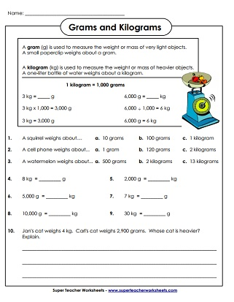
References | Mental Maths 3 : Unit 18, Activity D, pg 55

LESSON PLAN 6

Teacher | Name : Mrs Barth & Ms Willie  Subject : Mathematic

Date
Topic : Time
Lesson number : 6 (week 7)

Learning outcomes | · Students will identify the hour and minute hands in an analog clock. ·  They will tell time to the hour and define the characteristics of an analog clock. Reads and records time in one minute intervals  And make comparison between time units.
Introduction | Compose a song about time and sing to the students. Brain storm on starting and finishing time.  Breake down the different times when things starts and ends. Eg school starts ..7.30am ends 1.30pm. Ask them to tell about the time they know.
Catch phrase for the lesson
Life is measured in minutes
Learners notes | Summary  Each little hand stands for 1 minute.  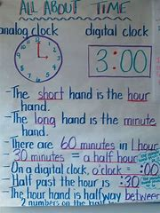
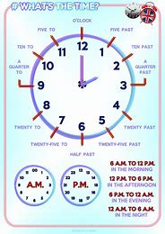
Activities

1. The above clock face has shown the reading time in words. Aiat eill help you to complete the times given below.
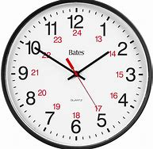eg 1:50 / Tens minutes to two

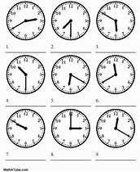

Assignment | Write the routine of things that you did on Saturday and Sunday.  Eg. 6.30am breakfast ( draw pictures for the whole day routine and write captions beside)
Assessment
References | Mental Maths 3 : Unit 19 : Activity C, pg 56

LESSON PLAN 7

Teacher | Name : Mrs Barth & Ms Willie  Subject : Mathematic

Date
Topic : Time
Lesson number : 7 (week 7)

Learning outcomes | · Students will identify the hour and minute hands in an analog clock. ·  They will tell time to the hour and define the characteristics of an analog clock. Reads and records time in one minute intervals  And make comparison between time units.
Introduction | Compose a song about time and sing to the students. Brain storm on starting and finishing time.  Breake down the different times when things starts and ends. Eg school starts ..7.30am ends 1.30pm. Ask them to tell about the time they know.
Catch phrase for the lesson
Life is measured in minutes
Learners notes | Summary  Each little hand stands for one minute
 | 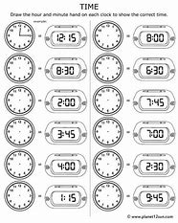
Assignment
Assessment
References | New Sign Post 3 : Activity 1 & 2 pg 125  Mental Maths 3 : Unit 19 : Activity A, pg 56

LESSON PLAN 8

Teacher | Name : Mrs Barth & Ms Willie  Subject : Mathematic

Date
Topic : Time
Lesson number : 8 (week 7)

Learning outcomes | · Students will identify the hour and minute hands in an analog clock. ·  They will tell time to the hour and define the characteristics of an analog clock. Reads and records time in one minute intervals  And make comparison between time units.
Introduction | Compose a song about time and sing to the students. Brain storm on starting and finishing time.  Breake down the different times when things starts and ends. Eg school starts ..7.30am ends 1.30pm. Ask them to tell about the time they know.
Catch phrase for the lesson
Life is measured in minutes
Learners notes | Summary  Each little hand stands for 1 minute
 | 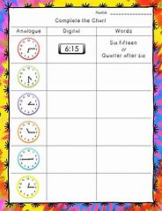
Assignment
Assessment
References | New Sign Post 3 :  Mental Maths 3 : Unit 19 : Activity C, pg 56

LESSON PLAN 9

Teacher | Name : Mrs Barth & Ms Willie  Subject : Mathematic

Date
Topic : Time
Lesson number : 9 (week 7)

Learning outcomes | · Students will identify the hour and minute hands in an analog clock. ·  They will tell time to the hour and define the characteristics of an analog clock. Reads and records time in one minute intervals  And make comparison between time units.
Introduction | Compose a song about time and sing to the students. Brain storm on starting and finishing time.  Breake down the different times when things starts and ends. Eg school starts ..7.30am ends 1.30pm. Ask them to tell about the time they know.
Catch phrase for the lesson
Life is measured in minutes
Learners notes | Summary  Each little hand stands for 1 minute
Assignment
Assessment
References | New Sign Post 3 : Activity 1 pg 139  Mental Maths 3 : Unit 19 : Activity C, pg 56

LESSON PLAN 10

Teacher | Name : Mrs Barth & Ms Willie  Subject : Mathematic

Date
Topic : Time
Lesson number : 10 (week 7)

Learning outcomes | · Students will identify the hour and minute hands in an analog clock. ·  They will tell time to the hour and define the characteristics of an analog clock. Reads and records time in one minute intervals  And make comparison between time units.
Introduction | Compose a song about time and sing to the students. Brain storm on starting and finishing time.  Breake down the different times when things starts and ends. Eg school starts ..7.30am ends 1.30pm. Ask them to tell about the time they know.
Catch phrase for the lesson
Life is measured in minutes
Learners notes | Summary  Each little hand stands for 1 minute
Activities

1. The above clock face has shown the reading time in words. Aiat eill help you to complete the times given below.
eg 1:50 / Tens minutes to two

Assignment | Write the routine of things that you did on Saturday and Sunday.  Eg. 6.30am breakfast ( draw pictures for the whole day routine and write captions beside)
Assessment
References | New Sign Post 3  Mental Maths 3 : Unit 19 : Activity C, pg 56

Week 8
LESSON PLAN 11

Teacher | Name : Mrs Barth & Ms Willie  Subject : Mathematic

Date
Topic :Goemetry ; Solid Shape ( 3D Shapes )
Lesson number : 11 (week 8)

Learning outcomes | The students should be able to:  - describe cones,cubes, cylinders, spheres and prisms.  - recognise three dimensional shapes and objects in the environment.  - read and write their names.
Introduction
Catch phrase for the lesson
Keep your eyes on the stars and your feet on the ground
Learners notes | Summary  Geometry can deal with three dimensional shapes with depth, such as cubes and spheres. We are surrounded by three dimensional shapes. We define a three dimensional shapes as any shapes that are three dimensions. What are these three dimensions ? They are lenght, width and height.  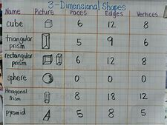
 | 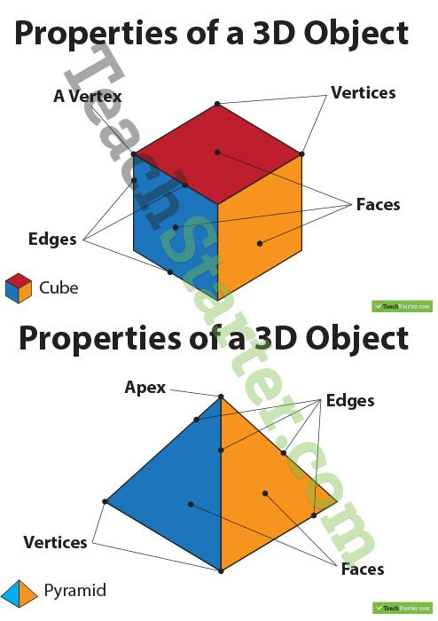
 | 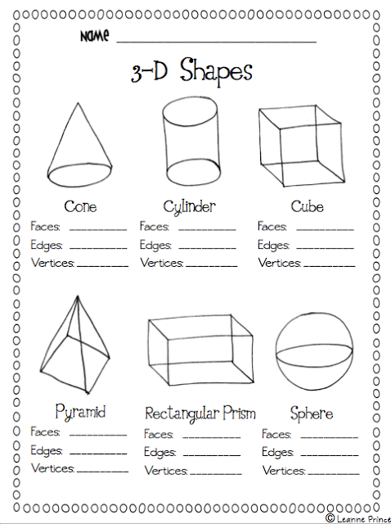
Assignment
Assessment
References | Mental Maths 3 : Unit 20: Activity A, pg57

LESSON PLAN 12

Teacher | Name : Mrs Barth & Ms Willie  Subject : Mathematic

Date
Topic :Goemetry ; Solid Shapes ( 3D Shapes )
Lesson number : 12 (week 8)

Learning outcomes | The students should be able to:  - describe cones,cubes, cylinders, spheres and prisms.  - recognise three dimensional shapes and objects in the environment.  - read and write their names.
Introduction
Catch phrase for the lesson
Keep your eyes on the stars and your feet on the ground
Learners notes | Summary  Geometry can deal with three dimensional shapes with depth, such as cubes and spheres. We are surrounded by three dimensional shapes. We define a three dimensional shapes as any shapes that are three dimensions. What are these three dimensions ? They are lenght, width and height.
Complete the activities.

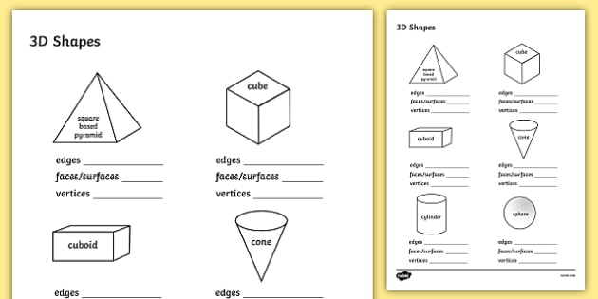

Assignment
Assessment
References | Mental Maths 3 : Unit 20: Activity B, pg57

LESSON PLAN 13

Teacher | Name : Mrs Barth & Ms Willie  Subject : Mathematic

Date
Topic :Goemetry ; Solid Shapes ( 3D Shapes )
Lesson number : 13 (week 8)

Learning outcomes | The students should be able to:  - describe cones,cubes, cylinders, spheres and prisms.  - recognise three dimensional shapes and objects in the environment.  - read and write their names.
Introduction
Catch phrase for the lesson
Keep your eyes on the stars and your feet on the ground
Learners notes | Summary  Geometry can deal with three dimensional shapes with depth, such as cubes and spheres. We are surrounded by three dimensional shapes. We define a three dimensional shapes as any shapes that are three dimensions. What are these three dimensions ? They are lenght, width and height.
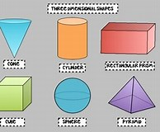

Activities :
Complete this table .

Name of 3D shapes | Number of Faces | Number of Edges | Number of vertices
Cone

Cylinder

Rectangular prism

Cube

Sphere

Pyramid

Assignment
Assessment
References | Mental Maths 3 : Unit 20: Activity C, pg 58

LESSON PLAN 14

Teacher | Name : Mrs Barth & Ms Willie  Subject : Mathematic

Date
Topic : Goemetry ; Solid Shapes ( 3D Shapes )
Lesson number : 14 (week 8)

Learning outcomes | The students should be able to:  - describe cones,cubes, cylinders, spheres and prisms.  - recognise three dimensional shapes and objects in the environment.  - read and write their names.
Introduction
Catch phrase for the lesson
Keep your eyes on the stars and your feet on the ground
Learners notes | Summary  Geometry can deal with three dimensional shapes with depth, such as cubes and spheres. We are surrounded by three dimensional shapes. We define a three dimensional shapes as any shapes that are three dimensions. What are these three dimensions ? They are lenght, width and height.
 | 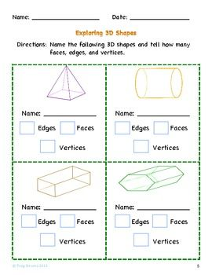
Assignment
Assessment
References | Mental Maths 3 : Unit 20: Activity D, pg 58

LESSON PLAN 15

Teacher | Name : Mrs Barth & Ms Willie  Subject : Mathematic

Date
Topic :Goemetry ; Solid Shapes ( 3D Shapes )
Lesson number : 15 (week 8)

Learning outcomes | The students should be able to:  - describe cones,cubes, cylinders, spheres and prisms.  - recognise three dimensional shapes and objects in the environment.  - read and write their names.
Introduction
Catch phrase for the lesson
Keep your eyes on the stars and your feet on the ground
Learners notes | Summary  Geometry can deal with three dimensional shapes with depth, such as cubes and spheres. We are surrounded by three dimensional shapes. We define a three dimensional shapes as any shapes that are three dimensions. What are these three dimensions ? They are lenght, width and height.
Complete the activities given by matching the 3D shapes with their names.

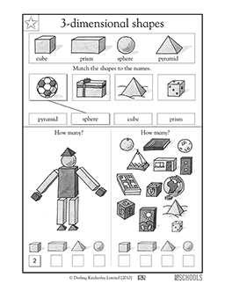

Assignment
Assessment
References | Learn times table 1-6

WEEKLY CHECKLIST For Parents:

Term: 2 Week number 1 Date…… to…… Month: …………

Subject | Number of lessons | Days | Tickwhenactivityiscomplete | Parents comment | Signature
 | 1
 | 2
 | 3
 | 4
 | 5
 | 6

Term: 2 Week number 2 Date…… to…… Month: …………

Subject | Number of lessons | Days | Tickwhenactivityiscomplete | Parents comment | Signature
 | 1
 | 2
 | 3
 | 4
 | 5
 | 6

Term: 2 Week number 3 Date…… to…… Month: …………

Subject | Number of lessons | Days | Tickwhenactivityiscomplete | Parents comment | Signature
 | 1
 | 2
 | 3
 | 4
 | 5
 | 6

Term: 2 Week number 4 Date…… to…… Month: …………

Subject | Number of lessons | Days | Tickwhenactivityiscomplete | Parents comment | Signature
 | 1
 | 2
 | 3
 | 4
 | 5
 | 6

Term: 2 Week number 5 Date…… to…… Month: …………

Subject | Number of lessons | Days | Tickwhenactivityiscomplete | Parents comment | Signature
 | 1
 | 2
 | 3
 | 4
 | 5
 | 6

Term: 2 Week number 6 Date…… to…… Month: …………

Subject | Number of lessons | Days | Tickwhenactivityiscomplete | Parents comment | Signature
 | 1
 | 2
 | 3
 | 4
 | 5
 | 6

Term: 2 Week number 7 Date…… to…… Month: …………

Subject | Number of lessons | Days | Tickwhenactivityiscomplete | Parents comment | Signature
 | 1
 | 2
 | 3
 | 4
 | 5
 | 6

Term: 2 Week number 8 Date…… to…… Month: …………

Subject | Number of lessons | Days | Tickwhenactivityiscomplete | Parents comment | Signature
 | 1
 | 2
 | 3
 | 4
 | 5
 | 6

Term: 2 Week number 9 Date…… to…… Month: …………

Subject | Number of lessons | Days | Tickwhenactivityiscomplete | Parents comment | Signature
 | 1
 | 2
 | 3
 | 4
 | 5
 | 6

Term: 2 Week number 10 Date…… to…… Month: …………

Subject | Number of lessons | Days | Tickwhenactivityiscomplete | Parents comment | Signature
 | 1
 | 2
 | 3
 | 4
 | 5
 | 6

Term: 2 Week number 11 Date…… to…… Month: …………

Subject | Number of lessons | Days | Tickwhenactivityiscomplete | Parents comment | Signature
 | 1
 | 2
 | 3
 | 4
 | 5
 | 6

Term: 2 Week number 12 Date…… to…… Month: …………

Subject | Number of lessons | Days | Tickwhenactivityiscomplete | Parents comment | Signature
 | 1
 | 2
 | 3
 | 4
 | 5
 | 6

Term: 2 Week number 13 Date…… to…… Month: …………

Subject | Number of lessons | Days | Tickwhenactivityiscomplete | Parents comment | Signature
 | 1
 | 2
 | 3
 | 4
 | 5
 | 6

