Central School
Home School Package

Year : 1

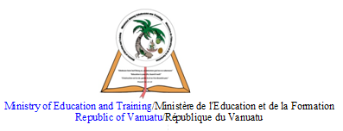

HOME SCHOOL PACKAGE CONTENT
Table Of Content | Content Page
Lesson Plan Week 6 | Page 3-Page 14
Lesson Plan Week 7 | Page 15- Page 25
Lesson Plan Week 8 | Page 26 – Page 43
Parent’s Home Schooling | Page 48 –Page 54

LESSON PLAN FOR WEEK 6

Teacher | Name : Rita Tatangis & Diana Maranda Lui  Subject : Mathematic
Date | Monday 22nd June 2020
Topic : Informal units of length
Lesson number :1

Learning outcomes | - Estimate, measure, compare and record lengths and distances using informal units.
Introduction | Informal units can be used to measure objects. They can be parts of the body or other objects apart from a ruler, a tape measure or a scale.
Catch phrase for the lesson.
Estimate to guess but measure for real.
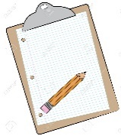  Learners notes | A fun way of finding lengths, widths and heights of objects is by using informal units of measurement. It provides a frequent opportunity for students to measure by placing informal units end to endwithout gaps or overlaps.
Use parts of your body to measure these objects.

Object | Unit | Estimate | Measure
Length of your house | Steps
Width of a window | Hand
Width of a book | Finger
Length of adining table | Hand
Length of your bedroom | Foot

Assignment | List down 3 objects that are shorter than your foot.  -  -  -
Assessment
References | New Signpost maths student book 1 page 52

LESSON PLAN
Teacher | Name : Rita Tatangis & Diana Maranda Lui  Subject : Mathematic
Date | Tuesday 23rd June 2020
Topic : Numeration : Addition to 10
Lesson number :2

Learning outcomes | - Create simple addition stories and picture problems.  - Record number sentences using the symbols + and =.
Introduction | To find the answer to an addition sum we have to add the two numbers together . The answer is always bigger than both numbers.
Catch phrase for the lesson
Addition increases, Subtraction decreases.
Learners notes | Addition is the joining of two groups. The symbol we use to show this is +.  Using counters or concrete materials to find the answer is more enjoyable and understandable by the students.
Assignment | .Write stories of 10.  - 0 + 10 = 10  - 1 + 9 =  - 2 + 8 =
Assessment
References | New Signpost maths students book 1page 53

LESSON PLAN
Teacher | Name : Rita Tatangis & Diana Maranda Lui  Subject : Mathematic
Date | Wednesday 24th June 2020
Topic : Numeration – Addition facts
Lesson number :3

Learning outcomes | - Recall and record addition facts to 20  - Explore the commutative law of addition  Eg : 2+3 = 3+2
Introduction | To find the answer to an addition sum we have to add the two numbers together . The answer is always bigger than both numbers.
Catch phrase for the lesson
Addition increases, Subtraction decreases.
Learners notes | Addition is the joining of two groups. The symbol we use to show this is +.  Using counters or concrete materials to find the answer is more enjoyable and understandable by the student.
Match :Draw a line from the sums to the answer in the middle column.

4 + 3 6 1 + 5

2 + 8 17 6 + 7

5 + 1 19 8 + 11

7 + 6 10 3 + 4

11 + 8 7 8 + 2

14 + 3 13 3 + 14

Assignment | .
Assessment
References | New Signpost maths students book page 54

LESSON PLAN
Teacher | Name : Rita Tatangis & Diana Maranda Lui  Subject : Mathematic
Date | Thursday 25th June 2020
Topic : Numeration – Addition facts
Lesson number : 4

Learning outcomes | - Recall and record addition facts to 20  - Draw pictures to illustrate a sum
Introduction | To find the answer to an addition sum we have to add the two numbers together . The answer is always bigger than the two numbers.  we can also draw pictures and use them to find the answers.
Catch phrase for the lesson
Addition increases, Subtraction decreases.
Learners notes | Addition is the joining of two groups. The symbol we use to show this is +.  Using counters or concrete materials to find the answer is more enjoyable and understandable by the student.  We can also draw pictures to find the answers.
Draw pictures and complete the sums.
- 8 + 2 = _____

- 5 + 9 = _____

- 4 + 2 = _____

- 3 + 11 = _____

- 12 + 7 = _____

- 15 + 5 = _____

Assignment | Write stories of 15.  - 0 + 15 = 15  - 1 + 14 =
Assessment
References | New Signpost maths students book page 54 : 3

LESSON PLAN
Teacher | Name : Rita Tatangis & Diana Maranda Lui  Subject : Mathematic
Date | Friday 26th June 2020
Topic : Space and Geometry : Symmetry
Lesson number : 5

Learning outcomes | - Draw a single line of symmetry on appropriate shapes.
Introduction | A line of symmetry cuts through a picture to divide it equally.
Catch phrase for the lesson
Its surrounding us but is invisible.
Learners notes | There can be one or more lines of symmetry cutting through a picture. It also means having exactly matching parts facing each other.
 | 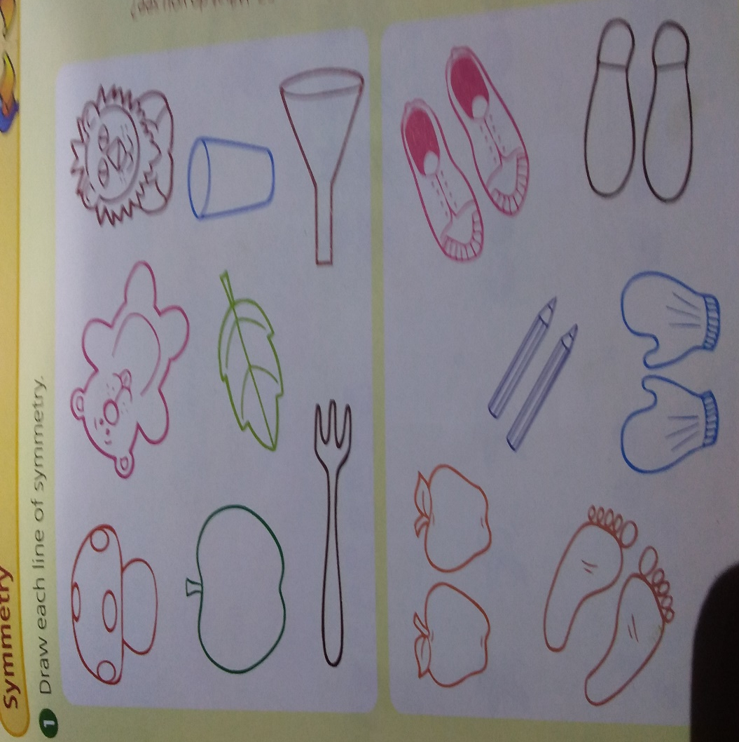
Assignment | .
Assessment
References | New Signpost maths students book page 55

LESSON PLAN FOR WEEK 7
Teacher | Name : Rita Tatangis & Diana Maranda Lui  Subject : Mathematic
Date | Monday 29th June 2020
Topic : Numeration : Subtraction
Lesson number : 6

Learningoutcomes | Solve a subtraction picture problem by crossing out things to be taken away and completing the number sentence.
Introduction | Subtraction means taking away or minus. We have to take away from the bigger number to find answers to our problem. We use pictures to illustrate our story or counters to work out the answer.
Catch phrase for the lesson
Subtraction decreases, Addition increases.
Learners notes | The symbol we use for subtraction is - . The answer of a subtraction problem is always smaller than the big number in the story.
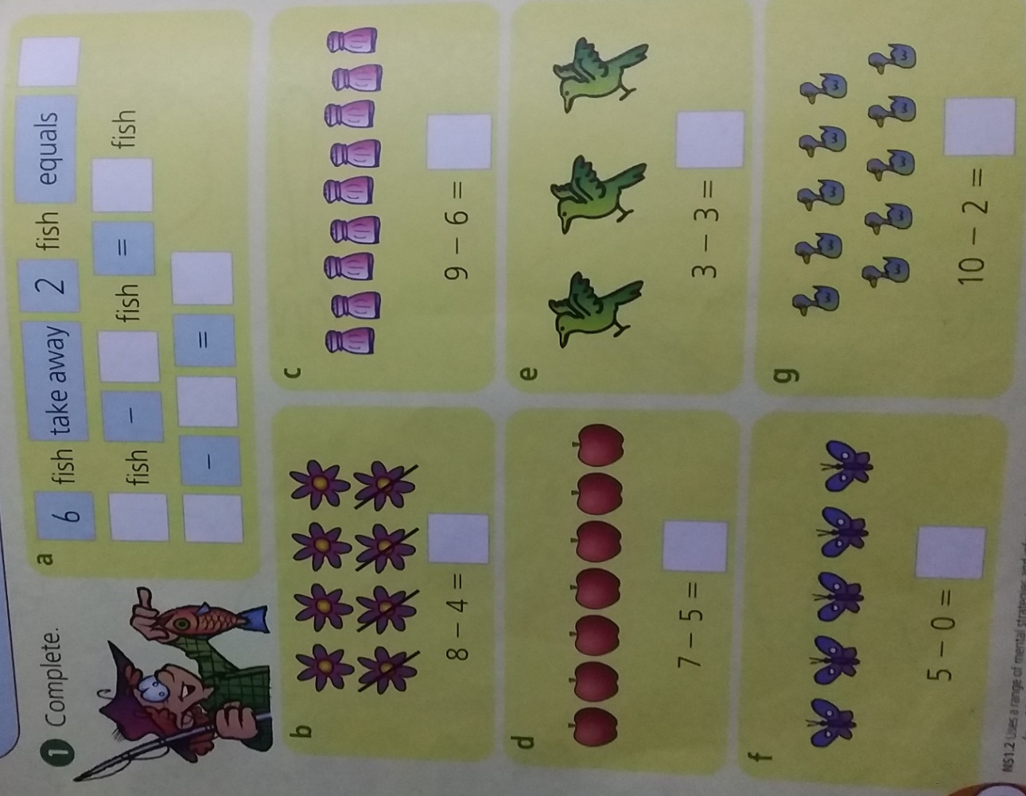

Assignment | Write your own subtraction stories of 10.  - 10 – 0 =  - 10 – 1 =
Assessment
Refrences | New signpost maths students book 1 page 56

LESSON PLAN
Teacher | Name : Rita Tatangis & Diana Maranda Lui  Subject : Mathematic
Date | Tuesday 30th June 2020
Topic :Space and Geometry : symmetry
Lesson number : 7
Learning outcomes | - Draw a single line of symmetry on appropriate shapes.  - Complete a symmetrical pattern.
Introduction | Refer to lesson number 5
Catch phrase for the lesson
Its surrounding us but is invisible.
Learners notes | Refer to lesson number 5
Assignment | Draw a picture with 2 lines of symmetry.
Assessment
References

LESSON PLAN
Teacher | Name : Rita Tatangis & Diana Maranda Lui  Subject : Mathematic
Date | Thursday 1st July 2020
Topic :Measurement : O’clock
Lesson number : 8
Learning outcomes | - Understands analog time  - Identify and read analog time  - Show time on a clock face
Introduction | The clock tells us the time. There is a time for everything. Some activities take longer time than others.
Catch phrase for the lesson
The past increases, the future recedes.
Learners notes | The clock face has numbers on it, a big hand which is the minute hand and a little hand as the hour hand.
 | 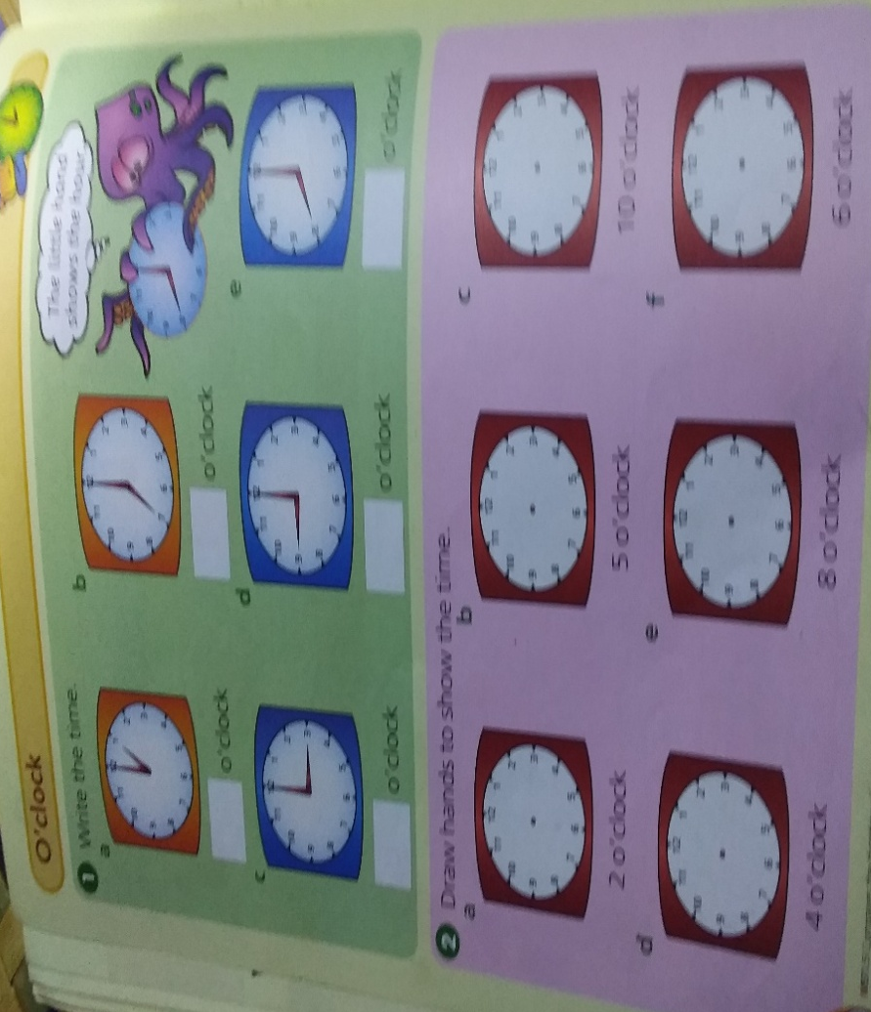
Assignment | Draw a clock face and show your bedtime.
Assessment
References | New Signpost maths students book page 58

LESSON PLAN
Teacher | Name : Rita Tatangis & Diana Maranda Lui  Subject : Mathematic
Date | Friday 2nd July 2020
Topic :Numeration : One quarter
Lesson number : 9
Learning outcomes | - describes and models halves and quarters  - uses fraction language in a variety of everyday contexts  - Recognizes when four parts are not quarters
Introduction | Provide practical experiments that emphasise the concept of quarter as being one of four equal parts.
Catch phrase for the lesson
Four equal parts in one.
Learners notes | A quarter is one of four equal parts, eg cutting an apple in quarters, folding paper into quarters etc.
 | 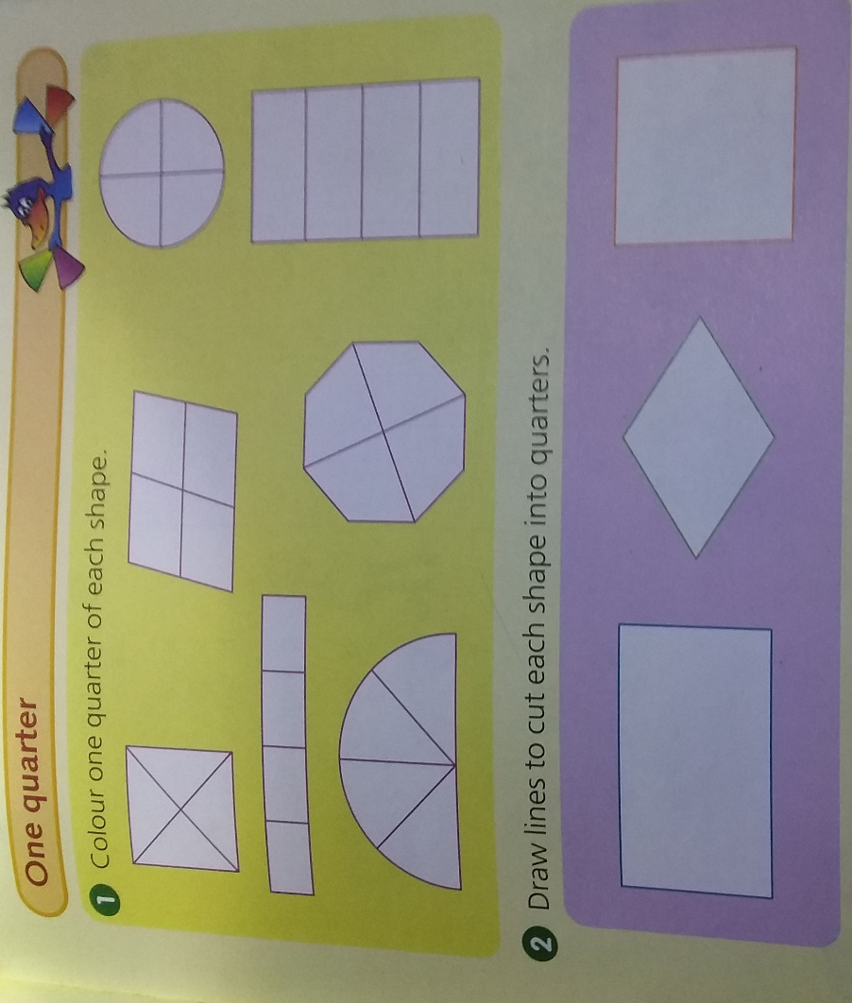
Assignment | .
Assessment
References | New Signpost maths students book page 59

LESSON PLAN FOR WEEK 8
Teacher | Name : Rita Tatangis & Diana Maranda Lui  Subject : Mathematic
Date | Monday 5th July 2020
Topic :Numeration : Numbers to 100
Lesson number : 10
Learning outcomes | - Counts forwards or backwards from a given two digit number  - Reads and writes numbers in words  - Counts forwards or backwards by twos, fives or tens  - Orders numbers from biggest to smallest or smallest to biggest.
Introduction | Counting by ones, twos and tens or from any starting point to 100 or using games to count forward and backward is a fun way of learning numbers.
Catch phrase for the lesson
The higher you climb, the bigger the number.
The lower you get, the smaller the number.

Learners notes | We are surrounded by numbers and everyday we do count a number of things around us. It might be the loaves of bread we buy at the shop, the number of cups and plates we wash or the number of clothes hanging on the line. Counting can be fun if it is learnt through games.
 | 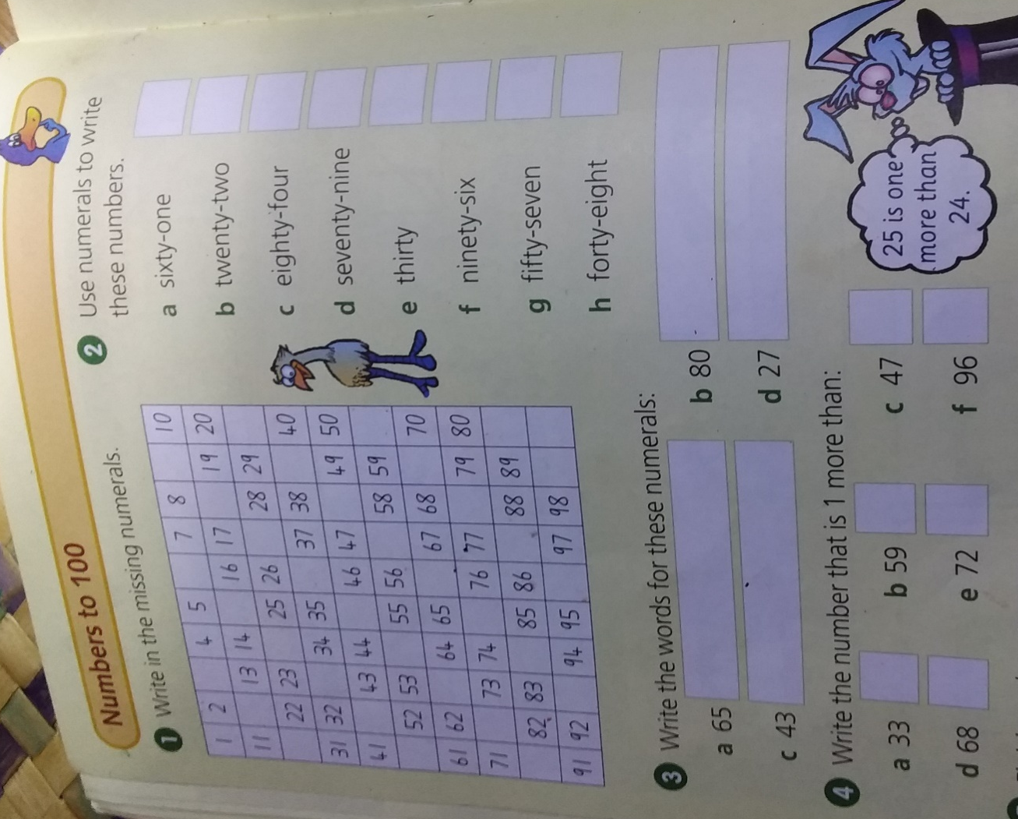
Assignment | .  Draw a number chart ( 1 – 100 ) on a big piece of paper. Colour the even numbers yellow and the odd numbers green.
Assessment
References | New Signpost maths students book page 60

LESSON PLAN
Teacher | Name : Rita Tatangis & Diana Maranda Lui  Subject : Mathematic
Date | Tuesday 6th July 2020
Topic :Space & Geometry : shapes in our world
Lesson number : 11
Learning outcomes | - Recognises, sorts and describes three dimentional objects and shapes.
Introduction | Shapes can be seen in all objects around us. Three dimentional objects look different from different views. Hidden sides are sometimes drawn as dotted lines so we can understand what the solid is like.
Catch phrase for the lesson
Length, width and height equals 3D .
Length and width equals 2D.
Learners notes | Everything around us has a shape. We can describe an object by the shape it has. Three-dimentional shapes include cones, cubes, cylinders, spheres and prisms.
 | 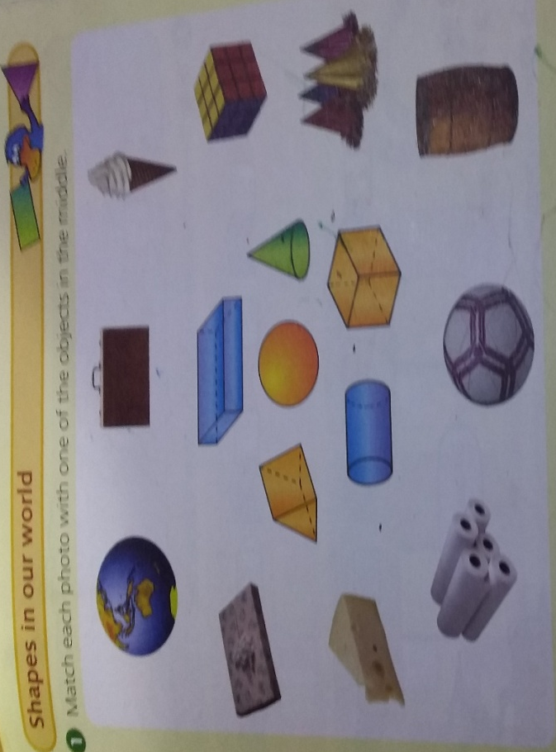
Assignment | .
Assessment
References | New Singpost maths students book page 61

LESSON PLAN
Teacher | Name : Rita Tatangis & Diana Maranda Lui  Subject : Mathematic
Date | Wednesday 7th July 2020
Topic :Numeration : Place value
Lesson number : 12
Learning outcomes | - Reads, writes and says two-digit numbers.  - States the place value of digits in a two-digit number.
Introduction | Provide opportunities for students to count by ones, twos and tens from any starting point to 100.
Catch phrase for the lesson
Refer to lesson 10
Learners notes | We are surrounded by numbers and everyday we do count a number of things around us. It might be the loaves of bread we buy at the shop, the number of cups and plates we wash or the number of clothes hanging on the line. Counting can be fun if it is learnt through games.
 | 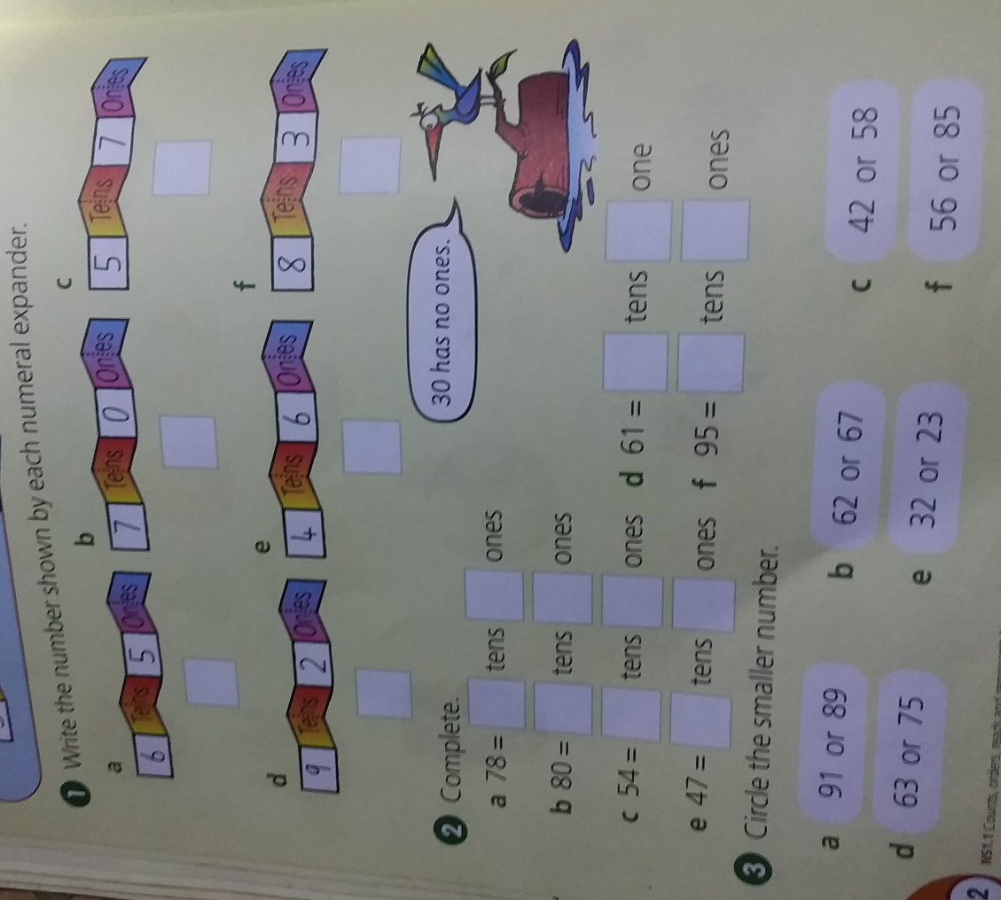
Assignment | .
Assessment
References | New Signpost maths students book page 62

LESSON PLAN
Teacher | Name : Rita Tatangis & Diana Maranda Lui  Subject : Mathematic
Date | Thursday 8th July 2020
Topic :Numeration : Addition to 10
Lesson number : 13
Learning outcomes | - Creates simple addition stories and picture problems.  - Recalls addition facts for numbers to 10.  - Explain how an answer to an addition is obtained.
Introduction | Refer to lesson 3
Catch phrase for the lesson
Addition increases, subtraction decreases.
Learners notes | Refer to lesson 3
 | 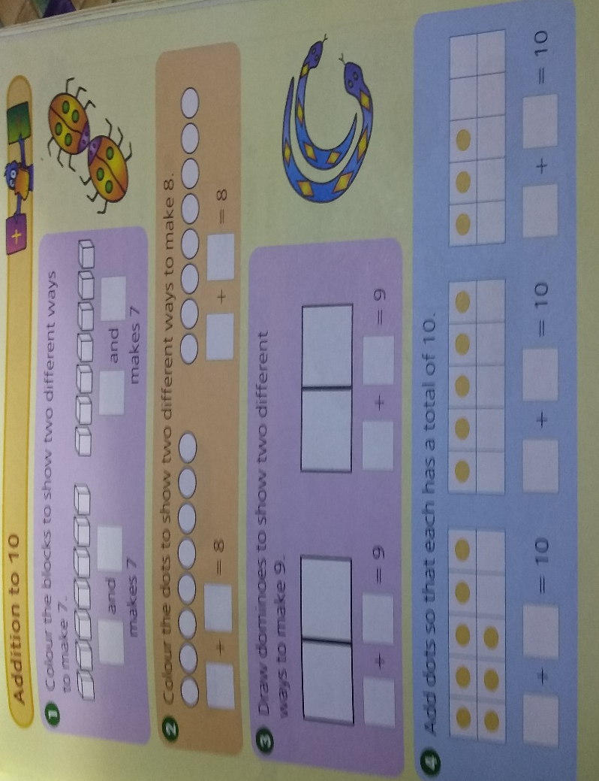
Assignment | .
Assessment
References | New Signpost maths students book page 63

LESSON PLAN
Teacher | Name : Rita Tatangis & Diana Maranda Lui  Subject : Mathematic
Date | Friday 9th July 2020
Topic :Numeration : Addition to 20
Lesson number : 14
Learning outcomes | - Recall and record addition facts to 20
Introduction | Refer to lesson 3
Catch phrase for the lesson
Addition increases, subtraction decreases.
Learners notes | Refer to lesson 3
Complete :
- T U b. T U c. T U d. T U
6 4 9 2
+ 3 + 2+ 8 + 8
_____ _____ _____ _____
_____ _____ _____ _____

e. T U f. T U g. T U h. T U
1 2 2 8 4 6 7 2
+ 5 +1 1+ 2 3 +1 0
____ _____ ______ _____
_____ ______ ______ _____

Assignment | . Make stories of 20  - 1 + 19 = 20  - 2 + 18 = 20
Assessment
References

LESSON PLAN
Teacher | Name : Rita Tatangis & Diana Maranda Lui  Subject : Mathematic
Date | 10th July 2020
Topic :Assessment
Lesson number : 15
Learning outcomes | - Recall and record what has been taught so far.
Introduction | Go through the questions one by one. Explain clearly to the student. He / she records the answer.
Catch phrase for the lesson
Listen well, get it right.
Learners notes | Refer to lessons 1 - 14
- Complete :

- 8 + 3 = _____ c.4 + 2 = _____

- 0 + 10 = _____ d. 13 + 6 = _____

e. T U f. T U g. T U
1 2 9 5 4
+ 1 3 + 5 + 2 0
______ ______ ______
_______ ______ ______

- Draw pictures and complete :

- 8 – 3 = ___

- 11 – 5 = ___

- Write the words for these numbers :

- 66 __________________________

- 51 ___________________________

- 43 ___________________________

- 20 ___________________________

- Draw a line of symmetry for each shape :

- Draw lines to cut the shape into quarters.
Colour one quarter.

- Circle the smaller number:
- 25 or 11
- 19 or 17
- 25 or 43
- 56 or 80

- Circle the bigger number:
- 22 or 7
- 36 or 100
- 89 or 16
- 92 or 99

- Write the number that is one more than:
- 12 ________
- 39 ________
- 99 ________
- 45 ________
- 8 _________

- Draw these 3D shapes.

A Sphere | A Cone | A Cube

Assignment
Assessment
References

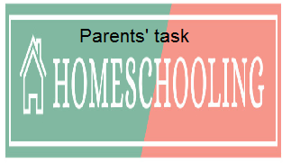

WEEKLY CHECKLIST For Parents:

Term: 2 Week number 1 Date…… to…… Month: …………

Subject | Number of lessons | Days | Tick when activity is complete | Parents comment | Signature
 | 1
 | 2
 | 3
 | 4
 | 5
 | 6

Term: 2 Week number 2 Date…… to…… Month: …………

Subject | Number of lessons | Days | Tick when activity is complete | Parents comment | Signature
 | 1
 | 2
 | 3
 | 4
 | 5
 | 6

Term: 2 Week number 3 Date…… to…… Month: …………

Subject | Number of lessons | Days | Tick when activity is complete | Parents comment | Signature
 | 1
 | 2
 | 3
 | 4
 | 5
 | 6

Term: 2 Week number 4 Date…… to…… Month: …………

Subject | Number of lessons | Days | Tick when activity is complete | Parents comment | Signature
 | 1
 | 2
 | 3
 | 4
 | 5
 | 6

Term: 2 Week number 5 Date…… to…… Month: …………

Subject | Number of lessons | Days | Tick when activity is complete | Parents comment | Signature
 | 1
 | 2
 | 3
 | 4
 | 5
 | 6

Term: 2 Week number 6 Date…… to…… Month: …………

Subject | Number of lessons | Days | Tick when activity is complete | Parents comment | Signature
 | 1
 | 2
 | 3
 | 4
 | 5
 | 6

Term: 2 Week number 7 Date…… to…… Month: …………

Subject | Number of lessons | Days | Tick when activity is complete | Parents comment | Signature
 | 1
 | 2
 | 3
 | 4
 | 5
 | 6

Term: 2 Week number 8 Date…… to…… Month: …………

Subject | Number of lessons | Days | Tick when activity is complete | Parents comment | Signature
 | 1
 | 2
 | 3
 | 4
 | 5
 | 6

Term: 2 Week number 9 Date…… to…… Month: …………

Subject | Number of lessons | Days | Tick when activity is complete | Parents comment | Signature
 | 1
 | 2
 | 3
 | 4
 | 5
 | 6

Term: 2 Week number 10 Date…… to…… Month: …………

Subject | Number of lessons | Days | Tick when activity is complete | Parents comment | Signature
 | 1
 | 2
 | 3
 | 4
 | 5
 | 6

Term: 2 Week number 11 Date…… to…… Month: …………

Subject | Number of lessons | Days | Tick when activity is complete | Parents comment | Signature
 | 1
 | 2
 | 3
 | 4
 | 5
 | 6

Term: 2 Week number 12 Date…… to…… Month: …………

Subject | Number of lessons | Days | Tick when activity is complete | Parents comment | Signature
 | 1
 | 2
 | 3
 | 4
 | 5
 | 6

Term: 2 Week number 13 Date…… to…… Month: …………

Subject | Number of lessons | Days | Tick when activity is complete | Parents comment | Signature
 | 1
 | 2
 | 3
 | 4
 | 5
 | 6

