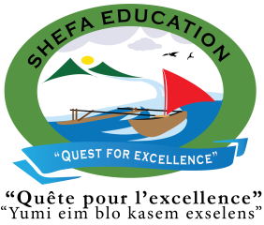

Central School
Home School Package

Year : 1

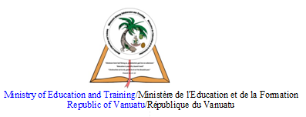

HOME SCHOOL PACKAGE CONTENT
Table Of Content | Page Number
Lesson Plan Week 6 | Page 3- Page 14
Lesson Plan Week 7 | Page 15 –Page 26
Lesson Plan Week 8 | Page 27 – Page 38
Parent’s Home Schooling | Page 39- Page 45

LESSON PLAN FOR WEEK 6

Teacher | Name :Diana Maranda Lui & Rita Tatangis  Subject :Our Communities
Date | Monday 22th June 2020
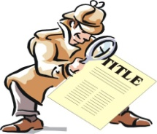 | Topic : Responsibilities with friends  Lesson number : One (1)
Learning Outcomes | The children should understand  -the definition of responsibilities with specific examples  -how friends help each other  -why co-operation and understanding are important
Introduction | -Introduce the activity asking a question to children  .what are ways you as a student should help your teacher at school ?
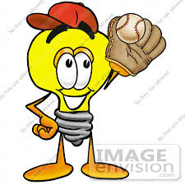 | Catch phrase for the lesson  .Be Responsible To Help Others.
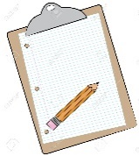  Learners notes | Summary  .Briefly discuss with the children the different responsibilities at home, school, community etc…  . Children can mime the different responsibilities that they did with their friends back at home, school or community.
 | -
Draw/ Labelling Activity
Instructions : Draw the diffrent pictures showing the different responsibilities to help others.

1.Sweeping The Room | 2.Planting Vegetables
3.Washing Plates / Cups | 4.Washing Clothes

Assignment | -
Assessment | .Review the lesson by asking student questions relate to different pictures on different responsibilities.
References | -Picture Cards  -Manila Cards  - Markers  -Different Pictures  -Glue

LESSON PLAN
Teacher | Name : Rita Tatangis & Diana Maranda Lui  Subject :Nutrition
Date | Thursday 25th June 2020
Topic :The three food group
Lesson number : 1
Learning outcomes | - Identify and name the different food found in the three food groups.  - Name their favourite food.
Introduction | Ask them these questions :  - What is your favourite fruit ?  - What is your favourite vegetable ?  - What is your favourite meat ?
Catch phrase for the lesson
Your health is your wealth
Learners notes | All our favourite food have different roles to play in our body to keep us healthy. Eating one kind of food only, does not meet the bodys needs to keep it healthy. A variety of food in a meal is always the best. Energy food includes all vegetables. Body building includes all meat and protective food has the greens and fruits.
Draw, name and colour :
- Your favourite fruit
- Your favourite vegetable
- Your favourite meat.

Assignment | .
Assessment
References

LESSON PLAN
Teacher | Name : Rita Tatangis & Diana Maranda Lui  Subject : Agriculture
Date | Friday 26th June 2020
Topic :Parts of a plant
Lesson number : 1
Learning outcomes | - Identify and name various parts of the plant.  - Describe them.  - Identify the importance of plants to man.
Introduction | Plants are living things. Why ?  Discuss the difference between a plant and an animal.
Catch phrase for the lesson
Life is living, death is non - living.
Learners notes | Plants are living things. Most of them grow from a tiny seed to a big tree. During their development process they produce roots, a stem, branches, leaves, flowers and fruits.  Plants are important to man because they give us the air that we need to breathe and they provide us with food.
 | Draw and name the different parts of a plant. ( Stem, Branch, Leaves, Flowers, Fruit, Roots ).
Assignment | .
Assessment
References

LESSON PLAN
Teacher | Name : Rita Tatangis & Diana Maranda Lui  Subject : Health
Date | Tuesday 23rd June 2020
Topic :Learning to care for hair
Lesson number : 1
Learning outcomes | - Understand the importance of having clean hair.  - Know what to do to have a clean hair.
Introduction | Sing the parts of the body song.  Discuss the different parts of the head and their function.
Catch phrase for the lesson
Your health is your life
Learners notes | Hair is part of our body which needs alot of care. To have a clean hair we need to wash it at least once or twice a week (girls). We need clean water, shampoo and a towel. After washing it we must make sure we dry it up very well then we put some oil or cream on and we must make sure to comb it or brush it well.
Complete the sentence below and draw your hair.
To have a healthy hair, we need to wash it _______ or twice a week. We need clean ________, _____________ and a ____________.
water | once | shampoo | towel
My Hair

Assignment | .
Assessment
References | Health Teachers Book page 108

LESSON PLAN
Teacher | Name :Diana Maranda Lui & Rita Tatangis  Subject :Our Environment
Date | Tuesday 23rd June 2020
Topic : Working with water
Lesson number : One (1)

Learning Outcomes | 1.The children should learn that fresh clean water is very important for our health  2. The children should also learn that heavy objects sink when placed in water and light objects float.
Introduction | -Introduce the activity by playing a water game.  .Encourage students to use descriptive words to describe the look, feel, smell and sounds that goes with water for example : splash ,clear,swim , sea etc…
Catch phrase for the lesson
.Water is our basic need.
Learners notes | Summary  .Briefly describe the importance of clean by showing an illustration .  -Have two drinking glasses :one filled with clean water and other with dirty water  Refer to the illustration ask questions relate to the two drinking glasses.
Draw and Labelling
Instructions : Draw the 2 following ways of using clean water and 2 following ways of dirty water.

Using tap water | Using water tank
Drinking water with bacteria inside the drinking glass | Playing on the muddy swam

Assignment | .Draw up a diagram of how we should preserve claen water in our community
Assessment | .Review the lesson by asking questions orally relate to the topic by showing picture cards.
References | -Picture Cards  -Manila Cards  - Markers  -Different Pictures  -Glue  -Crayons

LESSON PLAN FOR WEEK 7

Teacher | Name :Diana Maranda Lui & Rita Tatangis  Subject :Our Communities
Date | Monday 29th June 2020
Topic : Others around me
Lesson number : Two (2)

Learning Outcomes | 1.The children should understand to identify relationships with family and relatives.  2. The children should also understand the different roles and responsibilities in a family
Introduction | -Introduce the activity by encouraging children to talk about their immediate family .  -Introduce the different roles and responsibilities that me and my parents do during the weekend.
Catch phrase for the lesson
.Families are special to me.
Learners notes | Summary  .The children are encouraged to talk about their immediate families by looking at the chart shown.  My Mother My Father  ME  My Sister My Brother  .They may extend the chart , depending on the size of the household  Also the children can identify the important people within their community and how they are related to.  .As a class they can divide into groups of 4 and discuss things a family does at the weekend such as :  -cleaning the house  -gardening  -making laplap  -helping your neighbor  -going for picnic etc….  Children can describe how they feel if they had to do those things by themselves.What would be theeir reactions to other members of the family ?
 | -
Draw and Labelling – Who is in my family ?
Instructions : Draw the different members of my family

- My Father

- My Mother

- My Brother

- My Sister

- Me

Unjumble Activity : Different Responsibilities

Instructions: Read and spell the words correctly from the box below.

- ginnerdag - _______________________
- ginwes-_______________________
- ginkooc-________________________
- gintniap-_______________________

Painting , sewing, cooking , painting

Assignment | .Draw up a chat of your family tree
Assessment | .Review the lesson by asking student to do the matching activity relate to the topic.
References | -Picture Cards  -Manila Cards  - Markers  -Different Pictures  -Glue

LESSON PLAN
Teacher | Name : Rita Tatangis & Diana Maranda Lui  Subject : Nutrition
Date | 2nd July 2020
Topic :The three food group
Lesson number : 2
Learning outcomes | .Explain the importance of having a balanced meal.
Introduction | What is a balanced meal ? It is a meal which includes one food from each food group.
Catch phrase for the lesson
Your health is your wealth
Learners notes | Refer to nutrition lesson 1.
 | Draw a balanced meal on a plate. Colour your picture. Name the food on your plate.
Assignment | .  Help your mother prepare a balance meal for you.
Assessment
References

LESSON PLAN
Teacher | Name : Rita Tatangis & Diana Maranda Lui  Subject : Agriculture
Date | Friday 3rd July 2020
Topic :Growth of plants.
Lesson number : 2
Learning outcomes | - Identify the main contributors to a plants growth.
Introduction | Visit a flower or vegetable garden. Discuss the different stages in the growth of a plant. Talk about what plants need to grow.
Catch phrase for the lesson
Life is living death is non-living.
Learners notes | Plants are living things. They grow and reproduce. In order for them to grow well, they need water, sunlight and good soil. They need to be cared for just as we do.
 | Draw a plant and show the three different plant needs.
Assignment | .Draw and name parts of a plant.
Assessment
References

LESSON PLAN
Teacher | Name : Rita Tatangis & Diana Maranda Lui  Subject : Health
Date | Thursday 30th June 2020
Topic :Learning to care for teeth
Lesson number : 2
Learning outcomes | - Identify the importance of having clean healthy teeth.
Introduction | Discuss these questions together :  - What is the colour of a healthy teeth ?  - What makes our teeth healthy ?
Catch phrase for the lesson
Your health your life.
Learners notes | It is very important to keep our teeth clean because it helps us to smile, talk and eat our food.  Brushing our teeth 2 or 3 times a day with colgate and a tooth brush will give us strong healthy teeth. Avoid eating alot of sugary food too.
- Drawa tooth brush and a colgate.
Label them.

- Draw and name 2 healthy food.

- Draw and name 2 sugary food.

Assignment | .  Visit the dental clinic.
Assessment
References | Health Teachers Book page 110-121.

LESSON PLAN
Teacher | Name :Diana Maranda Lui & Rita Tatangis  Subject :Our Environment
Date | Tuesday 30th June 2020
Topic : Working with water
Lesson number : Two (2)

Learning Outcomes | 1.The children should learn that fresh clean water is very important for our health  2. The children should also learn that heavy objects sink when placed in water and light objects float.
Introduction | -Introduce the activity by playing a water game.  .Encourage students to use descriptive words to describe the look, feel, smell and sounds that goes with water for example : splash ,clear,swim , sea etc…  . Encourage students to identify different objects that float or sink in water
Catch phrase for the lesson
.Water is our basic need.
Learners notes | Summary  Review the previous lesson  .Briefly describe the importance of clean by showing an illustration .  -Have two drinking glasses :one filled with clean water and other with dirty water  Refer to the illustration ask questions relate to the two drinking glasses.  . Briefly illustrate the different objects to identify floating and sinking by using a basin of water with some objects (light /heavy)
Activity 1 : Classifying
Instructions : Classify the different objects to each heading
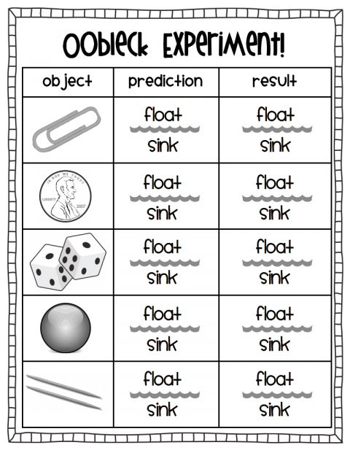

Assignment
Assessment | .Review the lesson by asking questions orally relate to the topic by showing picture cards.
References | -Picture Cards  -Manila Cards  - Markers  -Different Pictures  -Glue  -Crayons  -Pencils

LESSON PlAN FOR WEEK 8

Teacher | Name :Diana Maranda Lui & Rita Tatangis  Subject :Our Communities
Date | Monday 6th July 2020
Topic : Caring For Our Environment
Lesson number : Three (3)

Learning Outcomes | The children should understand  -the definition of environment with specific examples  -how we should keep our environment clean
Introduction | -Introduce the activity asking a question to children  .what are ways you as a student should help to care for our environment ?  -brainstorm and let student express their own views
Catch phrase for the lesson
.Be Responsible To Care For The Environment
Learners notes | Summary  .Briefly discuss with the children the different responsibilities to do to keep our environment clean at all times  . Children can mime the different ways of how to care for the environment.
 | -
Activity 1 :PostersActivity
Instructions : Draw the diffrent pictures showing the different responsibilities to help us care for our environment and ways of destroying our environment

1.Painting pictures to keep a clean environment | 2.Planting flowers along the foothpath
3.Throwing plastic bags / rubbish into the sea or river | 4.Stop throwing rubbish around the environment

Activity 2: Drama
Ask the students to divide into 3’s and create a drama of our we should care for our environment.

Assignment | -
Assessment | .Review the lesson by asking student questions relate to different pictures on different responsibilities.  . Assess the students role play , how they understand the topic and how they speak with confidence.
References | -Picture Cards  -Manila Cards  - Markers  -Different Pictures  -Glue

LESSON PLAN
Teacher | Name : Rita Tatangis & Diana Maranda Lui  Subject : Nutrition
Date | Thursday 9th July 2020
Topic :Examples of energy food
Lesson number : 3
Learning outcomes | - Identify and name energy food.  - Identify the best energy food we have around us.
Introduction | Discuss the importance of having an energy food in our meal.
Catch phrase for the lesson
Your health is your wealth
Learners notes | Energy or power foods help us move, work and play. It includes yams, taro, banana, kumala, manioc, breadfruit, bread, rice, butter, oil, corn and many more.
 | Draw and name four (4) energy food.
Assignment | .
Assessment
References | Nutrition Teachers Book Year one page 100

LESSON PLAN
Teacher | Name : Rita Tatangis & Diana Maranda Lui  Subject : Agriculture
Date | Friday 10th July 2020
Topic :Growth of plants in the garden
Lesson number : 3
Learning outcomes | - Identify and describe the different stages of plant growth ( from seed to fruit stages ).
Introduction | Plants are living things just as human beings. They grow from a tiny seed to a big tree and bear fruits.
Catch phrase for the lesson
Growing is part of life.
Learners notes | Plants go through different changes as they grow just as people do. Plants start their lives as seeds and seed germination is the first stage where the plant grow from the seed. As the plant grows it moves to the budding phase. This is where the plant flowers and bears fruit.
Draw a life cycle of a plant (seed to fruits ).

Life cycle of a plant

Assignment | .Now that you have learned about how a plant grows, its time to try out your own little garden. Plant a seed (bean) and see how it grows.Take note of the different stages that you see and draw a picture of your plant.
Assessment
References

LESSON PLAN
Teacher | Name : Rita Tatangis & Diana Maranda Lui  Subject : Health
Date | Monday 7th July 2020
Topic :Learning to care for teeth
Lesson number : 3
Learning outcomes | - Identify the importance of having clean healthy teeth.
Introduction | Discuss the importance of tooth brushing and what happens to our teeth when we dont brush it.
Catch phrase for the lesson
Your health your life.

Learners notes | Refer to Health lesson 2
 | Practise good tooth brushing together.
Assignment | Complete this one week tooth brushing table with a tick.  Day After breakfast After lunch After supper  Monday  Tuesday  Wednesday  Thursday  Friday  Saturday  Sunday
Assessment
References | Health Teachers Book Year one page 110

Teacher | Name :Diana Maranda Lui & Rita Tatangis  Subject :Our Environment
Date | Tuesday 7th July 2020
Topic : Working with water
Lesson number : Three(3)

Learning Outcomes | 1.The children should learn that fresh clean water is very important for our health  2. The children should also learn that heavy objects sink when placed in water and light objects float.
Introduction | -Introduce the activity by playing a water game.  .Encourage students to use descriptive words to describe the look, feel, smell and sounds that goes with water for example : splash ,clear,swim , sea etc…
Catch phrase for the lesson
.Water is our basic need.
Learners notes | Summary  Review Summary  .Briefly describe the importance of clean by showing an illustration .  -Have two drinking glasses :one filled with clean water and other with dirty water  Refer to the illustration ask questions relate to the two drinking glasses.  -Examine water by leaving a container outside to collect rain water and examine wheather it’s good for drinking or no  .Leave it uncovered for somedays and observe wheather it’s good for drinking or no  -Review floating and sinking activity with the students.
 | -
Draw and Labelling
Instructions : Draw the 2 following ways of using clean water and 2 following ways o dirty water.

Using tap water | Using water tank uncovered
Using dirty water for cooking | Using clean water for shower
Activity 2: Draw and Labelling
Instructions: Draw two objects which float and sink in water

Float In Water | Sink In Water

Assignment | .Draw up a diagram of how we should preserve claen water in our individual households
Assessment | .Review the lesson by asking questions orally relate to the topic by showing picture cards.
References | -Picture Cards  -Manila Cards  - Markers  -Different Pictures  -Glue  -Crayons

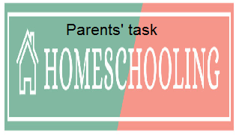

WEEKLY CHECKLIST For Parents:

Term: 2 Week number 1 Date…… to…… Month: …………

Subject | Number of lessons | Days | Tick when activity is complete | Parents comment | Signature
 | 1
 | 2
 | 3
 | 4
 | 5
 | 6

Term: 2 Week number 2 Date…… to…… Month: …………

Subject | Number of lessons | Days | Tick when activity is complete | Parents comment | Signature
 | 1
 | 2
 | 3
 | 4
 | 5
 | 6

Term: 2 Week number 3 Date…… to…… Month: …………

Subject | Number of lessons | Days | Tick when activity is complete | Parents comment | Signature
 | 1
 | 2
 | 3
 | 4
 | 5
 | 6

Term 2 Week number 6 Date …….. to ……. Month………..

Subject | Number of lessons | Days | Tick when activity is complete | Parents comment | Signature
 | 1
 | 2
 | 3
 | 4
 | 5
 | 6

Term: 2 Week number 5 Date…… to…… Month: …………

Subject | Number of lessons | Days | Tick when activity is complete | Parents comment | Signature
 | 1
 | 2
 | 3
 | 4
 | 5
 | 6

Term: 2 Week number 6 Date…… to…… Month: …………

Subject | Number of lessons | Days | Tick when activity is complete | Parents comment | Signature
 | 1
 | 2
 | 3
 | 4
 | 5
 | 6

Term: 2 Week number 7 Date…… to…… Month: …………

Subject | Number of lessons | Days | Tick when activity is complete | Parents comment | Signature
 | 1
 | 2
 | 3
 | 4
 | 5
 | 6

Term: 2 Week number 8 Date…… to…… Month: …………

Subject | Number of lessons | Days | Tick when activity is complete | Parents comment | Signature
 | 1
 | 2
 | 3
 | 4
 | 5
 | 6

Term: 2 Week number 9 Date…… to…… Month: …………

Subject | Number of lessons | Days | Tick when activity is complete | Parents comment | Signature
 | 1
 | 2
 | 3
 | 4
 | 5
 | 6

Term: 2 Week number 10 Date…… to…… Month: …………

Subject | Number of lessons | Days | Tick when activity is complete | Parents comment | Signature
 | 1
 | 2
 | 3
 | 4
 | 5
 | 6

Term: 2 Week number 11 Date…… to…… Month: …………

Subject | Number of lessons | Days | Tick when activity is complete | Parents comment | Signature
 | 1
 | 2
 | 3
 | 4
 | 5
 | 6

Term: 2 Week number 12 Date…… to…… Month: …………

Subject | Number of lessons | Days | Tick when activity is complete | Parents comment | Signature
 | 1
 | 2
 | 3
 | 4
 | 5
 | 6

Term: 2 Week number 13 Date…… to…… Month: …………

Subject | Number of lessons | Days | Tick when activity is complete | Parents comment | Signature
 | 1
 | 2
 | 3
 | 4
 | 5
 | 6

