Year 13 Biology Home Test 7 – 2020 (Time allowed: 1 hour)

Name:_________________________________________________________________

 |  | Assessor’s use only
1 | State a feature of sex-linked conditions. (SPFSC 2019, 2.5a p8)  _______________________________________________________________ |  | Skill Level 1  1  0  NR
2 | An example of linked genes found in fruit flies is that of eye and body colour. These genes are also sex-linked. (SPFSC 2019, 2.5b p9)  Compare linked genes and sex-linked genes.  ______________________________________________________________  ______________________________________________________________  ______________________________________________________________  ______________________________________________________________  ______________________________________________________________  ______________________________________________________________  ______________________________________________________________  ______________________________________________________________  ______________________________________________________________  ______________________________________________________________  ______________________________________________________________  ______________________________________________________________  ______________________________________________________________  ______________________________________________________________ |  | Skill Level 3  3  2  1  0  NR
3 | The metabolism of the essential amino acid phenylalanine is shown below, in simplified form. (SPFSC 2016, B17 p14)  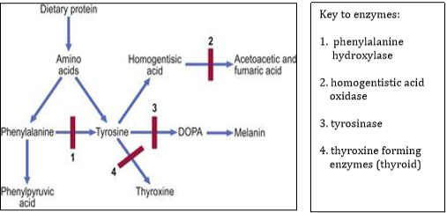  Phenylalanine (PKU) is a condition that affects approximately 1 in 1000 newborn infants. If left untreated it can lead to loss of skin pigment, fits and slowed mental development.  Explain how PKU is caused and how it can be treated.  ______________________________________________________________  ______________________________________________________________  ______________________________________________________________  ______________________________________________________________  ______________________________________________________________  ______________________________________________________________  ______________________________________________________________  ______________________________________________________________  ______________________________________________________________  ______________________________________________________________  ______________________________________________________________  ______________________________________________________________  ______________________________________________________________  ______________________________________________________________ |  | Skill Level 3  1  0  NR
4 | Define sex linkage.  ______________________________________________________________  ______________________________________________________________  ______________________________________________________________ |  | Skill Level 1  1  0  NR
5 | Describe the difference between sex linkage and genetic linkage.  ______________________________________________________________  ______________________________________________________________  ______________________________________________________________  ______________________________________________________________  ______________________________________________________________  ______________________________________________________________ |  | Skill Level 2  2  1  0  NR
6 | Describe the process of inheritance of colour blindness in humans as an example of sex linkage.  ______________________________________________________________  ______________________________________________________________  ______________________________________________________________  ______________________________________________________________  ______________________________________________________________  ______________________________________________________________  ______________________________________________________________ |  | Skill Level 2  2  1  0  NR
7 | Explain using a punnet square the process of inheritance of colour blindness.  ______________________________________________________________  ______________________________________________________________  ______________________________________________________________  ______________________________________________________________  ______________________________________________________________  ______________________________________________________________  ______________________________________________________________  ______________________________________________________________  ______________________________________________________________  ______________________________________________________________  ______________________________________________________________  ______________________________________________________________ |  | Skill Level 3  3  2  1  0  NR
8 | Discuss using examples the complications associated with the inheritance of haemophilia.  ______________________________________________________________  ______________________________________________________________  ______________________________________________________________  ______________________________________________________________  ______________________________________________________________  ______________________________________________________________  ______________________________________________________________  ______________________________________________________________  ______________________________________________________________  ______________________________________________________________  ______________________________________________________________  ______________________________________________________________  ______________________________________________________________  ______________________________________________________________  ______________________________________________________________  ______________________________________________________________  ______________________________________________________________  ______________________________________________________________  ______________________________________________________________  ______________________________________________________________  ______________________________________________________________  ______________________________________________________________  ______________________________________________________________  ______________________________________________________________  ______________________________________________________________  ______________________________________________________________ |  | Skill Level 4  4  3  2  1  0  NR

