Year 13 Biology Home Test 5 – 2020 (Time allowed: 1 hour)

Name:_________________________________________________________________

 |  | Assessor’s use only
1a | The diagram below summarises one stage in the process of protein synthesis. (SPFSC 2019, 2.2 p7; SPFSC 2017, 2.2a p7)  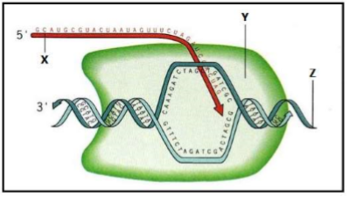  Define protein synthesis.  ______________________________________________________________ |  | Skill Level 1  1  0  NR
1b | Identify the letter that represents the mRNA strand in the diagram above  ______________________________________________________________  ______________________________________________________________ |  | Skill Level 1  1  0  NR
1c | State one function of mRNA.  ______________________________________________________________  ______________________________________________________________  ______________________________________________________________  ______________________________________________________________ |  | Skill Level 1  1  0  NR
2 | The genetic code defines a mapping between tri-nucleotide sequences called codons and amino acids; every triplet of nucleotides in a nucleic acid sequence specifies a single amino acid. (SPFSC 2019, 2.3 p7)  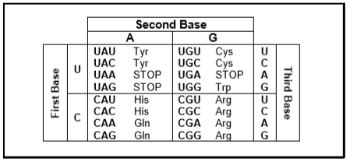  Using an example from the diagram, describe the use of the genetic code (codon dictionary) to identify an amino acid of your choice.  ______________________________________________________________  ______________________________________________________________  ______________________________________________________________  ______________________________________________________________ |  | Skill Level 2  2  1  0  NR
5a | There are two main stages in protein synthesis – transcription and translation.  (SPFSC 2018, 2.3 p8)  Define transcription.  ______________________________________________________________  ______________________________________________________________  ______________________________________________________________ |  | Skill Level 1  1  0  NR
5b | The bases on mRNA are called codons. Define the term codon.  ______________________________________________________________  ______________________________________________________________  ______________________________________________________________ |  | Skill Level 1  1  0  NR
5c | tRNA is found in the cytoplasm of a cell. State the role of tRNA in protein synthesis.  ______________________________________________________________  ______________________________________________________________  ______________________________________________________________ |  | Skill Level 1  1  0  NR
5d | State the term for the three bases attached to the end of a tRNA molecule.  ______________________________________________________________ |  | Skill Level 1  1  0  NR
6 | Explain the relationships between transcription and translation in protein synthesis. (SPFSC 2017, 2.2b p8)  In your answer you should consider:  - where each process occurs;  - the roles of nucleic acids – DNA, mRNA, tRNA;  - what is involved in each process;  - products from each process.  ______________________________________________________________  ______________________________________________________________  ______________________________________________________________  ______________________________________________________________  ______________________________________________________________  ______________________________________________________________  ______________________________________________________________  ______________________________________________________________  ______________________________________________________________  ______________________________________________________________  ______________________________________________________________  ______________________________________________________________  ______________________________________________________________  ______________________________________________________________ |  | Skill Level 3  3  2  1  0  NR
7a | Every day, we come into contact with many poisonous substances, which include industrial and household chemicals. The skin acts as a barrier and prevents many of these substances entering and harming the body.  The skin is one of the largest organs in the body, composed of several layers of 5 tissues. The outer layers consists of dead cells packed with keratins.  Keratins are a group of proteins that differ from each other in their primary structure. Each keratin molecule consists of several polypeptide chains, each individual chain wound into a spiral or helix. The polypeptide chains include many sulphur-containing amino acids and these help to give the keratin molecules their characteristic strength. (SPFSC 2018, 2.2 p7)  Use the evidences from the passage to describe the quaternary structure of the keratin molecule.  ______________________________________________________________  ______________________________________________________________  ______________________________________________________________  ______________________________________________________________  ______________________________________________________________  ______________________________________________________________  ______________________________________________________________  ______________________________________________________________  ______________________________________________________________  ______________________________________________________________  ______________________________________________________________ |  | Skill Level 2  2  1  0  NR
7b | Explain how sulphur-containing amino acids help to give keratin molecules their characteristic strength.  ______________________________________________________________  ______________________________________________________________  ______________________________________________________________  ______________________________________________________________  ______________________________________________________________  ______________________________________________________________  ______________________________________________________________  ______________________________________________________________  ______________________________________________________________  ______________________________________________________________  ______________________________________________________________ |  | Skill Level 3  3  2  1  0  NR

