Emma Jedrick
cENTRAL SECONDARY SCHOOL
CENTRAL SECONDARAY SCHOOL
YEAR 11 EARTH SCIENCE HOME SCHOOL WORKPLAN _8 WEEKS ( TERM I. 9-13) ( TERM 2. 1-3)

WEEK | STRAND | SLO | Activity
9 | Sub- Strand1.3  Earth Realms and their Interaction | -Define lithosphere.  -Define hydrosphere.  -Define atmosphere.  -Define biosphere.  -Describe exchanges between the lithosphere, hydrosphere, atmosphere and biosphere.  -Explain why carbon is considered the basic chemical element in the biosphere.  -Compare these reservoirs: atmosphere, hydrosphere, biosphere and lithosphere in terms of carbon content.  -Discuss the mechanisms of carbon transfer between the different reservoirs. | Activity 1.3.1,  Pg. 11
10 | Sub-Strand 1.4  Internal Structure of the earth | -Define shear (S) waves.  -Define compressional (P) waves.  -Identify the properties of different types of seismic waves.  -Describe the characteristics of S waves.  -Describe the characteristics of P waves.  -Interpret the characteristics of seismic waves in the study of terrestrial layers.  -Explain that the concentric layers of the earth—the crust (oceanic and continental), mantle and core—differ in thickness, mass and volume.  -Differentiate between the lithosphere and the underlying asthenosphere by its rigidity  -Discuss the Earth’s structure resulting partly from its accretion from small bodies of which chondrite meteorites are relics and partly from the process of differentiation | Activity1.4.1,  Pg. 12  Activity 1.4.2  Pg.19
STRAND 2 Climate change and Disaster Risk Reduction
11 | Sub-Strand 2.1  Earth Realm in Peril | -Define the stratospheric ozone.  -Define the lower atmospheric ozone.  -Illustrate the stratospheric ozone.  -Locate the stratospheric ozone on the given illustration.  -Illustrate the lower atmospheric ozone.  -Locate the lower atmospheric ozone on the given illustration.  -List the causes of the ozone layer destruction.  -List some sources of CFCs in the home.  -List some sources of CFCs in factories.  -State countries that produce the most chlorofluorocarbons (CFCs).  -Compare summer and winter smog.  -Explain the relationship between ultraviolet radiation and health.  -Discuss the impact of exposure to UV radiation on health and well-being of a certain population, using specific examples | Activity2.1.1  Pg.23
12 | Sub-Strand 2.2  Climate Changes Issues | -Define climate.  -Define weather.  -Identify factors causing climatic change. 1 -Differentiate between climate and weather (meteorology).  -Compare the time periods over which climatic changes have occurred.  -Analyse climatic changes during historical times.  -Distinguish between climate change and climate variability.  -Demonstrate how climate variability in Vanuatu is influenced by ENSO.  -Discuss social, cultural, economic and demographic consequences of climate change.  -Discuss how these may be mitigated.  -Predict causes of climate change. | Activity 2.2.1  Pg.25
13 | Sub Strand 2.3  Mitigation of Climate Change. | -Define anthropogenic climate change.  -Define mitigation of greenhouse gas emissions.  -Define adaptation to climate change.  -Explain ways in which greenhouses gases enter the atmosphere and cause global warming.  -Explain the relationship between global warming and climate change.  -Explain the difference between the mitigation of greenhouse gas emissions and adaptation to climate change.  -Describe measures for mitigating the anthropogenic emissions of greenhouse gases.  -Point out measures taken for the protection of the ozone layer.  -Define a carbon sink.  -Describe the role of carbon sinks.  -Prepare on the basis of given data, an action plan that will enable each individual to combat global warming.  -Prepare on the basis of given data, an action plan that will enable each individual to adapt to global warming. | Activity 2.3.1  Pg.29, 30
2 weeks Holiday.
TERM 2

Week 1 &2 | Sub Strand 2.4  Disaster Risk | - Define a risk.  -Define a disaster.  -Describe disaster “risks” associated with different disasters.  -State the features of “vulnerability.”  -Explain the potential impacts of disaster risks which threaten local communities.  -Indicate/List the frequent small scale disaster and other types of disasters that affect Vanuatu.  -Classify the potential impacts of disaster risks on vulnerable populations into various categories (e.g. impact on human lives, health, population/ demography, means of subsistence/ livelihoods/ agriculture, economy).  -Discuss the potential impacts of disaster risks on vulnerable populations (e.g. impact on human lives, health, population/ demography, means of subsistence/ livelihoods/ agriculture, economy). | Activity 2.4.1  Pg.34
Week 3 | Review and completion of in complete activities.

STRAND 1: PLANET EARTH, ITS GEOLOGY AND IT’S EXTERNAL AND INTERNAL MOVEMENTS.
Sub- strand 1.3 Earth Realms and their Interactions.
SLO 1.3.1.1 – 1.3.4.1

Environment and its Major components
Environment
The sum total of all surroundings of a living organism, including natural forces and other living things, which provide conditions for development and growth as well as of danger and damage. A person’s environment is made up of everything that surrounds him or her. It encompasses all living and non-living things occurring naturally on Earth or some region thereof.
At the very fundamental level, the planet Earth is our environment.

Major components of the environment
The environment may broadly be considered to comprise the following five segments:
(1) Lithosphere, (2) Hydrosphere, (3) Atmosphere, (4) Biosphere,.

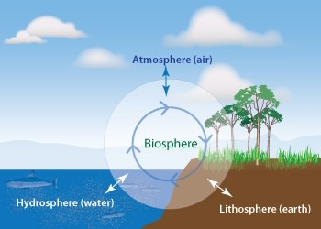
Lithosphere is the outermost layer of earth called crust, which is made of different minerals. Its depth can reach up to 100 kilometers and is found on both land (terrestrial crust) and oceans (oceanic crust). The main component of lithosphere is earth’s tectonic plates.
Hydrosphere comprises of all forms of water bodies on earth including oceans, seas, rivers, lakes, ponds, streams etc. It covers 70% of earth’s surface. 97.5% of water found on Earth is in the oceans in the form of salt water. Only 2.5 % of water on Earth is fresh water. Out of this, 30.8% is available in rivers, reservoirs and lakes and is easily accessible to man.
Atmosphere is gaseous layer enveloping the Earth. The atmosphere with oxygen in abundance is unique to Earth and sustains life. It mainly comprises 78.08% nitrogen, 20.95% oxygen, 0.93% argon, 0.038% carbon dioxide, and traces of hydrogen, helium, and noble gases. The amount of water vapor present is variable.
Biosphere refers to all the regions on Earth where life exists. The ecosystems that support life could be in soil, air, water or land. The term Biosphere was coined by Geologist Edward Suess who used this term for place on Earth where life can be found. Biosphere refers to the sum total of all life all living matter, the biomass or biota. It extends from the polar ice caps to the equator, with each region harboring some life form suitable to the conditions there.

Overlap between the spheres.
The present atmosphere would not exist without the biosphere. In order to put oxygen into the air, there had to be plants, which take in carbon dioxide and release oxygen in the process of photosynthesis. As plant life evolved, eventually it put more and more oxygen into the atmosphere, until the air became breathable for animal life. Thus, the atmosphere and biosphere have sustained one another.
Such overlap is typical and indeed inevitable where the open earth subsystems are concerned, and examples of this overlap are everywhere. For instance, plants (biosphere) grow in the ground (lithosphere), but to survive they absorb water (hydrosphere) and carbon dioxide (atmosphere). Nor are plants merely absorbing: they also give back oxygen to the atmosphere, and by providing nutrition to animals, they contribute to the biosphere. At the same time, the many components of the picture just described are involved in complex biogeochemical cycles, which we look at later.

Whycarbon is considered the basic chemical element in the biosphere.
Carbon is the fourth most abundant element in the universe and is the building block of life on earth. On earth, carbon circulates through the land, ocean, and atmosphere, creating what is known as the Carbon Cycle.
This global carbon cycle can be divided further into two separate cycles:
-the geological carbon cycles takes place over millions of years, whereas
-the biological or physical carbon cycle takes place from days to thousands of years.
In a nonliving environment, carbon can exist as carbon dioxide (CO₂), carbonate rocks, coal, petroleum, natural gas, and dead organic matter. Plants and algae convert carbon dioxide to organic matter through the process of photosynthesis, the energy of light.
Fig 1 The Carbon Cycle.
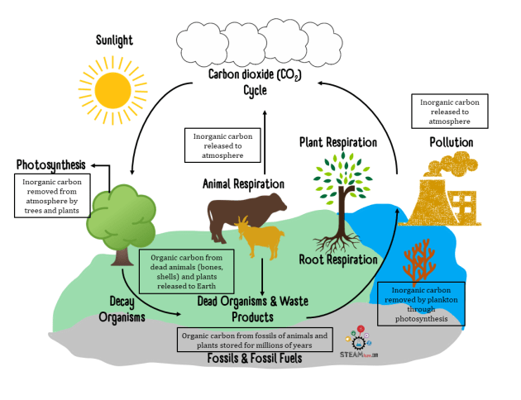
The carbon cycle describes the way the element carbon moves between the Earth's biosphere, hydrosphere, atmosphere, and geosphere/lithosphere or how carbon is recycled between the atmosphere, plants and animals.
- Plants absorb carbon dioxide during photosynthesis to produce food.
- Animals eat plants and pass the carbon compounds down the food chain.
- Animals breathe out carbon dioxide back into the air.
- When plants and animals die, they decompose and carbon dioxide is again returned to the air.

The carbon cycle is important for a few reasons:
1. Carbon is an essential element for all life, it is the fourth most abundant element in the universe after hydrogen, helium, and oxygen.Every living organism needs carbon to sustain itself – about 18% of mass in our bodies is carbon.So understanding how it moves helps us to understand biological processes and factors that influence them.
2. One form carbon takes is the greenhouse gas carbon dioxide, CO₂. Increased levels of carbon dioxide insulate the Earth, causing temperatures to rise. Understanding how carbon dioxide is absorbed and released helps us understand the climate and predict global warming.
3. Carbon is not in balance, so it's important to learn where it is being stored and released. The rate at which carbon is deposited into living organisms is not the same as the rate it is returned to the Earth. There is about 100x more carbon in living matter than in the Earth. Burning fossil fuels releases massive amounts of carbon into the atmosphere and to the Earth.
4. The carbon cycle is connected to the availability of all other elements and compounds in the 4 spheres. For example, the carbon cycle is tied to the availability of oxygen in the atmosphere. During photosynthesis, plants take carbon dioxide from the air and used it to make glucose (stored carbon), while releasing oxygen.

How does carbon get into living things?

Plants take in CO₂. They keep the carbon and give away the oxygen. Animals breathe in the oxygen and breathe out carbon dioxide.

Plants and animals depend on each other. It works out well. For hundreds of millions of years, plants and animals have lived and died. Their remains have gotten buried deep beneath Earth's surface. So for hundreds of millions of years, this material has been getting squished and cooked by lots of pressure and heat.
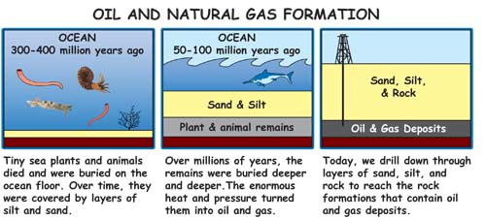
For hundreds of millions of years, dead plants and animals were buried under water and dirt. Heat and pressure turned the dead plants and animals into oil, coal, and natural gas.
So what happens to all this dead plant and animal stuff? It turns into what we call fossil fuels: oil, coal, and natural gas. This is the stuff we now use to energize our world. We burn these carbon-rich materials in cars, trucks, planes, trains, power plants, heaters, speed boats, barbecues, and many other things that require energy.

Fig.2 carbon content in each of the spheres/ reservoirs.
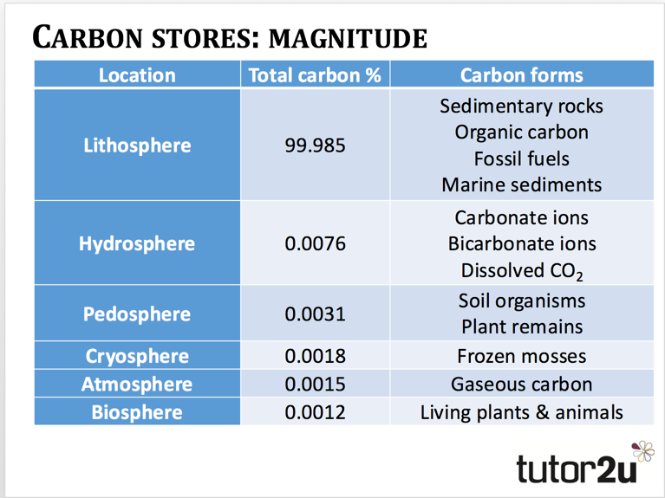
1. Carbon is found in the atmosphere mostly as carbon dioxide. Animal and plant respiration place carbon into the atmosphere. When you exhale, you are placing carbon dioxide into the atmosphere
2. Carbon is found in the lithosphere in the form of carbonate rocks. Carbonate rocks came from ancient marine plankton that sunk to the bottom of the ocean hundreds of millions of years ago that were then exposed to heat and pressure. Carbon is also found in fossil fuels, such as petroleum (crude oil), coal, and natural gas. Carbon is also found in soil from dead and decaying animals and animal waste.
3. Carbon is found in the biosphere stored in plants and trees. Plants use carbon dioxide from the atmosphere to make the building blocks of food during photosynthesis.
4. Carbon is found in the hydrosphere dissolved in ocean water and lakes. Carbon is used by many organisms to produce shells. Marine plants use carbon for photosynthesis. The organic matter that is produced becomes food in the aquatic ecosystem.
ACTIVITY 1.3.1
1. Give brief definition to the following:
-lithosphere
-hydrosphere
-Biosphere
-Atmosphere.
2. In your own words describe the exchange or the relationship between the four spheres.
3. Explain why carbon is considered the basic chemical element in the biosphere.
4. Discuss the mechanism of carbon transfer between the different reservoirs.

SUB STRAND1.4: INTERNAL STRUCTURE OF THEY EARTH
SLO: 1.4.1.1- 1,4,4,1
The different layers of the earth/ earth’s structure
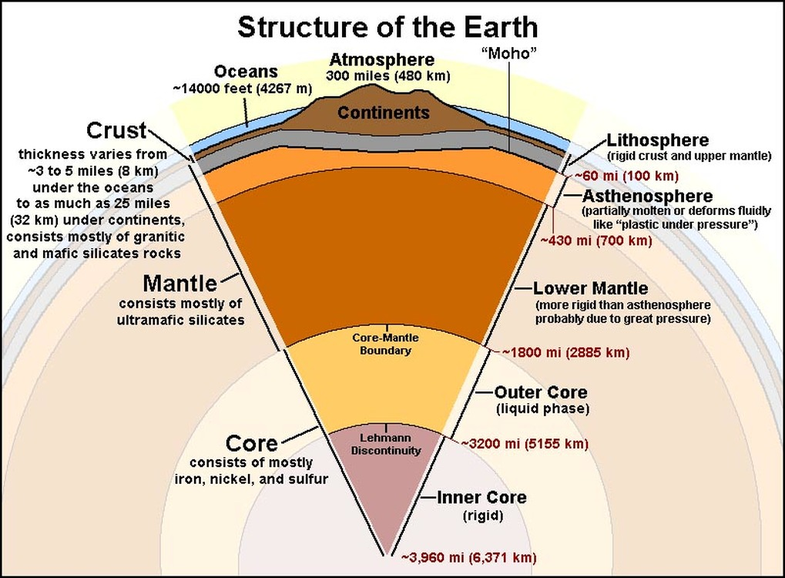
ACTIVITY 1.4.1
Study the above diagram and do additional research to answer the following questions
1. Describe the different layers of the earth in term so their thickness and composition
2. Differentiate between the lithosphere and the underlying asthenosphere by its rigidity.
3. Discuss the earths structure resulting partly from its accretion from small bodies of which chondrite meteorites are relics and partly from the process of differentiation.( Do not answer this question..leave enough space -to be discussed in class)
EARTHQUAKES
Earthquakes are vibrations in the Earth's crust that cause shaking at the surface. They are highly unpredictable and often occur suddenly without warning. As yet, we have no way of fully and accurately predicting when an earthquake will occur.
Reasons for Earthquakes happening
Earthquakes occur because stresses build up between the plates as one plate passes another. As the plates move past one another they don't do so smoothly, rather, they snag and grind, allowing energy to build up. When the plates eventually move again this energy is released as shock or seismic waves through the Earth's crust.
The point at which this slippage occurs is called the FOCUS, whilst the point on the ground surface above the earthquake FOCUS is called the EPICENTRE. Seismic shock waves will emanate radially outwards from these points and their energy will reduce with distance.
This is typical of destructive margins (which account for 90% of the World's earthquakes) where the Oceanic plate grinds under a Continental plate (as on the East coast of Japan -see Kobe case study).
They also occur at conservative margins, such as the San Andreas Fault line, where the North American plate and Pacific plate are grinding past one another.
Earthquakes can also occur at constructive plate margins. Here, the earthquake is the result of magmas forcing its way between the plates, causing the earth to tremble. Collision margins, where continental crust meets continental crust, can also have earthquakes as a result of the pressures generated by collision.

Features of an earthquake
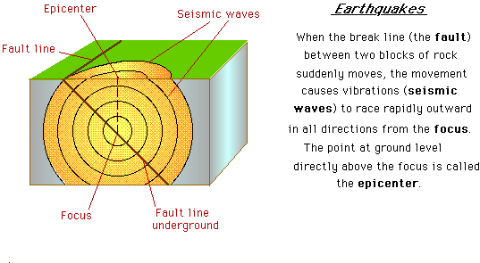

Characteristics/Properties of seismic waves
- The composition of the rocks, such as incompressibility, rigidity, and density, affects the speed at which the waves travel and the shape and duration of the wave train.
- The layering of the rocks and the physical properties of surface soil also affect wave characteristics
- Temperature tends to lower the speed of seismic waves
- Pressure tends to increase the speed.Pressure increases with depth in Earth because the weight of the rocks above gets larger with increasing depth
You should keep in mind that the specific speed throughout Earth will depend on composition, temperature, and pressure.
Types of Seismic waves

Body wave
A body wave is a seismic wave that moves through the interior of the earth, as opposed to surface waves that travel near the earth's surface. P and S waves are body waves. Each type of wave shakes the ground in different ways.

P-waves
The first type of body wave is called the primary wave or pressure wave, and is commonly referred to as P-waves. This type of seismic body wave travels at the greatest velocity through the ground. As a longitudinal compressional waveform, P-waves move in the same way as sound waves. As they spread out, they alternately push (compress) and pull (expand) the ground as they move through it.
P-waves are able to travel through both solid rock and liquid material, such as volcanic magma or oceans. They travel at velocities ranging from 1,600–8,000 m/s, depending on the material they’re moving through. Because of their speed, they are the first type of wave to be felt and to register on a seismograph during an earthquake.
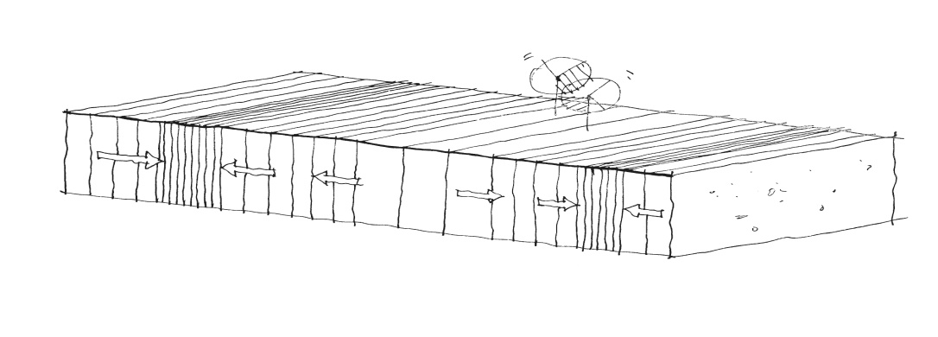

S-waves
The second type of body wave is called the secondary wave, shears wave or shaking wave, and is commonly referred to as S-waves. S-waves are a transverse waveform that shears the ground sideways at right angles to the direction of travel.
S-waves have different effects on the ground surface depending on their polarisation and direction of travel. Horizontally polarised S-waves will move the ground from side to side (left and right) relative to the direction they’re moving. Vertically polarised S-waves will move the ground up and down relative to the direction of travel. It is not possible to shear or twist a liquid, so S-waves cannot propagate through bodies of water, such as oceans and lakes.
S-waves are typically 40 percent slower than P-waves in any given material and have velocities ranging from approximately 900–4,500 m/s. These waves are the second to register on a seismograph during an earthquake. Despite their slower speed, S-waves are often more destructive than P-waves because they can have larger amplitudes and can cause greater levels of ground shaking. They are also called TRANSVERSE waves and are known to cause the most damage.

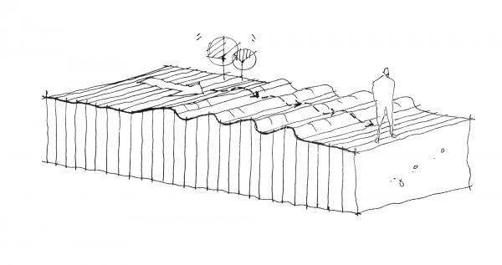
SURFACE WAVES – L waves –Love waves and Rayleigh waves travel along the surface only
Surface wave
A surface wave is a seismic seismic wave that is trapped near the surface of the earth.

Surface waves are typically generated when the source of the earthquake is close to the Earth’s surface. As their name suggests, surface waves travel just below the surface of the ground. Although they move even more slowly than S-waves, they can be much larger in amplitude and are often the most destructive type of seismic wave. There are several types of surface wave, but the two most common varieties are Rayleigh waves and Love waves.

Rayleigh waves
Rayleigh waves, also known as ground roll, spread through the ground as ripples, similar to rolling waves on the ocean. Like rolling ocean waves, Rayleigh waves move both vertically and horizontally in a vertical plane pointed in the direction in which the waves are travelling.
Eyewitnesses have claimed to observe Rayleigh waves in large open spaces, such as car parks, where they described the vehicles moving up and down like corks floating on the ocean.
Rayleigh waves are slower than body waves and typically travel at a speed that is 10% slower than S-waves.
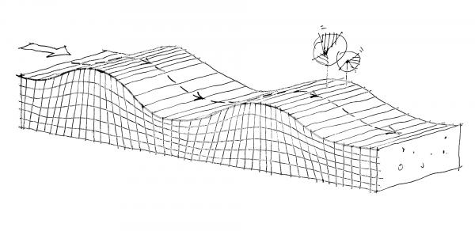

Love waves
Love waves have the same motion as S-waves but without the vertical displacement. They move the ground from side to side in a horizontal plane but at right angles to the direction of propagation. Love waves are particularly damaging to the foundations of structures because of the horizontal ground motion they generate. Love waves can also cause horizontal shearing of the ground. They usually travel slightly faster than Rayleigh waves, at a speed that is usually about 10% slower than S-waves, but like S-waves, they cannot spread through water.
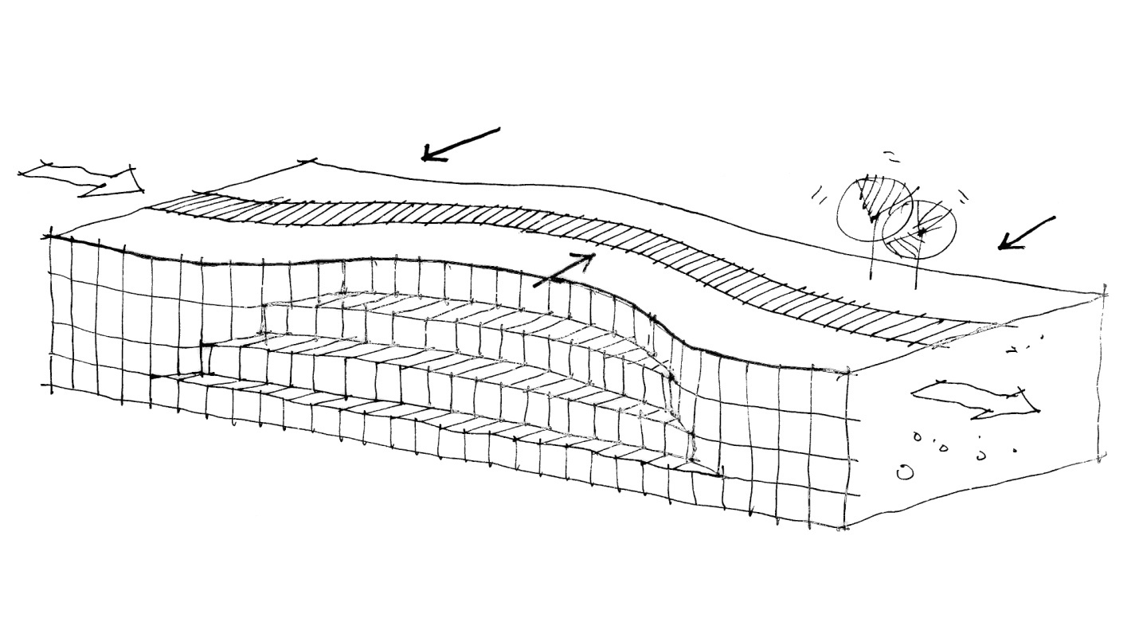How Earthquakes are measured
Earthquakes can be measured using 2 scales -the Richter scale or the Mercalli scale. The Mercalli scale measures the effects of the earthquake and runs from 1 to 12. The higher up the scale the more damage is experienced by people and building structures. The Richter scale is different in that it measures the energy of an earthquake. The scale is logarithmic, which means that for every jump up the scale you get a tenfold increase in power of an earthquake. Therefore a magnitude 6 is 10 times more powerful than a magnitude 5, and 100 times more powerfulthan a magnitude 4. The higher the magnitude of an earthquake the less frequent it’s occurrence. The largest ever recorded was in Valvidia in Chile in 1960 and recorded 9.5 on the scale.
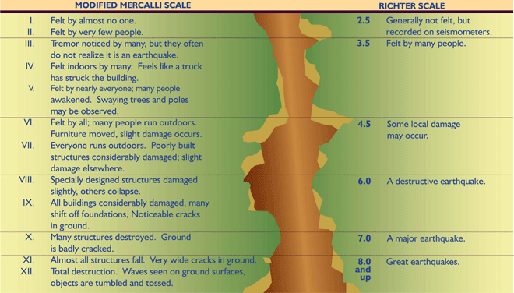
Activity.1.4.2
Answer the following questions based on your above notes.
1. Define the following words:
-earthquake
-Shear (S) waves
-Compressional (P) waves
2. State two characteristics of the S and P waves.
3. What affects the movement or the speed of the seismic wave through the earth?

STRAND 2: CLIMATE CHANGE AND DISASTER RISK REDUCTION
Sub-Strand 2.1 Earth Realms in Peril
SLO: 2.1.1.1 – 2.4.1.1
THE DIFFERENT LAYERS OF THE ATMOSPHERE
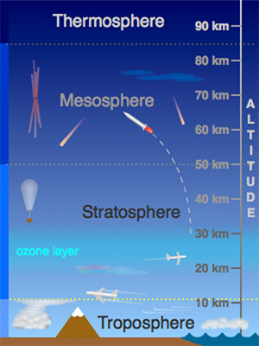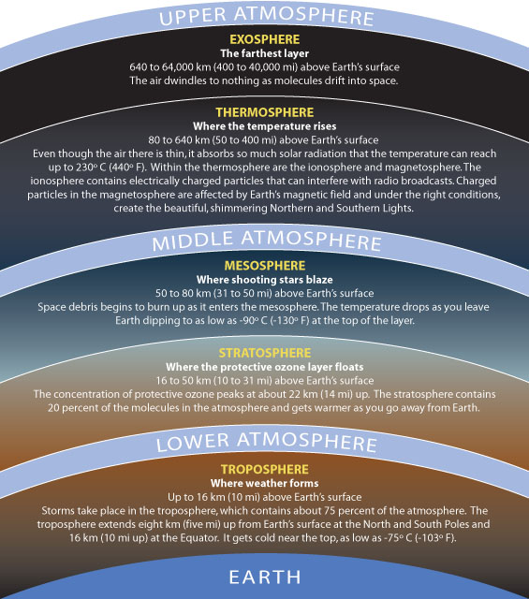

Troposphere
This is the part of the atmosphere where we live and is closest to the surface of the Earth. The troposphere contains about 75% of the air found in the atmosphere and nearly all the water vapor. Most of the weather will be contained within the troposphere, including the wind, rain, snow, and other precipitation. The pressure also decreases rapidly upon reaching the top of the troposphere which causes the air to expand.
The lowest part of the troposphere is called the boundary layer where the motion of the air is affected by the surface features of the Earth. The tropopause is the top area of the troposphere and encounters the stratosphere.
Stratosphere

The stratosphere is the area that extends about 50km above the troposphere. Here, the air that is present is warmer compared to the top of the troposphere because of heating by the ultraviolet (UV) light from the sun. You’ll find most of the ozone layer in the stratosphere as well which absorbs or deflects most of the UV light away from the Earth.

Mesosphere
This layer is directly above the stratosphere and the temperatures decrease because of the lack of air to heat. In fact, temperatures plummet to about 194F degrees in the mesosphere as it reaches the thermosphere. Located 80km above the stratosphere

Thermosphere or Ionosphere
The layer rests above the mesosphere and the temperatures begin to rise again because of the combination of UV light and x-ray radiation that emanates from the sun. This layer of the atmosphere extends about 80-500km above the mesosphere and is also called the ionosphere because the solar radiation is so intense, it separates the electrons from atoms which creates ions that are positively charged.
Because the ionosphere can absorb and reflect radio waves, it is possible to hear shortwave radio transmissions from other parts of the world. This is because the radio waves will bounce off the ionosphere and reach places that are not in a direct line of sight.

Exosphere
Located about beyond 500km above the surface of the Earth is the exosphere. While there are atoms of oxygen and hydrogen present, they are so few that they rarely meet. Instead, many of these atoms will either plunge deeper into the atmosphere or hurtle off into space.

The Ozone layer depletion

What is the ozone layer?
The ozone layer is a deep layer in the stratosphere, encircling the Earth, that has large amounts of ozone in it. The layer shields the entire Earth from much of the harmful ultraviolet radiation that comes from the sun because it absorbs them. This ultraviolet light from the sun (and sun lamps) has several harmful effects.
- It is particularly effective at damaging DNA.
- It is a cause of melanoma and other types of skin cancer.
- It has also been linked to damage to some materials, crops, and marine organisms.
The ozone layer protects the Earth against most UVB coming from the sun
It is always important to protect oneself against UVB, even in the absence of ozone depletion, by wearing hats, sunglasses, and sunscreen. However, these precautions will become more important as ozone depletion worsens.
What causes the depletion of the ozone?
The ozone layer is getting thinner. Chemicals called chlorofluorocarbons (CFCs) are a reason we have a thinning ozone layer. A chlorofluorocarbon (CFC) is a molecule that contains the elements carbon, chlorine, and fluorine. CFCs are everywhere, mostly in refrigerants and plastic products. Businesses and consumers use them because they're inexpensive, they don't catch fire easily, and they don't usually poison living things. But the CFCs start eating away at the ozone layer once they get blown into the stratosphere.
Ozone molecules, which are simply made of three joined oxygen atoms, are always being destroyed and reformed naturally. But CFCs in the air make it very difficult for ozone to reform once it’s broken apart. The ozone layer, which only makes up 0.00006 percent of Earth’s atmosphere, is getting thinner and thinner all the time.
“Ozone holes” are popular names for areas of damage to the ozone layer. This is inaccurate. Ozone layer damage is more like a really thin patch than a hole. The ozone layer is thinnest near the poles.

Activity 2.1.1.
1. Label correctly the layers of the atmosphere.
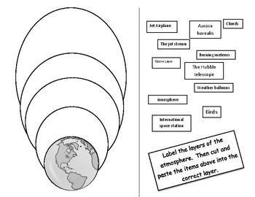
2. List some examples of CFCs in -:
- Your house
- In factories.
3. State countries that produce the most CFCs ( do your own research)
4. Explain the relationship between the ultraviolet radiation and health.
5. Discuss the impact of exposure to UV radiation on health and well-being of a certain population using specific examples. (Do not answer this question, to be discussed in class)
Which season releases more pollutants into the air, summer or winter? Why?

SUB STRAND 2.2: CLIMATE CHANGE ISSUES.
SLO 2.2.1.1- 2.2.4.3
Introduction to Climate change
Climate
This describes the total of all weather occurring over a period of years in a given place. It is the average weather condition of that place. Climate tells us what it’s usually like in the place where you live.
For example, some countries like Cameroon, Ghana and Liberia are all in the tropical wet region of Africa. They have a very sunny, hot and wet climate all year round. However, there may be very different day-to-day weather conditions in each village or town in these countries.
Weather
Weather is all around us. Weather may be one of the first things you notice when you wake up. Weather describes whatever is happening outdoors in a given place at a given time. It can change a lot within a very short time. For example, It can be windy at night, rainy in the morning, hot and sunny at noontime, and even back to windy before sunset. It includes daily changes in rainfall, temperature and wind in a given location.
Scientists have warned that the world's climate has changed a lot, and has affected many living and non-living things.
Many places that were warmer are now getting colder, and many colder regions are getting much colder or even warmer (know as Global Warming).
For example, between 1901 and 2012, it is believed that the earth's temperature has risen by 0.89 °C. Rainfall amounts have also risen in the mid-latitudes of the northern hemisphere since the beginning of the 20th Century. It is also believed that sea levels have risen up to about 19cm globally, with lots of glaciers melting in addition.
Some people do not believe that these are caused by human activities. They think it is all political and falsehood intended to cause panic among humans.
Climate change refers to general changes in climate patterns, including temperature, precipitation, winds, and other factors.
Global warming (as well as global cooling) refers specifically to any change in the global average surface temperature. Do not confuse the two.
Climate change is a change of the composition of global atmosphere, observed over a period of time, and in comparison to other time periods, as a direct or indirect result of human activity.
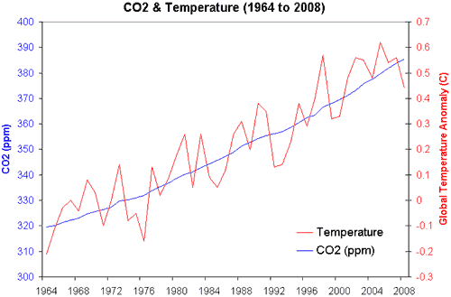
ACTIVITY 2.2.1
Study the graph above and answer the following questions.
1.Compare the time periods over which climate changes have occur by comparing the amount of CO2 over the years.
2. Explain why during the years 1964 -1972 temperature and CO2 was very low.
3. Explain how temperature and CO2 are impacted by each other.
4. Explain in your own words and from your knowledge of the green house effect what causes climate change.
What is climate Variability and climate change
Climate Variability
While the climate tends to change quite slowly, that doesn't mean we don't experience shorter-term fluctuations on seasonal or multi-seasonal time scales. There are many things that can cause temperature, for example, to fluctuate around the average without causing the long-term average itself to change. This phenomenon is climate variability, and when scientists talk about it they are usually referring to time periods ranging from months to as many as 30 years.
For the most part, when discussing climate variability, we're describing natural (that is, non-man-made) processes that affect the atmosphere.For example, the El Niño Southern Oscillation (ENSO) phenomenon near the equatorial Pacific Ocean, where fluctuations of sea surface temperatures typically alternate every few years between a warming phase (El Niño) and cooling periods (La Niña), with a neutral phase in between. Many researchers have found that negative ENSO years are correlated with ahigher probability of Atlantic hurricane formation, as well as warmer, dryer weather in northern states.ENSO is the most important driver of year to year variability in the region.
Climate Change
Alterations to the earth's atmosphere that occur over much longer periods—decades to millennia—are characterized as "climate change."

While climate change can be caused by natural processes—such as volcanic activity, solar variability, plate tectonics, or shifts in the Earth's orbit—we are usually referring to changes attributable to human activity when talking about climate change, such as increased greenhouse gas emissions.

The latest (Fifth) Assessment Report from the Intergovernmental Panel on Climate Change (IPCC 2013), for example, found that on average global temperatures increased about 0.85°C from 1880 to 2012, and concluded that more than half of the observed increase in global average temperatures was caused by elevated emissions of carbon dioxide and other greenhouse gases.

Researches have shown that while the overall number of tropical cyclones is likely to decrease, the most intense storms (Categories 4 and 5) are likely to increase in frequency and become even more intense.

What we can do
The climate threat is real, but so are the exciting possibilities to find new and creative approaches to living together with health and prosperity within the limits of the natural world. We need to demand and support collective climate action in our communities, cities, provinces, and Canada as a whole.
Climate change is a large-scale problem, but it’s also a direct result of our collective choices and actions. That means that we can make a difference.
ACTIVITY .2.2.2
Answer the following question based on your above notes.
- Distinguish between climate variability and climate change.
- Discuss causes of climate change.

SUB- STRAND 2.3: MITIGATION OF CLIMATE CHANGE.
SLO: 2.3.1.1 – 2.3.2.2
What is anthropogenic climate change?
Climate change is any change occurring to the planet's climate either permanently or lasting for long periods of time. It is the cumulative total of two related sources: anthropogenic climate change and natural climate change. Anthropogenic climate change is defined by the human impact on Earth's climate while natural climate change are the natural climate cycles that have been and continue to occur throughout Earth's history

Natural Climate Change
Earth’s climate has always been driven by the amount of incoming and outgoing energy. Without the influence of humans, the Earth has natural cycles that drive the climate.
The major factors contributing to Earth’s natural climate change are determined by the: [Axial tilt|Earth's orbit around the sun],the output of energy from our sun, the ocean’s natural cooling and warming cycles and the constant variability in volcanic activity.
Another factor to consider are the glacial advances and retreats that occur throughout Earth’s history. In the last 650,000 years, there have been around seven ice ages, the most recent ending around 12,000 years ago.^{[2]} Since then, the Earth has experienced a glacial advance known as the little ice age, which occurred from the 16th century through to the 19th century.
However, earth is still in the natural warming process from this glacial advance and many climate change deniers erroneously claim that this is the cause for the current dramatic climate changes. Although natural climate factors have some effect on the current global warming, they are not as drowned out by the human induced factors.

Anthropogenic Climate Change
Human induced climate change is directly linked to the amount of fossil fuels burned, aerosol releases and land alteration from agriculture and deforestation.^{[1]} The beginning of the Industrial Revolution shows a major spike in temperature levels and climate influences. The product of fossil fuel burning is the emission of a greenhouse gas: carbon dioxide which traps heat. Climate change is generally associated with global warming; however some small areas like the tropical Pacific show that the release of aerosols into the atmosphere the area has actually cooled (or at least warmed much slower than the rest of the world).^{[3]}
Some noticeable evidence occurring from anthropogenic climate change is the overall sea level rise, temperature rise, melting ice sheets and glaciers, increased extreme events such as hurricanes getting stronger and ocean acidification. The oceans naturally rise as glaciers and snow covers melt, however compared to the last century, the rate of rise in the last decade is approaching twice as much.

.Mitigation
The most important thing we can do to prevent climate change from getting worse is to reduce greenhouse gas emissions. Cutting back on emissions will demand a wide range of approaches, ranging from replacing fossil fuels with renewable energy, to rethinking how we plan and build, to figuring out how to be more productive with fewer resources.
We can all support the transition to a low-carbon energy economy by welcoming and insisting on using renewable sources of energy wherever possible, reducing our collective reliance on the high-carbon fuels that pose such a serious threat.
Canada’s national and regional carbon pricing plans are one possible approach to help us make this transition. An effective carbon tax can help wean us off fossil fuels and at the same time raise money to invest in much-needed low-carbon technologies and ideas.
Climate change mitigation can be defined as action to decrease the intensity of radiative forcing in order to reduce the warming of the planet. ... Most often, climate change mitigation scenarios involve reductions in the concentrations of greenhouse gases, either by reducing their sources or by increasing their sinks.

Adaptation
It is important to realize that the greenhouse gases we have already released guarantee that at least some climate changes are underway and more change is unavoidable. Adapting to this new reality requires us to take the threat seriously, examine how it will impact us locally, and figure out what measures will be most effective.
Itmeans anticipating the adverse effects of climate change and taking appropriate action to prevent or minimize the damage they can cause, or taking advantage of opportunities that may arise. It has been shown that well planned, early adaptation action saves money and lives later.
ACTIVITY 2. 3.1
Based on your notes and your additional research answer the following questions in your own words.
1. Define the following words:
- Anthropogenic climate change
- Mitigation of greenhouse gases
- Adaptation to climate change.
2. Explain ways in which greenhouse gases enter the atmosphere and cause global warming
3. Explain the relationship between global warming and climate change.
4. Explain the difference between the mitigation of the greenhouse emissions and adaptation to climate change.
5. Describe measures for mitigating the anthropogenic emissions of greenhouse gases.

SUB-STRAND 2.4 DISASTER RISK
SLO: 2.4.1.1-2.4.1.1

What is disaster?
"A disaster is a natural or man-made event that negatively affects life, property, livelihood or industry often resulting in permanent changes to human societies, ecosystems and environment."

As the definition suggests, disasters are highly disruptive events that cause suffering, deprivation, hardship, injury and even death, as a result of direct injury, disease, the interruption of commerce and business, and the partial or total destruction of critical infrastructure such as homes, hospitals, and other buildings, roads, bridges, power lines, etc.
Disasters can be caused by naturally occurring events, such as earthquakes, hurricanes, flooding, or tornadoes, or they can be due to man-made events, either accidental (such as an accidental toxic spill or nuclear power plant event), or deliberately caused (such as various terrorist bombings and poisonings).
Certain types of natural disasters are more likely to occur in particular parts of the world. For instance, areas near coastline, lakes or rivers are more likely to experience flooding problems than are land-locked areas. However, most every place you could live is prone to one type of natural disaster or another. No place is absolutely safe from natural disaster. And, of course it goes without saying, that no place is safe from the threat of terrorism and other man-made disaster events.
What is Risk?
Risk is the potential for uncontrolled loss of something of value. Values (such as physical health, social status, emotional well-being, or financial wealth) can be gained or lost when taking risk resulting from a given action or inaction, foreseen or unforeseen (planned or not planned). Risk can also be defined as the intentional interaction with uncertainty.^{[1]} Uncertainty is a potential, unpredictable, and uncontrollable outcome; risk is an aspect of action taken in spite of uncertainty.
A probability or threat of damage, injury, liability, loss, or any other negative occurrence that is caused by external or internal vulnerabilities, and that may be avoided through preemptive action.
What is Disaster Risk Management?
Disaster Risk Management is the application of disaster risk reduction policies and strategies, to prevent new disaster risks, reduce existing disaster risks, and manage residual risks, contributing to the strengthening of resilience and reduction of losses. Disaster risk management actions can be categorized into; prospective disaster risk management, corrective disaster risk management and compensatory disaster risk management (also referred to as residual risk management).

How do we reduce risk?
Disaster risk management involves activities related to:

Prevention
Activities and measures to avoid existing and new disaster risks (often less costly than disaster relief and response). For instance, relocating exposed people and assets away from a hazard area.

Mitigation
The lessening or limitation of the adverse impacts of hazards and related disasters. For instance, constructing flood defences, planting trees to stabilize slopes and implementing strict land use and building construction codes.

Transfer
The process of formally or informally shifting the financial consequences of particular risks from one party to another whereby a household, community, enterprise or state authority will obtain resources from the other party after a disaster occurs, in exchange for ongoing or compensatory social or financial benefits provided to that other party. For instance, insurance.

Preparedness
The knowledge and capacities of governments, professional response and recovery organisations, communities and individuals to effectively anticipate, respond to, and recover from the impacts of likely, imminent or current hazard events or conditions. For instance, installing early warning systems, identifying evacuation routes and preparing emergency supplies.
What is Vulnerability?
Vulnerability describes the characteristics and circumstances of a community, system or asset that make it susceptible to the damaging effects of a hazard. There are many aspects of vulnerability, arising from various physical, social, economic, and environmental factors. Examples may include:
- poor design and construction of buildings,
- inadequate protection of assets,
- lack of public information and awareness,
- limited official recognition of risks and preparedness measures, and
- Disregard for wise environmental management.
Vulnerability varies significantly within a community and over time. This definition identifies vulnerability as a characteristic of the element of interest (community, system or asset) which is independent of its exposure. However, in common use the word is often used more broadly to include the element’s exposure.
There are four (4) main types of vulnerability:
1. Physical Vulnerability may be determined by aspects such as population density levels, remoteness of a settlement, the site, design and materials used for critical infrastructure and for housing (UNISDR).
Example: Wooden homes are less likely to collapse in an earthquake, but are more vulnerable to fire.
2. Social Vulnerability refers to the inability of people, organizations and societies to withstand adverse impacts to hazards due to characteristics inherent in social interactions, institutions and systems of cultural values. It is linked to the level of well being of individuals, communities and society. It includes aspects related to levels of literacy and education, the existence of peace and security, access to basic human rights, systems of good governance, social equity, positive traditional values, customs and ideological beliefs and overall collective organizational systems (UNISDR).
Example: When flooding occurs some citizens, such as children, elderly and differently-able, may be unable to protect themselves or evacuate if necessary.
3. Economic Vulnerability. The level of vulnerability is highly dependent upon the economic status of individuals, communities and nations The poor are usually more vulnerable to disasters because they lack the resources to build sturdy structures and put other engineering measures in place to protect themselves from being negatively impacted by disasters.
Example: Poorer families may live in squatter settlements because they cannot afford to live in safer (more expensive) areas.
4. Environmental Vulnerability. Natural resource depletion and resource degradation are key aspects of environmental vulnerability.
Example: Wetlands, such as the Caroni Swamp, are sensitive to increasing salinity from sea water, and pollution from stormwater runoff containing agricultural chemicals, eroded soils, etc.

Characteristics of Vulnerability
Vulnerability is:
1. Multi-dimensional:
One of the characteristics of vulnerability is that it is multi-dimensional, that is it can be categorized as physical, social, economic, environmental, institutional, and even human factors can define vulnerability
2. Dynamic:
Vulnerability changes over time and from one disaster to another disaster.
3. Scale-Dependent:
Vulnerability can be expressed in different scales from human to household to community to country resolution;
4. Site-Specific:
Every site and locality has it's own vulnerability and is different from the other ones.

When a hazard event (such as a drought, flood, cyclone, earthquake or tsunami – among others) occurs, triggering a loss of life and damage to infrastructure, it highlights the reality that society and its assets are vulnerable to such events. When discussing disaster risk management, a disaster can highlight the following in a community:
- The geographical area where the community is settled is exposed to such a hazard;
- The society (including individuals) and its infrastructure, assets and other processes - as well as services which may have experienced damage or destruction - are vulnerable.

Diagram below summarise the cause of a disaster with regards to the peoples vulnerability.
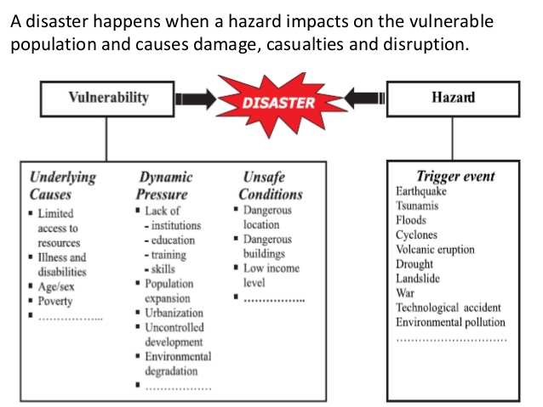
ACTIVITY.2.4.1
Now complete the following questions.
1.Define Risk and Disaster.
2. What is Vulnerabity and what are its features?
3. List frequent small scale disasters and other types of disasters that affects Vanuatu.
4. Study the diagram above and
a) Describe how a disaster is created
b) Explain how people may be vulnerable to disasters

