Central School
Home School Package

Year 11 : Biology

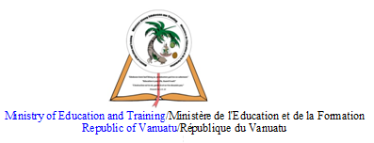

LESSON Plan

Date | Term 2 Week 8  Wednesday – 8th July, 2020
Strand 3 : Organism Level Biology
Sub-strand 3.3 : Animal Digestion
Lesson number : 8

Learning outcomes | - Distinguish between the different types of digestive systems of a carnivore, herbivore and omnivore. (BIO3.3.3.2 - Skill Level 3)
ACTIVITY

1. Explain the differences between the different types of digestive systems of a carnivore, herbivore, and omnivore.
__________________________________________________________________
__________________________________________________________________
__________________________________________________________________
__________________________________________________________________
__________________________________________________________________
__________________________________________________________________
__________________________________________________________________
__________________________________________________________________
__________________________________________________________________
__________________________________________________________________
__________________________________________________________________
__________________________________________________________________
__________________________________________________________________
__________________________________________________________________
__________________________________________________________________
__________________________________________________________________
__________________________________________________________________
__________________________________________________________________
__________________________________________________________________
__________________________________________________________________
__________________________________________________________________
__________________________________________________________________
__________________________________________________________________
__________________________________________________________________
__________________________________________________________________

References | Bunn, T. & Roberts, A. (2008). NCEA Level 2 Biology. New Zealand : ESA Publications, pp 162 – 172  Roberts, A. (2011). ESA Study Guide Level 2 Biology. New Zealand : ESA Publications, pp 187 – 195

