Central School
Home School Package

Year 11 : Biology

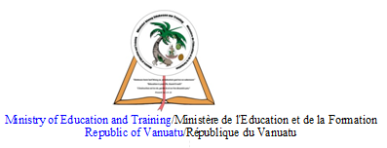

LESSON Plan

Date | Term 2 Week 8  Tuesday – 7th July, 2020
Strand 3 : Organism Level Biology
Sub-strand 3.3 : Animal Digestion
Lesson number : 7

Learning outcomes | - List the digestive organs in a human being. (BIO3.3.2.5 - Skill Level 2)  - Describe the functions of each of the digestive organs in humans. (BIO3.3.2.6 - Skill Level 2)
Learners notes | Digestive organs in human  The diagram below shows the digestive organs in a human being.  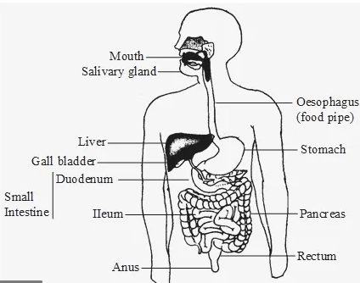  (digestive organs in human)  Functions of the digestive organs in human  Mouth. Food starts to move through your GI tract when you eat. When you swallow, your tongue pushes the food into your throat. A small flap of tissue, called the epiglottis, folds over your windpipe to prevent choking and the food passes into your esophagus.  Esophagus. Once you begin swallowing, the process becomes automatic. Your brain signals the muscles of the esophagus and peristalsis begins.  Lower esophageal sphincter. When food reaches the end of your esophagus, a ringlike muscle—called the lower esophageal sphincter —relaxes and lets food pass into your stomach. This sphincter usually stays closed to keep what’s in your stomach from flowing back into your esophagus.  Stomach. After food enters your stomach, the stomach muscles mix the food and liquid with digestive juices. The stomach slowly empties its contents, called chyme, into your small intestine.  Small intestine. The muscles of the small intestine mix food with digestive juices from the pancreas, liver, and intestine, and push the mixture forward for further digestion. The walls of the small intestine absorb water and the digested nutrients into your bloodstream. As peristalsis continues, the waste products of the digestive process move into the large intestine.  Large intestine. Waste products from the digestive process include undigested parts of food, fluid, and older cells from the lining of your GI tract. The large intestine absorbs water and changes the waste from liquid into stool. Peristalsis helps move the stool into your rectum.  Rectum. The lower end of your large intestine, the rectum, stores stool until it pushes stool out of your anus during a bowel movement.
 | https://www.youtube.com/watch?v=X3TAROotFfM&t=99s
ACTIVITY

1. Define ingestion.
__________________________________________________________________
__________________________________________________________________

2. Describe the process of ingestion in omnivores.
__________________________________________________________________
__________________________________________________________________
__________________________________________________________________
__________________________________________________________________
__________________________________________________________________
__________________________________________________________________
__________________________________________________________________

3. Describe the process of ingestion in carnivores.
__________________________________________________________________
__________________________________________________________________
__________________________________________________________________
__________________________________________________________________
__________________________________________________________________
__________________________________________________________________
__________________________________________________________________

4. Describe the process of ingestion in herbivores.
__________________________________________________________________
__________________________________________________________________
__________________________________________________________________
__________________________________________________________________
__________________________________________________________________
__________________________________________________________________
__________________________________________________________________
References | Bunn, T. & Roberts, A. (2008). NCEA Level 2 Biology. New Zealand : ESA Publications, p.168  Roberts, A. (2011). ESA Study Guide Level 2 Biology. New Zealand : ESA Publications, pp 190 – 191  https://www.niddk.nih.gov/health-information/digestive-diseases/digestive-system-how-it-works

