Central School
Home School Package

Year 11 : Biology

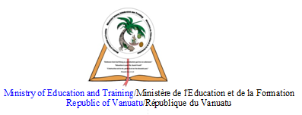

LESSON Plan

Date | Term 2 Week 7  Thursday – 2nd July, 2020
Strand 3 : Organism Level Biology
Sub-strand 3.3 : Animal Digestion
Lesson number : 4

Learning outcomes | - Define absorption. (BIO3.3.1.3 - Skill Level 1)  - Describe the process of absorption. (BIO3.3.2.3 - Skill Level 2)
Learners notes | Absorption  - Absorption for omnivores, carnivores, and herbivores takes place in the second part of the small intestine, the ileum, when the small molecules pass through the membranes of the cells lining the wall of the small intestine.  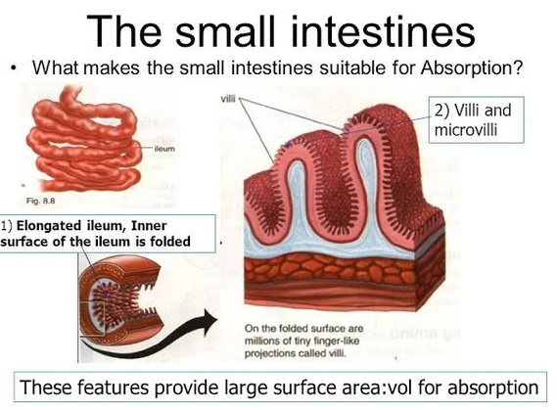  - Absorption is efficient because of the very large surface area formed by villi, infoldings of the wall of the ileum.  - Cells lining the villi also have infoldings, called microvilli.  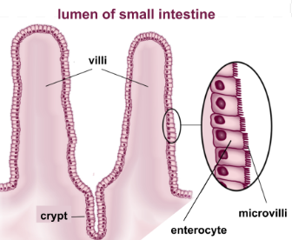  - Fatty acids pass into the villi and enter the lacteal vessels, which connect with vessels of the lymph system.  - All other molecules pass into the blood capillaries within each villus.  - Blood is taken from the villi by the hepatic portal vein to the liver where the food molecules are altered for storage, detoxified, or further broken down for ujse by body cells.  - Assimiliation can take place. For example, the digested nutrients are :  - used by body organs such as the liver, and body cells, to make new substances  - used by cells for fuel, eg in respiration  - stored until needed, eg the liver changes glucose into glycogen for storage  - broken down into other substances eg excess amino acids are de-aminated in the liver, coverted to urea, and sent to the kidneys for excretion in the form of urine  - Indigestible material that cannot be absorbed passes into the large intestine or colon.
https://www.youtube.com/watch?v=5VW5-VXlWic

https://www.youtube.com/watch?v=cEh2Qip0-E4

https://www.youtube.com/watch?v=8Fp91-ostBE
ACTIVITY

1. Define absorption.
__________________________________________________________________
__________________________________________________________________

2. Describe the process of absorption in herbivores.
__________________________________________________________________
__________________________________________________________________
__________________________________________________________________
__________________________________________________________________
__________________________________________________________________
__________________________________________________________________
__________________________________________________________________
__________________________________________________________________
__________________________________________________________________
__________________________________________________________________
__________________________________________________________________
__________________________________________________________________
__________________________________________________________________
__________________________________________________________________
__________________________________________________________________

References | Bunn, T. & Roberts, A. (2008). NCEA Level 2 Biology. New Zealand : ESA Publications, p.171  Roberts, A. (2011). ESA Study Guide Level 2 Biology. New Zealand : ESA Publications, p.194  https://socratic.org/questions/how-is-the-structure-of-a-villi-in-the-small-intestine-related-to-its-function  https://www.quora.com/What-does-the-ileum-do-in-the-digestion-system

