Central School
Home School Package

Year 11 : Biology

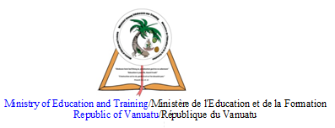

HOME SCHOOL PACKAGE CONTENT

This home school package contains the activities for Week 7 and Week 8 of Term 2, 2020 in the following order :

- Week 7 – Monday : 29th June, 2020 – Lesson 1
- Week 7 – Tuesday : 30th June, 2020 – Lesson 2
- Week 7 – Wednesday : 1st July, 2020 – Lesson 3
- Week 7 – Thursday : 2nd July, 2020 – Lesson 4
- Week 7 – Friday : 3rd July, 2020 – Lesson 5
- Week 8 – Monday : 6th July, 2020 – Lesson 6
- Week 8 – Tuesday : 7th July, 2020 – Lesson 7
- Week 8 – Wednesday : 8th July, 2020 – Lesson 8
- Week 8 – Thursday : 9th July, 2020 – Lesson 9
- Week 8 – Friday : 10th July, 2020 – Lesson 10 (Home Test 3.3)

Note to Parents :
- Kindly monitor your child’s learning at home.
- Fill in the weekly checklist on pages 8 and 9 of this lesson activity (Lesson 1) after your child completes the activity for each day (Monday 29th June – Friday 10th July).

LESSON Plan

Date | Term 2 Week 7  Monday – 29th June, 2020
Strand 3 : Organism Level Biology
Sub-strand 3.3 : Animal Digestion
Lesson number : 1

Learning outcomes | - Define ingestion. (BIO3.3.1.1 - Skill Level 1)  - Describe the process of ingestion. (BIO3.3.2.1 - Skill Level 2)
Learners notes | Nutrition in animals  - All organisms require food for their survival and growth.  - Nutrition in animals depends upon the feeding habits of the animals.  - The process of nutrition in animals involves the following steps :  - Ingestion  - Digestion  - Absorption  - Assimilation  - Egestion  Ingestion  - The process of taking in food is called ingestion.  - The method of ingestion is different in different animals. For example :  - Bees and humming birds suck nectar from plants.  - Cattle feed on grass.  - Animals can be divided into the following groups depending upon their food habits :  - Herbivores – animals that depend upon plants and fruits for nutrition (eg cows, goats etc)  - Carnivores – animals that depend upon animals for food (eg sharks, lions)  - Omnivores – organisms that eat both plants and animals (eg humans)  - Ingestion in other animals is assisted by specialised teeth :  - Incisors have chisel-like edges to cut off pieces of food  - Canines are pointed to puncture, rip, and tear food  - Molars and premolars are ridged (blunt in herbivores, pointed in carnivores) to chew, crush and grind food so it can be swallowed. This is mechanical digestion.  - The presence, size, and shape of the three types of teeth show adaptations to diet :  - In omnivores, all three types of teeth are present but are fairly uniform in size and shape as an adaptation to ingest a wide variety of food, both plant and animal.  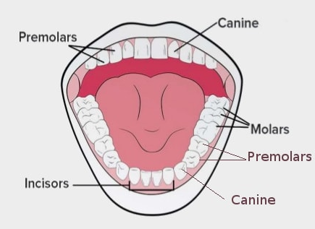  (human’s teeth)  - In carnivores, all three types of teeth are present. Incisors are very sharp for biting off chunks of meat ; canines are well developed and pointed for puncturing and shredding the meat ; molars are pointed, with large carnassial teeth to crack bones and cut flesh.  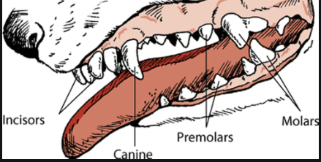  (dog’s teeth)  - In herbivores, canine teeth are absent since they are not needed. Incisors are very large and blunt for tearing off grasses and vegetation. The top incisors are missing in cattle and the lower incisors move against the bony pad of the upper jaw, which acts as a cutting board. A gap exists between the incisors and the large ridged, grinding molars at the back of the mouth allows room to manipulate food with the tongue for thorough chewing. The large ridged molars provide an efficent grinding surface for tough plant material. Plants have strong cellulose cell walls that must be broken by grinding to release the cell contents.  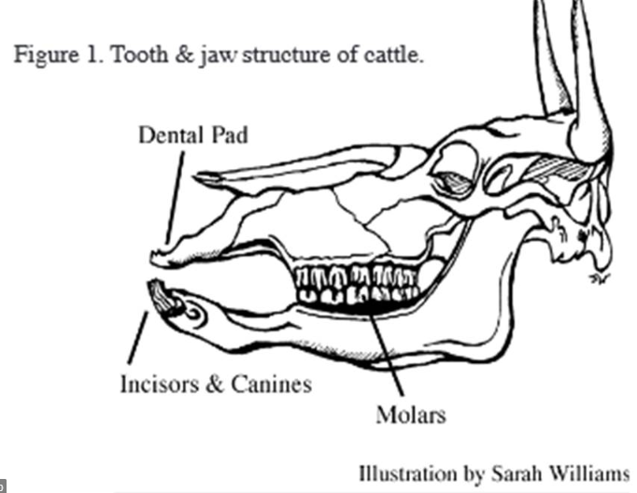
https://www.youtube.com/watch?v=pxmEtROtXbs

https://www.youtube.com/watch?v=co4kSPqRi9o

ACTIVITY

1. Define ingestion.
__________________________________________________________________
__________________________________________________________________

2. Describe the process of ingestion in omnivores.
__________________________________________________________________
__________________________________________________________________
__________________________________________________________________
__________________________________________________________________
__________________________________________________________________
__________________________________________________________________
__________________________________________________________________

3. Describe the process of ingestion in carnivores.
__________________________________________________________________
__________________________________________________________________
__________________________________________________________________
__________________________________________________________________
__________________________________________________________________
__________________________________________________________________
__________________________________________________________________

4. Describe the process of ingestion in herbivores.
__________________________________________________________________
__________________________________________________________________
__________________________________________________________________
__________________________________________________________________
__________________________________________________________________
__________________________________________________________________
__________________________________________________________________
References | Bunn, T. & Roberts, A. (2008). NCEA Level 2 Biology. New Zealand : ESA Publications, pp 163 - 172  Roberts, A. (2011). ESA Study Guide Level 2 Biology. New Zealand : ESA Publications, pp 187 – 195  https://byjus.com/biology/nutrition-animals/  https://www.infodentis.com/tooth-anatomy/dentition.php  http://clipart-library.com/clipart/961982.htm  https://agriculturalwithdrlindsay.com/2013/11/08/toothless-grins-fun-fact-friday/

WEEKLY CHECKLIST For Parents:

Term: 2 Week number 7 Date: 29th June, 2020 to 3rd July, 2020

Subject | Number of lessons | Days | Tick when activity is complete | Parents comment | Signature
Year 12 Biology | 1 | Monday  29th June 2020
 | 2 | Tuesday  30th June 2020
 | 3 | Wednesday  1st July 2020
 | 4 | Thursday  2nd July 2020
 | 5 | Friday  3rd July 2020

Term: 2 Week number 8 Date: 6th July, 2020 to 10th July, 2020

Subject | Number of lessons | Days | Tick when activity is complete | Parents comment | Signature
Year 12 Biology | 6 | Monday  6th July 2020
 | 7 | Tuesday  7th July 2020
 | 8 | Wednesday  8th July 2020
 | 9 | Thursday  9th July 2020
 | 10 | Friday  10th July 2020

