Strand 4: Oxidation and Reduction
Lesson 3 of Week 9: Oxidation and Reducation
Resource: Esa study Guide, Level 2 Chemistry, Chapter 21 & 24 (chpt 24 was photocopy last year 2019), online as well
The learning outcomes targeted in this activity are provided in the table below,
SLO Code | SPECIFIC LEARNING OUTCOMES (SLO): | SKILL LEVEL
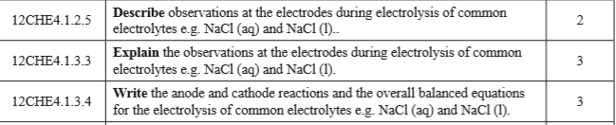

Activity
- Describe the observations at the electrodes during electrolysis of common electrolytes (NaCl). (Watch a video of electrolysis of NaCl then answer)

- Write the anode and cathode reaction of NaCl

- Write an overall balanced equations for the electrolysis of NaCl

