Strand 4: Oxidation and Reduction
Lesson 2 of Week 9: Oxidation and Reducation
Resource: Esa study Guide, Level 2 Chemistry, Chapter 21 & 24 (chpt 24 was photocopy last year 2019), online as well
The learning outcomes targeted in this activity are provided in the table below,
SLO Code | SPECIFIC LEARNING OUTCOMES (SLO): | SKILL LEVEL
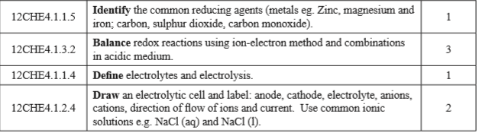
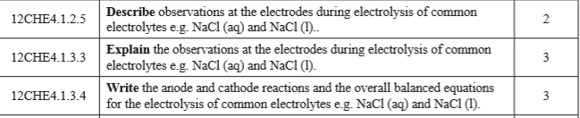

Activity
- List seven common reducing agents

- Define the following terms
  - Electrolytes

  - Electrolysis

- Draw/Sketch an electrolytic cell of ionic solution of NaCl and label as cathode, anode, positive, negative, electrolyte, direction of flow of ions and current.(follow example of lithium chloride in your textbook/handout)

- Describe the observations at the electrodes during electrolysis of common electrolytes (NaCl). (Watch a video of electrolysis of NaCl then answer)

- Write the anode and cathode reaction of NaCl

- Write an overall balanced equations for the electrolysis of NaCl

