Strand 4: Oxidation and Reduction
Lesson 1 of Week 9: Oxidation and Reducation
Resource: Esa study Guide, Level 2 Chemistry, Chapter 21, online as well
The learning outcomes targeted in this activity are provided in the table below,
SLO Code | SPECIFIC LEARNING OUTCOMES (SLO): | SKILL LEVEL
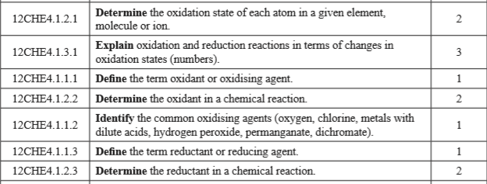

Activity:
- What is the oxidation number of the following:

- Explain the following in terms of changes in oxidation states (number)

- Define the term following
  - Oxidant(oxidising agent)

  - Reductant (reducing agent)

- For the reaction Fe + Cu²⁺ Fe²⁺ + Cu
  - Identify the oxidant, explaining your reasoning

  - Identify the reductant, explaining your reasoning

- For the reaction 2PbO + C 2Pb + CO₂
  - Identify the oxidant, explaining your reasoning

  - Identify the reductant, explaining your reasoning

- List the seven common oxidising agents (oxidant)

