STRAND TWO: QUANTITATIVE AND AQUEOS CHEMISTRY
Major Learning Outcome: Students are able to demonstrate understanding of chemical principles and relate it to quantitative analysis and properties of aqueous solutions.

SUB-STRAND 2.1: Quantitative Chemistry
Key Learning Outcome: Students are able to demonstrate understanding of the application of stoichiometry in finding substance yield and in preparing solutions.

LESSON ACTIVITY 1 OF WEEK 8: CALCULATION OF CONCENTRATION
The learning outcomes targeted in this activity are provided in the table below,
SLO # | SPECIFIC LEARNING OUTCOMES (SLO): | SKILL LEVEL | SLO CODE | ACHIEVED (put a tick)
1 | Prepare a standard solutions and report on the process and results | 4 | 12Che2.1.4.1
2 | Use the formula C1V1=C2V2 to calculate C1, V1, C2 or V2 | 3 | 12Che2.1.3.5
3 | Calculate simple concentration in solutions. | 1 | 12Che2.1.1.4

Key words: Standard solution, concentration, report process, formula

Standard solution

A Standard solution is a solution for which the concentration is accurately known. This solution is used for finding the concentration of other solutions.

There are primary standards and secondary standards: Primary standards solution is when the concentration is determined by directly weighing a reactant and dissolving the reactant to give a solution of known volume. Secondary standard solution is when the concentration is determined by experiment where the solution is standardized by titrating against a primary standard.

How to prepare a primary standard solution

Apparatus used: Bench mat 100 cm3
Beaker 250 cm3 beaker 250 cm3
Volumetric flask with stopper Filter funnel
Glass rod Teat pipette
Spatula Label De-ionised water
Anhydrous sodium carbonate, Na2CO3(s)

Method
- Accurately weigh the required solute into a clean, dry, glass container (eg. Beaker, watch glass). Record the mass of the solute used.
- Transfer the solute to a volumetric flask using a funnel and wash-bottle. Take care to transfer all the solute to the volumetric flask. Use deionized/distilled water if available.
- Partially fill the volumetric flask with deionized water, stopper, and shake to dissolve the solute
- Remove stopper and let any solution run down from the top of the neck of the volumetric flask. Add deionized water to fill the volumetric flask up o the volume mark. Ensure the bottom of the meniscus sits on the volume mark. Stopper the flask, and invert it a number of times to mix well. Label the flask, stating the name and concentration of the solution.
Result: After experimentation
Interpretation/Discussion: After experimentation
Conclusion: After experimentation when an aim is place

Example 1: Finding the required amount of solute
if 100.0ml of an approximately 0.200mol/L standard solution of sodium carbonate is required, the amount of sodium carbonate needed is:
n = cV
= 0.200mol/L X 0.100L (substituting and changing ml to L)
= 0.0200 mol

Example 2: Hence, Finding the mass of sodium carbonate needed is:
m = nM
= 0.0200mol(from mol above) X 106.0g/mol (molar mass of Na2CO3)
= 2.12g

Example 3: Calculating the concentration of a primary stardard
If 2.05g of sodium carbonate was weighted out (rather than the 2.12g calculated above) calculate the concentration of the standard solution (would be close enough).
- Find the amount(mol) of sodium carbonate:
n=m/M
= 2.05g/106.0g/mol (M Na₂CO₃)
= 0.0193 mol

- Calculate the concentration of sodium carbonate standard solution
C = n/v
= 0.0193mol / 0.100L (Millilitre change to litre)
= 0.193mol/L
Note that the concentration is known to be 0.193 mol/L - this concentration is close enough to 0.200mol/L
Use the formula C1V1=C2V2 to calculate C1, V1, C2 or V2

Dilution is the process of decreasing the concentration of a solute in a solution, usually simply by mixing with more solvent like adding more water to a solution. ... If one adds 1 litre of water to this solution the salt concentration is reduced. The diluted solution still contains 10 grams of salt (0.171 moles of NaCl). Dilution refers to the process of adding additional solvent to a solution to decrease its concentration. This process keeps the amount of solute constant, but increases the total amount of solution

The simple formula of C₁V₁ = C₂V₂ is a lifesaver for chemist in the lab who are wanting to do dilutions. Here I will explain what the equation means and how you can use it.
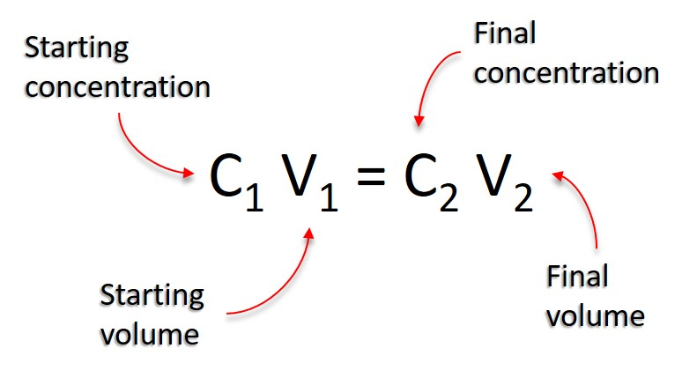The equation has four components:
- C₁ = Initial concentration of solution
- V₁ = Initial volume of solution
- C₂ = Final concentration of solution
- V₂ = Final volume of solution
Put together, the equation translates to: the starting concentration multiplied by the starting volume is equal to the final concentration multiplied by the final volume.
Basically, if you have three of the four components of the equation then you can use these within the formula to calculate the unknown component. All you have to do is to rearrange the formula for your needs.
For example, if you want to calculate the final volume of a solution you would change the formula to:
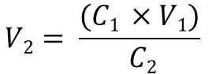
Or, if you want to calculate the initial starting concentration of a solution you would use:
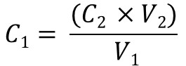
Once you understand the equation, it will become accustomed to your everyday lab work. Let’s take a look at some examples including numbers to help you understand this further.

Examples
- Calculate the amount of 10 μM forward primer solution to add to a CR reaction (25 μL total reaction) to make a final concentration of 0.4 μM forward primer in the reaction.
So by using the C₁V₁ = C₂V₂ equation, we need to first rearrange this to work out V₁ (the initial volume of primer we need to add). This would then make:
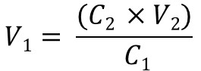
Next, we need to fill in what we know. We know the values for C₂ (0.4), V₂ (25) and C₁ (10). So:
V₁ = (0.4 x 25) / 10
V₁ = 10 / 10
V₁ = 1
Therefore, in this example, we would need to add 1 μL of 10 μM forward primer solution to a PCR reaction containing a total volume of 25 μL to achieve a final forward primer concentration of 0.4 μM.
- Calculate the amount of water you need to add to make a final concentration of 70% ethanol solution by using 100 mL of pure (100%) ethanol.
In this example, we are asked to calculate the final volume (V₂). Therefore, the equation will look like:
We know the starting concentration (C₁) of pure ethanol is 100%, the volume (V₁) of pure ethanol we have is 100 mL and the final concentration (C₂) we want to make is 70%. Putting this into the equation will look like:
V₂ = (100 x 100) / 70
V₂ = 10,000 / 70
V₂ = 142.9
The final volume we need to make therefore is 142.9 mL. We know 100 mL of that is the 100% pure ethanol, so the volume of water must be 42.9 mL (142.9 – 100 = 42.9). So, adding 42.9 mL of water to 100 mL of 100% pure ethanol will achieve a final concentration of 70% ethanol.
Concentration of solutions

The concentration of a solution is a measure of the quantity of dissolved solute in a given volume of solution. The concentration of a chemical solution is often measure in moles per litre, calculated using the following equation:
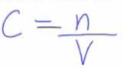 where c = concentration in mole per litre (Mol/L)
n = number of moles of dissolved solute (mol)
V = volume of solution (L)
Example:
Find the concentration of a salt solution of 0.3mol to make up a volume of 100ml
Therefore,
= 0.3 mol/0.1 L (change to Litre)
= 3 mol/L

Exercise:
- Calculate the amount(mol) of the following:
  - 5 ml of 0.1 mol/L sodium chloride solution

  - 10 ml of 0.2 mol/L sodium carbonate solution

  - 0.5 ml of 0.30 mol/L sodium sulfate solution

- Calculate the concerntration of the following solution in mol/L
  - 0.004 mol sodium chloride in 20ml of solution

  - 0.050 mol postassium iodide in 40ml of solution

  - 0.15mol of sodium carbondate in 250ml of solution

- Find the concentration of the following solutions, before and after dilution
  - 0.5 mol NaCl in 500ml soution is diluted by adding to 500ml of water

  - 0.1 mol sodium hydroxide in 250ml is diluted to 1 000ml

- How much 10% solution is needed to make up 500ml of a 2% solutioln?

- How much 5% solution is needed to make up 80ml of a 0.4% solution

- In an experiment, a student needs 250.0ml of a 0.100 M CuCl₂ solution. A stock solution of 2.00 M CuCl₂ is available. How do you prepare this?

- If 45.0ml of a 6.00 M HCl solution are diluted to a final volume of 0.250L, what is the final concentration?

