Strand 5: Organic Chemistry
Lesson 3 of Week 5, Term 2: Carboxylic Acid
Resource: Esa study Guide, Level 2 Chemistry, Chapter 15, online as well
The learning outcomes targeted in this activity are provided in the table below,
SLO Code | SPECIFIC LEARNING OUTCOMES (SLO): | SKILL LEVEL
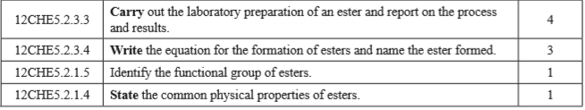

Activity
- Watch a video on the laboratory preparation of an ester. Outline the process of laboratory preparation.

- Write the equation for the formation of ester (reactant)

- Name the ester formed above (product)

- Identify/write the functional group of esters

- State four properties of esters

- Ethanol is wormed with ethanoic acid in the presence of concentrated sulfuric acid
  - Draw the structural formula for the organic product

  - Name the organic product

