Strand 5: Organic Chemistry
Lesson 1 of Week 5, Term 2: Carboxylic Acid
Resource: Esa study Guide, Level 2 Chemistry, Chapter 15, online as well
The learning outcomes targeted in this activity are provided in the table below,
SLO Code | SPECIFIC LEARNING OUTCOMES (SLO): | SKILL LEVEL
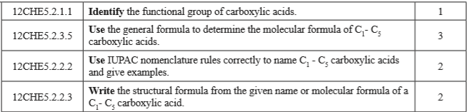

Activity
- Identify the functional group of carboxylic acids

- Write the general formula for Carboxylic acid

- Determine the molecular formula and structural formula of C₁ – C₅ carboxylic acids and name them using IUPAC nomenclature rules.
Carbon Number | Structural formula | Molecular Formula Structure | Name
1
2
3
4
5
6

