Strand 3: Physical Chemistry
Lesson 2 of Week 3, Term 2: Chemical Equilibrium System
Resource: Esa study Guide, Level 2 Chemistry, Chapter 18 (was photocopied last year 2019), online as well
The learning outcomes targeted in this activity are provided in the table below,
SLO Code | SPECIFIC LEARNING OUTCOMES (SLO): | SKILL LEVEL
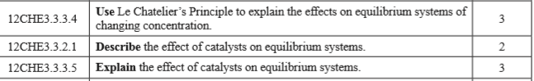
Activity
- Explain the effects on equilibrium system of changing concentration

- Describe the effect of a catalysts on equilibrium systems

- Explain the effect of a catalysts on a equilibrium systems

