Strand 3: Physical Chemistry
Lesson 1 of Week 3, Term 2: Chemical Equilibrium System
Resource: Esa study Guide, Level 2 Chemistry, Chapter 18 (was photocopied last year 2019), online as well
The learning outcomes targeted in this activity are provided in the table below,
SLO Code | SPECIFIC LEARNING OUTCOMES (SLO): | SKILL LEVEL
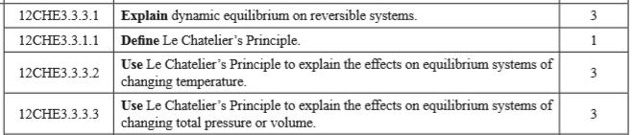

Activity
- Define the following terms
  - Dynamic equilibrium

  - Le Chaterlier’s Principle

- Explain dynamic equilibrium on reversible systems

- Explain the effects on equilibrium systems of changing temperature using Le Chaterlier’s Principles

- Explain the effects on equilibrium systems of changing total pressure or Volume using Le Chaterlier’s Principles

