Strand 3: Physical Chemistry
Lesson 1 of Week 2, Term 2: Rate of Reaction
Resource: Esa study Guide, Level 2 Chemistry, Chapter 17 (was photocopied last year 2019), online as well
The learning outcomes targeted in this activity are provided in the table below,
SLO Code | SPECIFIC LEARNING OUTCOMES (SLO): | SKILL LEVEL
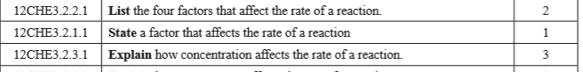
Activity
- List the four main factors that is affecting the rate of a reaction

- Explain or point out how concentration affects the rate of reaction

- Use collision theory to explain the following observation
  - Fine coal dust in coal mine has caused explosions when accidentally sparked

  - A piece of wood will burn faster when splintered

  - A pieced of iron placed in a Bunsen flame gets hot. Iron wool (fine threads of iron) placed in a flame burns to produced iron oxides.

