Strand 3: Physical Chemistry
Lesson 3 of Week 1, Term 2: Energy Changes
Resource: Esa study Guide, Level 2 Chemistry, Chapter 11, online as well
The learning outcomes targeted in this activity are provided in the table below,
SLO Code | SPECIFIC LEARNING OUTCOMES (SLO): | SKILL LEVEL
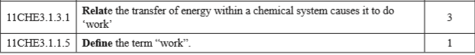

Activity
- Define the term work

- Relate by giving three examples of transfer of energy within a chemical system causing it to do work

