Strand 3: Physical Chemistry
Lesson 1 of Week 1 of Term 2: Energy Change
Resource: Esa study Guide, Level 2 Chemistry, Chapter 11 (was photocopied last year 2019), online as well
The learning outcomes targeted in this activity are provided in the table below,
SLO Code | SPECIFIC LEARNING OUTCOMES (SLO): | SKILL LEVEL
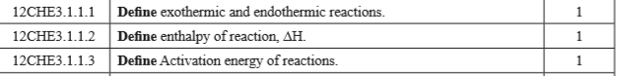

Activity
- Define the following terms and provide one example:
  - Exothermic reaction

  - Endothermic reaction

  - Enthalpy of reaction, H

  - Activation energy of reactions

