Strand 4: Oxidation and Reduction
Lesson 3 of Week 10: Oxidation and Reduction
Resource: Esa study Guide, Level 2 Chemistry, Chapter 21 & 24 (chpt 24 was photocopied last year 2019), online as well
The learning outcomes targeted in this activity are provided in the table below,
SLO Code | SPECIFIC LEARNING OUTCOMES (SLO): | SKILL LEVEL
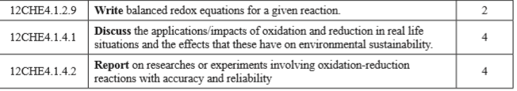

Activity
- The extraction of aluminium is carried out by the electrolysis of molten aluminium oxide(alumina) dissolved in cryolite (sodium aluminium fluoride)
  - Write a balanced half-equation for the reaction at the cathode

  - Write a balanced half-equation for the reaction at the anode

  - Combine the two half-equation from a. and b. to give a balanced equation for the overall reaction

- Discuss/list the impacts/applications of oxidation-reduction in real life

- Point out the effects (to above list) that these have on environment sustainability

- Report on researches or experiments involving oxidation-reduction reactions with accuracy and reliability: Note to watch a video on oxidation-reduction reaction and make your judgement.
  - Accuracy

  - Reliability

