Strand 4: Oxidation and Reduction
Lesson 2 of Week 10: Oxidation and Reducation
Resource: Esa study Guide, Level 2 Chemistry, Chapter 21 & 24 (chpt 24 was photocopied last year 2019), online as well
The learning outcomes targeted in this activity are provided in the table below,
SLO Code | SPECIFIC LEARNING OUTCOMES (SLO): | SKILL LEVEL
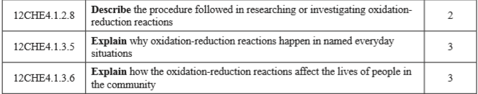

Activity
- Describe/Outline the procedure of investigating/researching oxidation-reduction reactions

- Explain why oxidation-reduction reaction happen in everyday situation

- Explain how the oxidation-reduction reactions affect the lives of people in the community(bad side/disadvantage of everyday oxidation-reduction reactions)

