Strand 3: Physical Chemistry
Lesson 3 of Week 1 of Term 2: Energy Change
Resource: Esa study Guide, Level 2 Chemistry, Chapter 11 (was photocopied last year 2019), online as well
The learning outcomes targeted in this activity are provided in the table below,
SLO Code | SPECIFIC LEARNING OUTCOMES (SLO): | SKILL LEVEL
Activity
- Calculate and classify as exothermic or endothermic reaction:
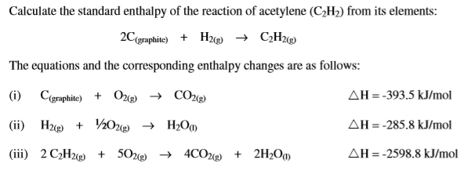

2. Calculate and classify as exothermic or endothermic reaction:
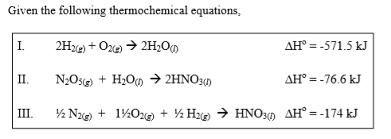
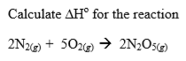

3. Calculate and classify as exothermic or endothermic reaction:
