Central School
Home School Package

Year :12

HOME SCHOOL PACKAGE CONTENT
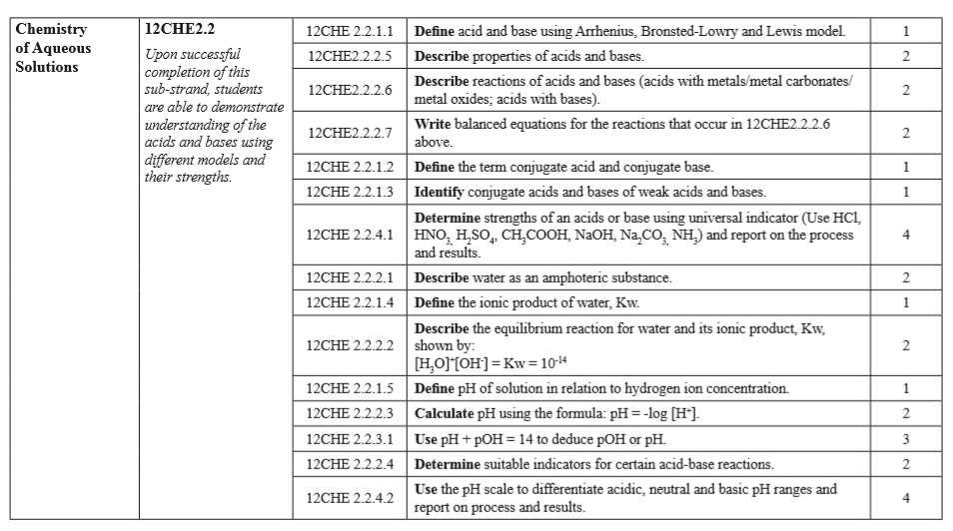

LESSON Plan

Teacher | Name :Judy W Vire  Subject : Chemistry
Date | Week 8 of term 2
Topic : Chemistry of Aqueous solutions
Lesson number : 1

Learning outcomes | - Define acid and base using Arrhenius, Bronsted –Lowry and Lewis model  - Describe properties of acids and bases  - Describe reactions of acids and bases.  - Write balanced equations for the reactions that occur above
Introduction | Highlights  - The role of acid/basic nature of supports was studied.  - Acid–basic properties of supports affected the selectivity of products.  - The doping of another weak basic site affected the selectivity to glyceric acid.  - The role of supports in affecting the selectivity of products was proposed.
Catch phrase for the lesson

Insight into effect of acid/base nature of supports

Learners notes | Summary  Arrhenius, Bronsted-Lowry, and Lewis Acids and Bases in Organic Chemistry  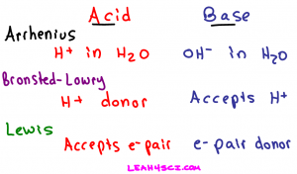  Categories of Acids and Bases  Acids and bases will fall under one or more of the following three categories:  - Arrhenius acids/bases  - Bronsted-Lowry acids/bases  - Lewis acids/bases  The key here is to recognize that while each classification has a specific definition, any given molecule can fall into more than one category, some into all 3. Again, something we’ll look at later in this article.  Arrhenius Acid  An Arrhenius acid is a molecule that when dissolved in water will donate an H+ in solution. Simply put, a proton donor.  The trick to recognizing an Arrhenius acid is to look for a molecule that starts with an H, and typically contains an oxygen or halogen.  Common examples of Arrhenius acids include:  - Hydrochloric Acid – HCl  - Nitric Acid – HNO3  - Sulfuric Acid – H2SO4  - Acetic Acid – HCH3CO2  - and so many more…  An acid dissociating in water does not form a free-floating proton. Instead one of the water molecules in solution will grab the H+ yielding a hydronium or H3O+ ion. Here’s what happens when nitric acid dissociates in water.  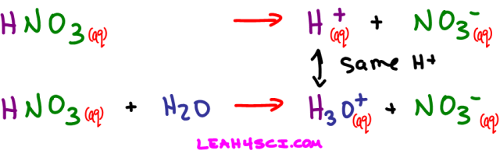  Arrhenius Base  An Arrhenius base is a molecule that when dissolved in water will break down to yield an OH- or hydroxide in solution. To recognize the Arrhenius base look for a molecule ending in OH, but not following CHx which refers to an alcohol.  Arrhenius base examples include:  - Sodium hydroxide – NaOH  - Potassium hydroxide – KOH  - Magnesium hydroxide – Mg(OH)2  - and so many more…  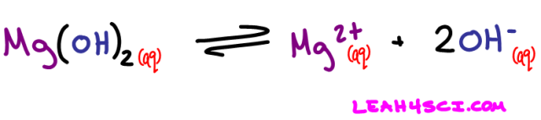  But what if the acid/base is not dissolved in water?  The Arrhenius definition for acids and bases only refers to compounds dissolved in water. Does this mean that acids and bases cannot exist out of water? Not quite, that’s where the Bronsted-Lowry definition comes in.  Bronsted-Lowry Acid  A Bronsted-Lowry acid, like an Arrhenius acid, is a compound that breaks down to give an H+ in solution. The only difference is that the solution does not have to be water. We can still refer to the exact same acids as listed for the Arrhenius acid examples, but this time we’ll change the solvent to ammonia, alcohol, or anything else.  We saw what happens when nitric acid (HNO3) dissolves in water. Now let’s see what happens when it dissolves in ammonia (NH3) or even methanol (CH3OH)  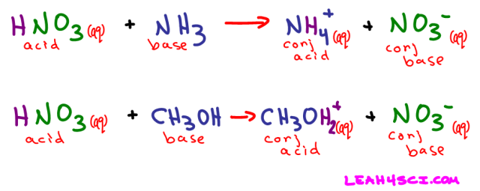  Nitric acid still dissolved to yield an H+ and NO3-, but this time it was NH3 and not water that picked up the free-floating proton.  Bronsted-Lowry Base  This is where we start to see the difference between the Bronsted-Lowry and Arrhenius definitions. While the Arrhenius base referred specifically to the hydroxide (OH-) ion, the Bronsted-Lowry base refers to any atom or ion capable of accepting or bonding to a free proton in solution.  Referring back to the HNO3 + NH3 reaction above, when ammonia picks up the free H+ it acts as a proton-acceptor. NH3 is the Bronsted-Lowry base in this example.  Additional examples include:  - Methanol – CH3OH  - Formaldehyde – H2CO  - And even water – H2O  Lewis Acids and bases  The Lewis definition for acids and bases is the most extreme because it’s not dealing with protons specifically. Instead the Lewis definition deals with the movement of electrons.  Lewis Acid  A Lewis acid refers to an atom or molecule that accepts an electron pair. Think back to your ‘pushing arrows’ for orgo mechanisms. Every time you draw an arrow representing the movement of electrons, the atom getting attacked or accepting those electrons is the Lewis acid in that reaction.  Common Lewis Acid Examples  - Borane – BH3 (hydroboration reaction)  - Aluminum Chloride – AlCl3 (electrophilic aromatic substitution reaction)  - Iron (III) Bromide – FeBr3 (electrophilic aromatic substitution reaction)  - and our good friend H+ (keep reading)  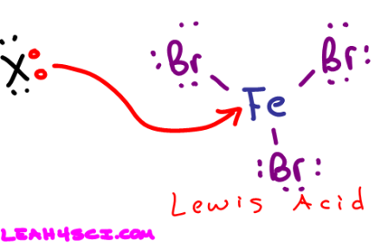  Lewis Base  Since the Lewis definition has to do with the transfer of electrons, you can guess by now that a Lewis Base is an electron pair donor. Once again think back to your reaction mechanisms. The molecule using its electrons to attack another atom is an electron pair donor and a Lewis Base.  Here is the first step in acid catalyzed hydration. The pi bond attacking H+ makes the alkene a Lewis Base.  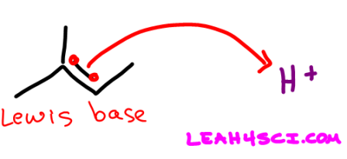  Arrhenius Acid Definition: Hydronium breaks up to yield an H+ in solution.  Arrhenius Base Definition: Hydroxide is an OH- dissolved in water.  Bronsted-Lowry Acid Definition: Hydronium is an H+ donor regardless of solution  Bronsted-Lowry Base Definition: Hydroxide attacks and accepts the H+ from hydronium.  Lewis Acid Definition: The H+ on Hydronium accepts the attacking electron pair to form a bond.  Lewis Base Definition: Hydroxide donates its electron pair to form a bond between itself and H+  Reactions of Acids and Base  1. Acid reacts with a metal  When an acid reacts with metal, a salt and hydrogen are produced: acid + metal → salt + hydrogen  Eg : nitric acid + calcium → calcium nitrate + hydrogen The salt that is produced depends upon which acid and which metal react.  2. Acids reacts with Metal carbonate  When acids react with carbonates, such as calcium carbonate (found in chalk, limestone and marble), a salt, water and carbon dioxide are made which is an exothermic reaction.  - acid + metal carbonate → salt + water + carbon dioxide  Eg: Sulfuric acid + iron(II) carbonate → iron(II) sulfate + water + carbon dioxide  H₂SO₄ + FeCO₃ → FeSO₄ + H₂O + CO₂  3. Acids reacts with a base  When acids react with a base, a salt and water are made.  - acid + base → salt + water  - nitric acid + magnesium oxide → magnesium nitrate + water  2HNO₃ + MgO → Mg(NO₃)₂ + H₂O  Also note that the reaction of metal oxides with acids is exothermic (ie heat energy is given out).  4. Acid reacts with metal oxides  A salt and water are produced when acids react with metal oxides. Metal oxides are bases, because they neutralise acids.  In general:  acid + metal oxide → salt + water  For example:  sulfuric acid + copper(II) oxide → copper(II) sulfate + water  H₂SO₄(aq) + CuO(s) → CuSO₄(aq) + H₂O(l)
- Reaction of acids with metal carbonates by Khan Academy https://www.khanacademy.org/science/in-in-class-10-chemistry-india/x87dd2847d57ee419:in-in-acids-bases-and-salts/x87dd2847d57ee419:in-in-reaction-of-acids-and-bases/v/reaction-of-acids-with-metal-carbonates-and-bicarbonates-chemistry-khan-academy
- Metal and non-metal oxides reacting with acid and bases by Khan Academy https://www.khanacademy.org/science/in-in-class-10-chemistry-india/x87dd2847d57ee419:in-in-acids-bases-and-salts/x87dd2847d57ee419:in-in-reaction-of-acids-and-bases/v/metal-and-non-metal-oxides-reacting-with-acids-and-bases-chemistry-khan-academy
- Acid and Base definition https://www.youtube.com/watch?v=EyBkPwsRY2E
- Define acid and base using Arrhenius, Bronsted –Lowry and Lewis model
- Describe four properties of acids
- Decribe four properties of bases
- Describe reactions of acids and bases.
- Write balanced equations for the reactions that occur above
- Complete the following word equation:
(acid + metal → salt + hydrogen)
- hydrochloric acid + ___________→ calcium chloride + hydrogen
- ____________________ + magnesium → magnesium nitrate + water
Assignment
Assessment | Detemine the strength of an acids or base using universal indicator. A List of base/acids will be provided
References | - http://leah4sci.com/arrhenius-bronsted-lowry-and-lewis-acids-and-bases-in-organic-chemistry  - https://www.bbc.co.uk/bitesize/guides/z7g26yc/revision/1  - https://www.khanacademy.org/science/in-in-class-10-chemistry-india/x87dd2847d57ee419:in-in-acids-bases-and-salts/x87dd2847d57ee419:in-in-reaction-of-acids-and-bases/v/reaction-of-acids-with-metal-carbonates-and-bicarbonates-chemistry-khan-academy

WEEKLY CHECKLIST For Parents:

Term: 2 Week number 1 Date…… to…… Month: …………

Subject | Number of lessons | Days | Tick when activity is complete | Parents comment | Signature
 | 1
 | 2
 | 3
 | 4
 | 5
 | 6

Term: 2 Week number 2 Date…… to…… Month: …………

Subject | Number of lessons | Days | Tick when activity is complete | Parents comment | Signature
 | 1
 | 2
 | 3
 | 4
 | 5
 | 6

Term: 2 Week number 3 Date…… to…… Month: …………

Subject | Number of lessons | Days | Tick when activity is complete | Parents comment | Signature
 | 1
 | 2
 | 3
 | 4
 | 5
 | 6

Term: 2 Week number 4 Date…… to…… Month: …………

Subject | Number of lessons | Days | Tick when activity is complete | Parents comment | Signature
 | 1
 | 2
 | 3
 | 4
 | 5
 | 6

Term: 2 Week number 5 Date…… to…… Month: …………

Subject | Number of lessons | Days | Tick when activity is complete | Parents comment | Signature
 | 1
 | 2
 | 3
 | 4
 | 5
 | 6

Term: 2 Week number 6 Date…… to…… Month: …………

Subject | Number of lessons | Days | Tick when activity is complete | Parents comment | Signature
 | 1
 | 2
 | 3
 | 4
 | 5
 | 6

Term: 2 Week number 7 Date…… to…… Month: …………

Subject | Number of lessons | Days | Tick when activity is complete | Parents comment | Signature
 | 1
 | 2
 | 3
 | 4
 | 5
 | 6

Term: 2 Week number 8 Date…… to…… Month: …………

Subject | Number of lessons | Days | Tick when activity is complete | Parents comment | Signature
 | 1
 | 2
 | 3
 | 4
 | 5
 | 6

Term: 2 Week number 9 Date…… to…… Month: …………

Subject | Number of lessons | Days | Tick when activity is complete | Parents comment | Signature
 | 1
 | 2
 | 3
 | 4
 | 5
 | 6

Term: 2 Week number 10 Date…… to…… Month: …………

Subject | Number of lessons | Days | Tick when activity is complete | Parents comment | Signature
 | 1
 | 2
 | 3
 | 4
 | 5
 | 6

Term: 2 Week number 11 Date…… to…… Month: …………

Subject | Number of lessons | Days | Tick when activity is complete | Parents comment | Signature
 | 1
 | 2
 | 3
 | 4
 | 5
 | 6

Term: 2 Week number 12 Date…… to…… Month: …………

Subject | Number of lessons | Days | Tick when activity is complete | Parents comment | Signature
 | 1
 | 2
 | 3
 | 4
 | 5
 | 6

Term: 2 Week number 13 Date…… to…… Month: …………

Subject | Number of lessons | Days | Tick when activity is complete | Parents comment | Signature
 | 1
 | 2
 | 3
 | 4
 | 5
 | 6

