TOURISM AND HOSPITALITY
Strand 2: The development of tourism and hospitality | Sub Strand 2.2: Flow of tourists into and within the Pacific
Lesson Activity 1

The learning outcomes targeted in this activity are outlined below:

SLO | Specific Learning Outcomes (SLO) | Skill score | SLO code | Achieved
1 | Identify the country that contributes to the largest number of tourists for your country or for the Pacific region | 1 | Toh2.2.1.1
2 | Describe the features or patterns of flow of tourists into the Pacific region | 2 | Toh2.2.2.1
3 | Describe trends or patterns in tourist arrival numbers | 2 | Toh2.2.2.2
4 | Describe trends or patterns in the average daily expenditure of tourists | 2 | Toh2.2.2.3
5 | Describe trends or patterns in lengths of stay of tourists in Pacific destinations | 2 | Toh2.2.2.4
6 | Describe trends or patterns in purposes of visits by tourists | 2 | Toh2.2.2.5
7 | Describe trends or patterns in tourist market segments | 2 | Toh2.2.2.6
12 | Analyse the flow of tourists into the Pacific region by purpose of visit/ main market segments/tourist arrival numbers/average daily expenditure/length of stay/purpose of visit, based on given data tables | 3 | Toh2.2.3.2
13 | Analyse the flow of tourists into the Pacific region by purpose of visit/ main market segments/tourist arrival numbers/average daily expenditure/length of stay/purpose of visit, based on given data tables | 3 | Toh2.2.3.2

Learning Objectives

Upon completion of this lesson, students should be able to:

- Identify the country that contributes to the largest number of tourists for your country or for the Pacific region.
- Describe the following:
- features or patterns of flow of tourists into the Pacific region
- trends or patterns in tourist arrival numbers
- trends or patterns in the average daily expenditure of tourists
- trends or patterns in lengths of stay of tourists in Pacific destinations
- trends or patterns in purposes of visits by tourists
- trends or patterns in tourist market segments
- Analyse the flow of tourists into the Pacific region.
- Analyse the flow of tourists into the Pacific region

OVERVIEW

Tourist Arrivals to the ACP and SPTO Member Countries

Destinations in the Pacific ACP and SPTO member countries² welcomed 2,137,538 tourist arrivals (by air) to its shores in 2017 which represents a 3.1% gain over 2016 or 65,004 more tourist arrivals during the period. The growth reflected the shared positive performances by the majority of the destinations triggered by the sustained outbound travel demand, increased connectivity, massive promotional campaigns and improved infrastructure developments over the year. By destinations, double-digit growth was recorded for Cook Islands, Kiribati, Niue, Timor Leste, Solomon Islands and Vanuatu with moderate growth from FSM, Fiji, French Polynesia, New Caledonia, Samoa, Tonga and Tuvalu. By sea arrivals, mainly by cruise, the region received a total of 982,7983 from nine Pacific destinations in 2017. This brings the total visitor arrivals (both air and sea) to the region at 3,120,336 during the year. Refer to the table below:

Tourist arrivals to ACP Pacific and SPTO member countries, 2017
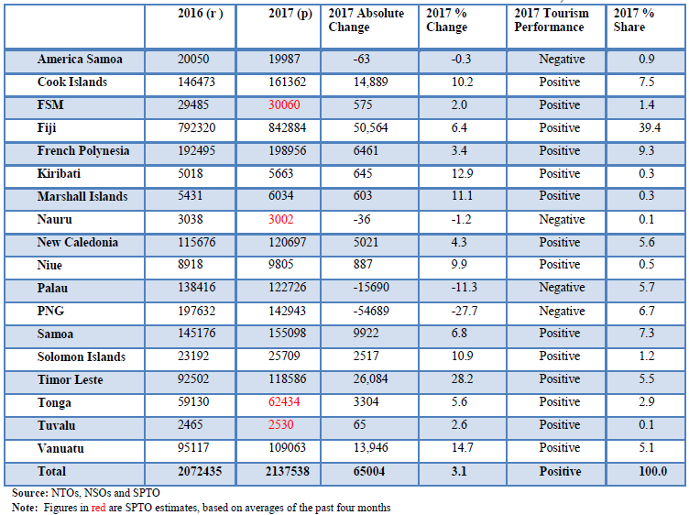
On shares, Fiji, the lead tourism destination in the region attracted an incremental 39.4% share of the total arrivals. French Polynesia the second-highest accounted for 9.3% share, followed by the Cook Islands at 7.5%, Samoa 7.3%, PNG 6.7%, Palau 5.7%, New Caledonia 5.6%, Timor Leste 5.5% and Vanuatu at 5.1%. The remaining 7.7% was shared among all the other destinations. Refer to the table above.

Source Markets

In terms of market shares, Australia and New Zealand continued to top the source markets ranking with 29.5% and 20.8%. However, both shares of 50.3% in 2017, is slightly below their 51.4% share in 2016. USA, the third largest source market represented 10%, Europe and Other Asia edged at 8.9% each and Other Pacific Islands elevated to 7.5% whilst China reduced to 6.7%. All other source markets represented the remaining 7.7% share. Refer to the table below:

Tourist Arrivals in Pacific ACP and SPTO Member Countries by Source Market, 2017
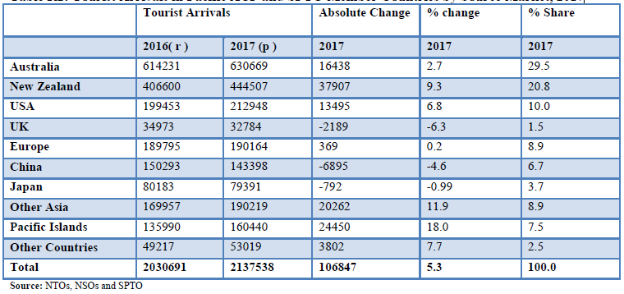

Tourist Arrivals by Purposes
Disaggregating arrivals by purpose of visit, leisure tourists dominated the region in 2017 at a remarkable 64% share. Business tourists followed at 14% share, VFR closely behind at 13% and other purposes of visit at 9% share. Countries with the highest shares in leisure tourists include Cook Islands, Fiji, Vanuatu, Kiribati, New Caledonia, Niue, Samoa, Solomon Islands and Tonga. Meanwhile, PNG, Marshall Islands and Tuvalu received more business tourists while American Samoa was dominated by tourists on visiting friends and relatives. Refer to the graph below:

Tourist Arrivals in Pacific ACP and SPTO Member Countries by Purpose of Visit, 2017
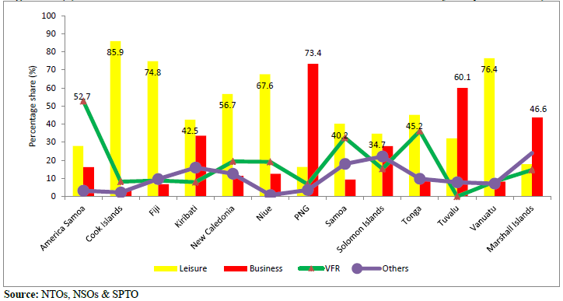

Tourism earning / expenditure

Tourism earnings by each person allow easier comparisons across countries with vastly different population size. On average, tourism receipts per person in 2017 from a combined population of about 12.7 million recorded US$2272. By destinations, tourism receipts per person range from US$38 in PNG to US$14,557 in the Cook Islands. The results indicated that while PNG generated an estimated total earnings of US$347.6 million, receipt per person is low due to a high population of more than 8 million. In contrast, Cook Islands with a total receipt of US$254.1 million recorded the maximum receipts per capita of US$14,557 owed to a smaller population base of more than 14 thousand. Refer to graph below:

Tourism earnings by per visitor arrival measures the average spend by each visitor in a destination in 2017. On average, tourist receipts per visitor to the region recorded US$1822 with French Polynesia posting the highest receipts per visitor at US$3429. More spending per arrival indicates that a destination has achieved a higher yield. Further, receipt per travel may also highlight the price competitiveness of a destination, allowing high cost destinations to tailor marketing campaigns or investigate measures to lower costs. The wide variations in reported total receipts and spending per arrival in 2017 could reflect the differences in the average length of stay and the daily spend of visitors and the exchange rate movements in national currencies against USD. Refer to graph below:

Annual Tourism Earnings by Destinations, 2017
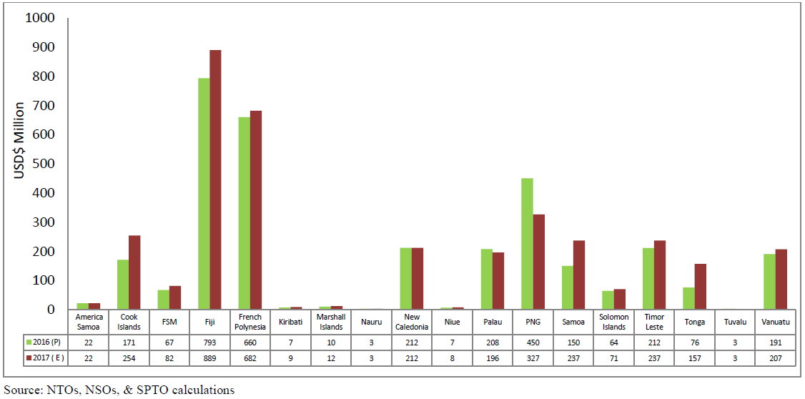

Lesson Activity
- This task is a group activity that requires each group (3 or 4 students) to discuss the answers to each question. During the process each group needs to discuss, compare answers to the other groupsand take notes.

- Teachers shall guide the students to use the resources above, internet and their own knowledge to do this lesson activity.

- Identify the country that contributes to the largest number of tourists for your country or for the Pacific region (skill level 1 / SLO code Toh2.2.1.1)

- Describe the following: | Skill level | SLO code
- features or patterns of flow of tourists into the Pacific region | 2 | Toh2.2.2.1
- trends or patterns in tourist arrival numbers | 2 | Toh2.2.2.2
- trends or patterns in the average daily expenditure of tourists | 2 | Toh2.2.2.3
- trends or patterns in lengths of stay of tourists in Pacific destinations | 2 | Toh2.2.2.4
- trends or patterns in purposes of visits by tourists | 2 | Toh2.2.2.5
- trends or patterns in tourist market segments | 2 | Toh2.2.2.6

- Analyse the flow of tourists into the Pacific region (skill level 3 / SLO code Toh2.2.3.2)
- Interpret and Evaluate the patterns in the flow of tourists into the Pacific region by purpose of visit/main market segments/tourist arrival numbers/ average daily expenditure/length of stay/purpose of visit (skill level 4 / SLO code Toh2.2.4.1)

