The present continuous / present progressive explained
The present continuous tense is used to describe an action that is happening at the moment of speaking:

I am leaving work.

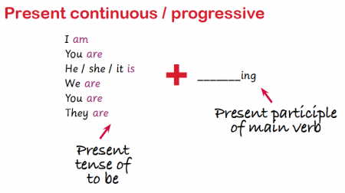

The past continuous / past progressive explained
The past continuous is used for a continuous action in the past, for example:
I was working hard when the telephone interrupted me.
Everyone was shouting.
They were always arguing.

