**Strand 2: Gene Expression**

***Sub-strand 2.4 Metabolic Pathways, Linkages and Sex Linkages***

**LESSON 1: Metabolic Pathways**

**Key Learning Outcome**:

Students are able to demonstrate understanding of metabolic pathways, and ways in which they influence DNA functioning

* metabolic pathways e.g. PKU
* effects of mutation on enzyme control of metabolic pathways

The **specific learning outcomes** targeted in this lesson are provided below: Tick the last column when you have achieved the learning outcome.

|  |  |  |  |  |
| --- | --- | --- | --- | --- |
| **SLO #** | **Specific Learning Outcomes:**  *Students are able to* | **Skill level** | **SLO code** | **√** |
| 1 | Define metabolic pathway | 1 | Bio2.4.1.1 |  |
| 2 | Describe the characteristics of phenylketonuria (PKU) | 2 | Bio2.4.2.1 |  |
| 3 | Explain the relation between metabolic pathways disorder and PKU | 3 | Bio2.4.3.1 |  |
| 4 | Represent diagrammatically the metabolic pathway for PKU | 3 | Bio2.4.3.2 |  |
| 5 | Explain the effects of untreated PKU | 3 | Bio2.4.3.3 |  |
| 6 | Explain the effects of mutation on enzyme control of metabolic pathways | 3 | Bio2.4.3.4 |  |
| 7 | Interpret effects of mutation on enzyme control of metabolic pathways based on given information | 3 | Bio2.4.3.5 |  |

**Key Terms:** Tick when you are able to define and use the term correctly in context.

|  |  |  |  |  |
| --- | --- | --- | --- | --- |
| **Term** | **Achieved** |  |  |  |
| Metabolic pathway |  |  |  |  |
| phenylketonuria |  |  |  |  |
| Metabolic disorder |  |  |  |  |

**Recommended Readings:**

|  |  |  |
| --- | --- | --- |
| **Reading Text** | **Page(s)** | **Achieved** |
| Hanson, M., & Sinclair, M. (2006). *Year 13 Biology Study Guide, NCEA Level 3*. Auckland: ESA Pubilcations Ltd. | 111 |  |
| Bradfield, P., Dodds, J., Dodds, J., and Taylor, N. (2001). *AS Level Biology*. Essex: Pearson Education Limited. | 145 |  |

**METABOLIC PATHWAYS**

*Metabolic pathways are the series of biochemical reactions that are involved in the metabolism (synthesis or breakdown) of substances within organisms*. They occur in almost every cell of the body. Photosynthesis and respiration are two examples of metabolic pathways in plants.

At each step of a metabolic pathway, there are important enzymes that are involved. These enzymes are produced from the genetic instructions provided within genes in DNA. In order for a particular enzyme to function correctly it needs to be produced correctly through the process of protein synthesis. If the gene responsible for producing the enzyme is mutated or damaged, then the enzyme will not be produced or it will be produced but it will be non-functional. As a result, the reaction which the enzyme needs to carry out in the metabolic pathway will not occur. Any disruptions in a metabolic pathway because of a faulty enzyme will result in the following:

* build up of substrates that needed to be broken down.
* lack of products that needed to be produced.

The buildup or lack of certain substances within cells as a result of disruptions in a metabolic pathway, can cause phenotypic changes in the organism which can sometimes become medical disorders if not diagnosed early or treated properly.

**The metabolism of phenylalanine**

A very important metabolic pathway in humans, is the metabolism of the amino acid, phenylalanine.

Phenylalanine undergoes a series of biochemical reactions to break it down to its final product, **CO2 and H2O.** Along the metabolic pathway, several substances are produced which are important for the body. These substances depend upon enzymes for their production. If specific enzymes responsible for particular reactions in the pathway are faulty, then these important substances will not be produced. The lack of or abundance of a chemical substance because of the absence of these enzymes can lead to different medical complications.

**Important products of the metabolism of phenylalanine:**

* Thyroxine (A growth hormone)
* Melanin (pigment that controls skin color)

**Phenylketonuria – medical disorder caused by faulty metabolism of phenylalanine**

***Phenylketonuria*** (***PKU***) is caused by the buildup of phenylalanine in body cells.

* Since high levels of phenylalanine is toxic to the nervous system, many of the symptoms of PKU are brain defects.
* *Symptoms:* mental disability, delayed development, behavioural, emotional and social problems, hyperactivity and mousy body odor.

**METABOLIC PATHWAY OF PHENYLALANINE**

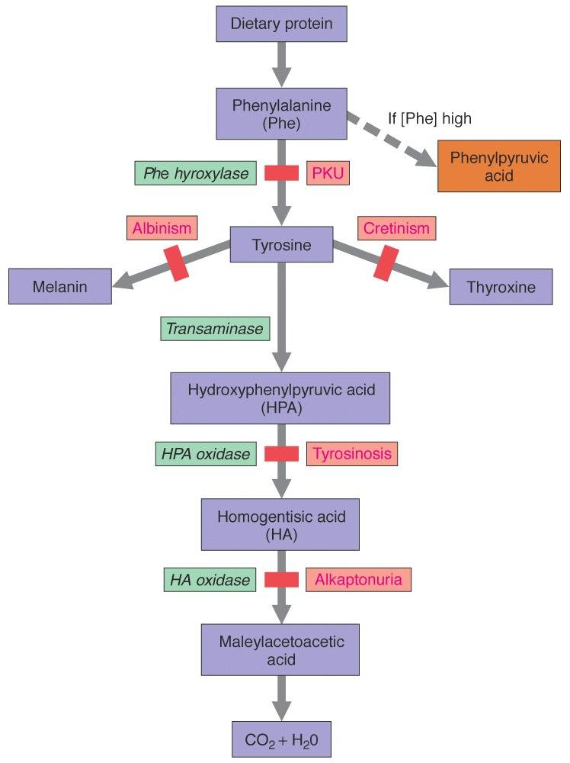

*Symptoms:* excessive sleep, stunted growth, poor bone development.

*Symptoms:*

* Enlarged spleen and liver.
* Liver disease and damage (cirrhosis).

*Symptoms:*

* High levels of homogentisic acid in urine..
* Ostheoarthritis in the spine and large joints.

*Symptoms:*

* White skin and hair.
* Sensitivity to sunlight.
* Prone to skin infections.

*Symptoms:*

* White skin and hair.
* Sensitivity to sunlight.
* Prone to skin infections.

**LESSON ACTIVITIES**

**Question One**

Define the term **metabolic pathway**. **(L1) Bio2.4.1.1)**

_____________________________________________________________________________________________________________________________________________________________________________________________________________________________________________________________________________________________________________________________________________________________________________

**Question Two**

Describe the characteristics of phenylketonuria (PKU). **(L2) Bio2.4.2.1**

_________________________________________________________________________________________________________________________________________________________________________________________________________________________________________________________________________________________________________________________________________________________________________________________________________________________________________________________________________________________________________________________________________________________________________________________________________________________________________________________________________________

**Question Three**

Explain the relation between metabolic pathways disorder and PKU. **(L3) Bio 2.4.3.1**

_____________________________________________________________________________________________________________________________________________________________________________________________________________________________________________________________________________________________________________________________________________________________________________________________________________________________________________________________________________________________________________________________________________________________________________________________________________________________________________________________________________________________________________________________________________________________________________________________________________________________________________________________________________________________________________________________________________________________________________________

**Question Four**

Represent diagrammatically the metabolic pathway for PKU. **(L3) Bio2.4.3.2**

|  |
| --- |
|  |

**Question Five**

Explain the effects of untreated PKU. **(L3) (Bio2.4.3.3)**

_____________________________________________________________________________________________________________________________________________________________________________________________________________________________________________________________________________________________________________________________________________________________________________________________________________________________________________________________________________________________________________________________________________________________________________________________________________________________________________________________________________________________________________________________________________________________________________________________________________________________________________________________________________________________________________________________________________________________________________________

**Question Six**

Explain the effects of mutation on enzyme control of metabolic pathways. **(L3) Bio2.4.3.4**

_____________________________________________________________________________________________________________________________________________________________________________________________________________________________________________________________________________________________________________________________________________________________________________________________________________________________________________________________________________________________________________________________________________________________________________________________________________________________________________________________________________________________________________________________________________________________________________________________________________________________________________________________________________________________________________________________________________________________________________________

**Question Seven**

The following diagram shows part of a metabolic pathway in humans for the synthesis of the amino acid phenylalanine.



A mutation occurs in the gene that produces enzyme 3. Explain how the mutation can affect the action of this enzyme in the metabolic pathway**. (L3) (Bio2.4 3.5)**

________________________________________________________________________________________________________________________________________________________________________________________________________________________________________________________________________________________________________________________________________________________________________________________________________________________________________________________________________________________________________________________________________________________________________________________________________

**LESSON 2: Linkage & Sex Linkage**

**Key Learning Outcome:**

* linkage and sex linkage
* inheritance of: red-green colour blindness in humans; haemophilia in human.
* The **specific learning outcomes** targeted in this lesson are provided below: Tick the last column when you have achieved the learning outcome.

|  |  |  |  |  |
| --- | --- | --- | --- | --- |
| SLO # | Specific Learning Outcome: *Students are able to:* | Skill level | SLO code |  |
| 9 | Identify/State feature or example of sex-linked conditions, in a given context | 1 | Bio2.4.1.4 |  |
| 11 | Compare linked genes to sex-linked genes./sex linkage to genetic linkage | 3 | Bio2.4.3.6 |  |
| 12 | Describe the process of genetic linkage and sex linkage | 2 | Bio2.4.2.3 |  |
| 13 | Discuss linkage and sex linkage as the biological basis of heredity | 3 | Bio2.4.4.2 |  |
| 15 | Describe an example of genetic linkage in humans | 2 | Bio2.4.2.6 |  |

**Key Terms:**

|  |  |  |  |  |
| --- | --- | --- | --- | --- |
| **Term** | **Achieved** |  | **Term** | **Achieved** |
| Linkage |  |  | Crossing over |  |
| Sex linkage |  |  | Sex linked genes |  |
| Homologous chromosome |  |  | Autosomal linked genes |  |

**Recommended Readings:**

|  |  |  |
| --- | --- | --- |
| **Reading Text** | **Page(s)** | **Achieved** |
| Hanson, M., & Sinclair, M. (2006). *Year 13 Biology Study Guide, NCEA Level 3*. Auckland: ESA Pubilcations Ltd. | 85 – 91 |  |
| Bradfield, P., Dodds, J., Dodds, J., and Taylor, N. (2002). *A2 Level Biology*. Essex: Pearson Education Limited. | 77 – 84 |  |

**LINKED GENES**

The chromosomes within diploid cells come in pairs. Chromosome pairs are called **homologues** and will be similar in size and genetic information. The genes that are present on one chromosome will also be found on its chromosome pair at the same locus (position along the chromosome). No same gene will be found on another different chromosome.

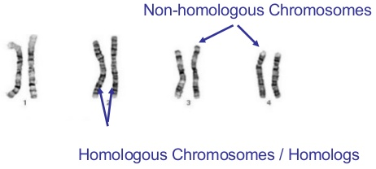

Linked genes are therefore ***genes that are found on the same chromosome*** ***pair*** NOT on different chromosomes. They are inherited together as a unit and do not undergo independent assortment.

**How to write the genotype of a person with linked genes**

1. Write both alleles for the genotype of the individual based upon its phenotype.
2. Rule a double line under the genotype to signify the gene is on the same chromosome. *The lines represent the homologous chromosomes where the genes are linked.*

For example:

If genes for hair color and second toe length are linked.

Alleles for hair color: B – black hair; b – brown hair

Alleles for 2nd toe length: T – longer than 1st toe; t – shorter than 1st toe

Examples of genotypes:

|  |  |  |
| --- | --- | --- |
| **Phenotype** | **Genotype** | **Gametes** |
| Heterozygous black hair, homozygous longer 2nd toe | B T  b T | B T and b T |
| Brown hair; shorter 2nd toe length (Homozygous recessive for both traits) | b t  b t | b t |

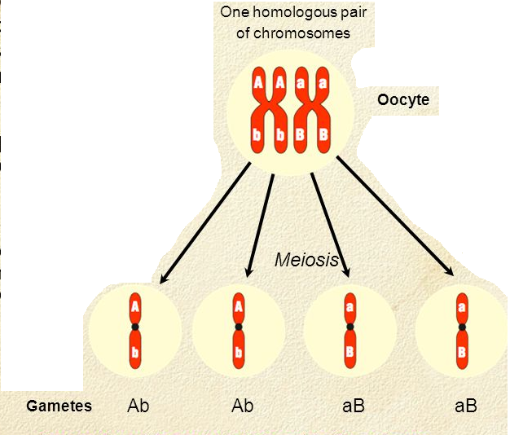**Biological basis for heredity**

Linkage can alter genotype and phenotype ratios in the offspring.

The diagram on the right shows how linked genes are passed onto gametes during meiosis.

Genes A and B control different traits and are on the same chromosome (linked). As a result of meiosis, only two types of gametes are produced instead of the expected four kinds if the genes were on different chromosomes (not linked).

**SEX-LINKED GENES**

These are genes that are found only on the sex chromosomes. In humans, the **sex chromosomes** are chromosome pair 23 which are normally represented as **X** and **Y** because of how they look as chromatids during meiosis. Female sex chromosomes are homologous in size and are called **X** and **X** (or **XX**). Males have an odd pair of sex chromosomes. One is the **X** chromosome but the other is a shorter chromosome called a **Y** chromosome. Males are therefore symbolized as **XY.**

Any chromosome that is found on the upper portion of the X chromosome for both males and females are called sex-linked genes.

***How to write the genotype of a person with a sex-linked trait:***

1. Write down the sex chromosomes for the person (whether male, XY or female, XX)
2. Write the allele for the gene above each chromosome.

For example:

Haemophilia is a medical disorder of the blood whereby clots are not able to be formed. It is caused by a sex-linked, recessive allele. The following alleles represent the traits for haemophilia:

H – normal blood h – haemophilia

Therefore the genotype of a woman with haemophilia would be XhXh. A man with haemophilia would have the genotype XhY.

**Biological basis of heredity**

Any sex-linked gene found on the males X chromosome will be automatically expressed as a phenotype. Since the Y chromosome is shorter, it lacks some of the genes that should be present on its other X chromosome pair. This is because the other allele for the gene would be missing on the shorter Y chromosome. It is for this reason that ***males can never be heterozygotes.***

|  |  |
| --- | --- |
| **Phenotype** | **Genotype** |
| Woman with haemophilia | XhXh |
| Woman with normal blood | XHXH |
| Woman carrier for haemophilia (has normal blood but also carries the allele for haemophilia | XHXh |
| Male with haemophilia | XhY |
| Male with normal blood | XHY |

Example:

The following table shows the possible genotypes of people with or without haemophilia.

**Features of sex-linkage**

* Genes are found on the X sex chromosome.
* Females can be carriers (heterozygotes) of sex-linked traits.
* Males can never be carriers (heterozygotes) for sex-linked traits.
* Male Y chromosome is missing some genes. So any allele for a gene that is found on the X chromosome will be expressed in the phenotype.
* Fathers who carry the sex-linked gene will pass the trait onto their daughters.
* Mothers who have the sex-linked gene will pass the trait on to their sons.

**Other sex-linked traits**

|  |  |  |  |  |  |
| --- | --- | --- | --- | --- | --- |
|  |  | **Genotype(s)** | | | |
| **Trait** | **Represented by** | **Female with the condition** | **Normal female** | **Male with the condition** | **Male carrier** |
| Red-green colour blindness in humans | **Recessive allele**  C – normal sight  c – color blind | XcXc | XCXC or XCXc | XcY | Not possible |
| Tortoise-shell coat color in cats | **Heterozygous genotype**  B – black coat color  b – ginger coat color  Bb – tortoise shell | XGXg | XBXB**=** black  XbXb = ginger | Not possible | Not possible |

***Example of how to solve genetics problems involving linked genes***

Example: Genes for hair color and second toe length are linked.

Alleles for hair color: B – black hair; b – brown hair

Alleles for 2nd toe length: T – longer than 1st toe; t – shorter than 1st toe

A man heterozygous for both hair color and toe length marries a woman homozygous dominant for black hair and has a shorter 2nd toe. Determine the phenotypic ratio of their offspring.

**Phenotype of parents:** heterozygous for homozygous dominant

hair color for black hair; shorter

x

& toe length second toe

**Genotype of parents:** B T B t

x

b t B t

**Genotype of gametes:** B T and b t B t

|  |  |  |
| --- | --- | --- |
|  | **B T** | **b t** |
| **B t** | B T  B t | b t  B t |

**Punnet cross:**

**Phenotypic ratio of offspring:** 1 Black hair, long 2nd toe ; 1 Black hair, short 2nd toe

***Example of how to solve sex-linked genetics problems***

A man with haemophila marries a woman who is a carrier for haemophila. Determine the phenotypic ratio of their offspring.

H – normal blood h – haemophilia

**Phenotype of parents:** Haemophilic male x Carrier female

**Genotype of parents:** XhY x XHXh

**Gametes:** Xh and Y XH and Xh

|  |  |  |
| --- | --- | --- |
|  | Xh | Y |
| XH | XHXh | XHY |
| Xh | XhXh | XhY |

**Punnet cross:**

**Phenotypic ratio of offspring:** 1 haemophilic : 1 normal

(or 1 normal female : 1 haemophilic female : 1 normal male : 1 haemophilic male)

**LESSON ACTIVITY**

**Question One:**

The following illustration shows a medical condition that is sex-linked. **(L1) (Bio2.4.1.3)**

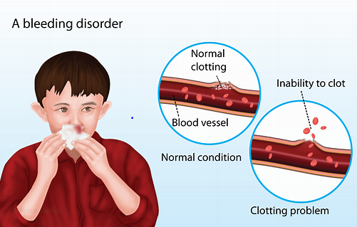

The medical condition shown above is known as: ________________________________________

**Question Two**

Describe the process of: **(L2) (Bio2.4.2.3)**

(i)**Genetic Linkage:** ______________________________________________________________________________________________________________________________________________________________________________________________________________________________________________________________________________________________________________________________________________________________________________________________________________________________________________________________________________

(ii)**SexLinkage:**_________________________________________________________________________________________________________________________________________________________________________________________________________________________________________________________________________________________________________________________________________________________________________________________________________________________________________________________________

**Question Three**

Describe an example of **Linked Genes** in Humans. **(L2) (Bio2.4.2.5)**

___________________________________________________________________________________________________________________________________________________________________________________________________________________________________________________________________________________________________________________________________________________________________________________________________________________________________________________________________________________________________________________________________________________________

**Question Four**

Compare **sex linkage** to **genetic linkage**. **(L3) (Bio2.4.3.6)**

**__________________________________________________________________________________________________________________________________________________________________________________________________________________________________________________________________________________________________________________________________________________________________________________________________________________________________________________________________________________________________________________________________________________________________________________________________________________________________________________________________________________________________________________________________________________________________________________________________**

**Question Five**

Discuss **Genetic Linkage** and **Sex Linkage** as the biological basis of heredity.

**(L4) (Bio2.4.4.1)**

**__________________________________________________________________________________________________________________________________________________________________________________________________________________________________________________________________________________________________________________________________________________________________________________________________________________________________________________________________________________________________________________________________________________________________________________________________________________________________________________________________________________________________________________________________________________________________________________________________**