GEOGRAPHY
STRAND 3: LOCAL, REGIONAL AND GLOBAL STUDIES
Major landform types in the Pacific Region
Mountains, hills, plateaus, and plains are the four major types of landforms. Minor landforms include buttes, canyons, valleys, and basins. Tectonic plate movement under the Earth can create landforms by pushing up mountains and hills.
Compare the sizes of island
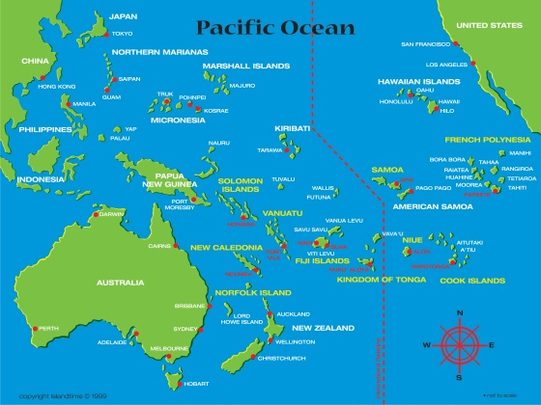

Major Pacific island countries (Refer to the Pacific Map above)

Boundaries and territories of the Pacific island countries
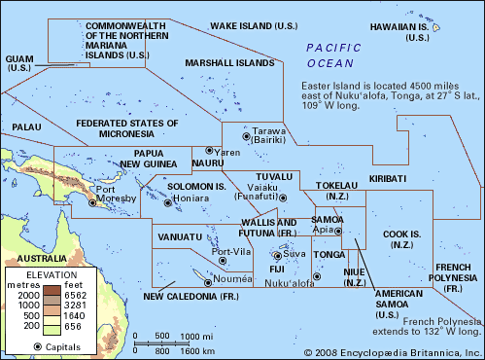
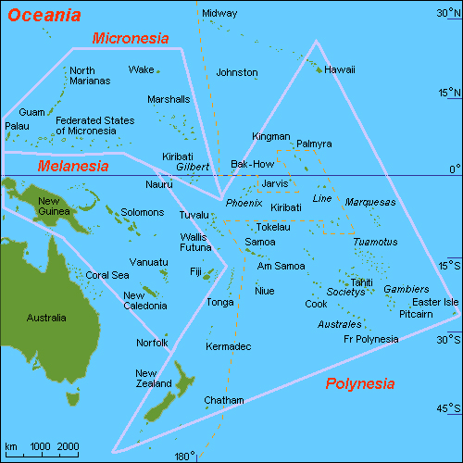

What is a Climate?
The weather conditions prevailing in an area in general or over a long period.
Climate Change?
is any significant long-term change in the expected patterns of average weather of a region (or the whole Earth) over a significant period of time. Climate change is about abnormal variations to the climate, and the effects of these variations on other parts of the Earth.
Characteristics of climate change
For example, sea levels are rising, and snow and ice cover is decreasing. Rainfall patterns and growing seasons are changing. Further sea-level rise and melting of snow and ice are likely as Earth warms. The warming climate likely will cause more floods, droughts and heat waves.
What are global climate patterns?
Global climate patterns are dynamic: They are continually changing in response to solar radiation, atmospheric greenhouse gas concentrations, and other climate forcing factors. Among the more predictable of these changes are cyclical changes in solar radiation reaching the poles.
Effects of climate change on people and their environment.

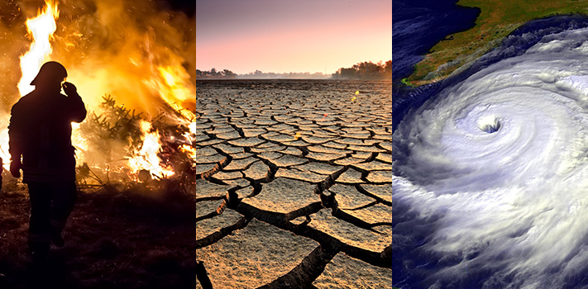

EL NINO
is an abnormal weather pattern caused by the warming of the Pacific Ocean near the equator, off the coast of South America. The sun warms the water near the equator, which can make more clouds and, therefore, more rain. However, normally there are trade winds, which blow that warm water west.
La NINA
an irregularly recurring upwelling of unusually cold water to the ocean surface along the western coast of South America that often occurs following an El Niño and that disrupts typical regional and global weather patterns especially in a manner opposite to that of El Niño.
Impacts of El Nino and La Nina on Vanuatu and around the globe
Severe drought and associated food insecurity, flooding, rains, and temperature rises due to El Niño are causing a wide range of health problems, including disease outbreaks, malnutrition, heat stress and respiratory diseases.
Matrimonial Society- are systems of property ownership between spouses providing for the creation or absence of a marital estate and if created, what properties are included in that estate, how and by whom it is managed, and how it will be divided and inherited at the end of the marriage.
Patrimonial Society - is defined as any form of political domination or authority based on personal and bureaucratic power exerted by a royal household.
Governing institution the Pacific
Pacific Community
The Pacific Community. SUSTAINABLE PACIFIC DEVELOPMENT THROUGH SCIENCE, KNOWLEDGE AND INNOVATION. "" ...

Pacific Islands Forum Secretariat
It aims to strengthen collective action as one "Blue Pacific Continent" by putting "The Blue Pacific" at the centre of the policy making and collective action for

Council of Regional Organisations in the Pacific
The Council of Regional Organisations in the Pacific (CROP) is an inter-organisational consultative process which aims to prevent either overlaps, or gaps, appearing between the work-programmes of its various members.

USP: The University of the South Pacific
The University of the South Pacific (USP) is the premier provider of tertiary education in the Pacific Region, and an international centre of excellence for teaching ...

South Pacific Regional Environment Programme (SPREP)

The South Pacific Regional Environment Programme (SPREP) is a regional organization established by the governments and administrations of the Pacific ..

South Pacific Tourism Organisation

The South Pacific Tourism Organisation (STPO) is an intergovernmental organisation for the tourism sector in the South Pacific. The STPO markets, promotes, ...

Forum Fisheries Agency (FFA) – Forum Sec - Pacific Islands ...

The Pacific Islands Forum Fisheries Agency (FFA) strengthens national capacity and regional solidarity so its 17 members can manage, control and develop

Western and Central Pacific Fisheries Commission

The Western and Central Pacific Fisheries Commission (WCPFC) is a treaty-based organisation established to conserve and manage tuna and other highly ...

Cultural conflicts between the Pacific Islanders and the causes towards instability
- The challenges to internal resilience in the Pacific Islands are both structural — in the form of issues arising from population growth, urbanisation, land, immigration, health, and gender relations — and particular to the political situation in each Island nation.
- The inability of Pacific states to match service provision in cities with their growing populations is a major challenge to resilience.
- Of all political issues in Papua New Guinea, loss of customary land is the most likely to provoke protest and conflict.
Example,
- Riot in the Solomon Islands against the Chinese embassy 1999, 1998 -2003, civil war between the Malaitans and the Guadalcanal rebels.
- Ethical conflict between Ambrym and Tanna in 2007.
- Coupe in Fiji in 1989 and 2002( Indo –Fijians vs Native Fijians)
- West Papuans(Bougainville) vs Indonesians

Economic system in the Pacific
Tourism. Tourism has become a large source of income for many in the Pacific; tourists come from Australia, New Zealand, Japan, the United Kingdom and the United States. Fiji currently draws almost half a million tourists each year; more than a quarter from Australia.

Service industry
The overwhelming majority of people living in the Pacific islands work in the service industry which includes tourism, education and financial services. Oceania's largest export markets include Japan, China, the United States and South Korea. The majority of people living in Australia and to a lesser extent, New Zealand work in mining, electrical and manufacturing sectors also.

Manufacturing
The manufacturing of clothing is a major industry in some parts of the Pacific, especially Fiji, although this is decreasing.
Australia boasts the largest amount of manufacturing in the region. Producing cars, electrical equipment, machinery and clothes.

Tourism has become a large source of income for many in the Pacific; tourists come from Australia, New Zealand, Japan, the United Kingdom and the United States. Fiji currently draws almost half a million tourists each year; more than a quarter from Australia. This contributes $1 billion or more since 1995 to Fiji's economy but the Government of Fiji islands underestimate these figures due to invisible economy inside tourism industry.

Agriculture and fishing
Agriculture and natural resources constitutes only 5% to 10% of Oceania's total jobs, but contributes substantially to export performance. The most populous two nations, Australia and New Zealand, are also the most developed and have majority service industries. This dilutes the data from the less developed Pacific Island nations who have major agricultural economies. Most of the Pacific countries (excluding Australia and New Zealand) the primary industry is agriculture. Many nations are still quintessentially agricultural; for example, 80% of the population of Vanuatu and 70% of the population of Fiji works in agriculture. The main produce from the pacific is copra or coconut, but timber, beef, palm oil, cocoa, sugar and ginger are also commonly grown across the tropics of the Pacific. Fishing provides a major industry for many of the smaller nations in the Pacific, although many fishing areas are exploited by other larger countries, namely Japan. Natural Resources, such as lead, zinc, nickel and gold, are mined in Australia and the Solomon Islands. Oceania's largest export markets include Japan, China, the United States, India, South Korea and the European Union.

Causes of Economic downfall in the Pacific
- High unemployment Rate
- Agricultural production is declining
- High level of emigration (e.g. Tonga and Samoa)
- Political Instability
- Trade Dispute (Market Price – Fiji vs Vanuatu over kava export)
- Natural disasters

Sustainable Development: economic development that is conducted without depletion of natural resources.
Examples of Fragile ecosystem in the Pacific
The characteristics of size, shape and degree of isolation make many of these islands ecologically and culturally unique. However these same characteristics also make islands fragile and vulnerable ecosystems. Islands have the highest proportion of recorded species extinctions.
- Wetlands
- Deserts
- Mountains
- Coral reefs
- Coastal areas
Examples of Conservation measures in the Pacific
- Kari Reserve on Erromango
- Nguna –Pele MPA Network 2003 -SPREP
- Crab bay MPA Network 2004 –SPREP
- Rich terrestrial and Marine biota of uninhabited Tetepare island, Solomon Islands in 2006 –SPREP
- MPA in Yadua, Fiji in 2011- SPREP

The Role of SPREP in the Pacific
Under the Agreement Establishing SPREP(secretariat of the Pacific Regional Environment programme), the purposes of SPREP are to promote cooperation in the South Pacific Region and to provide assistance in order to protect and improve the environment and to ensure sustainable development for present and future generations
Headquarter in Apia, Samoa.

Challenges by the SPREP in implementing the conservation measures
The region faces a limited range of resources, dependence on imports, high population growth on many islands and increasing urbanization, limited supplies of freshwater, high transaction costs, costly administration and infrastructure and limited institutional capacities and domestic markets. There is high species endemism and globally significant biodiversity, but relatively low species diversity. Soils and land resources are limited in capacity and ability to accommodate growing development demands, and coastal and marine resources are under increasing pressure. The degradation of ecosystems, land and marine resources impinge on the quality of life opportunities for many island communities.

Traditional methods of protecting resources
- Traditional knowledge and resources use
- Tabus or Taboo
- Community Management
- Cooperative Management

