AGRICULTURAL SCIENCE
Strand 2: Sustainable Primary Production | Sub-strand 2.3: GLOBAL ISSUES AFFECTING PRIMARY PRODUCTION
LESSON ACTIVITY 5 Biodiversity

The Specific Learning Outcome (SLO) targeted in this activity are provided below.
SLO# | Specific Learning Outcomes: Students are able to | Skill level | SLO code
18 | Define biodiversity | 1 | agr2.3.1.5
19 | Define genetic resource conservation. | 1 | agr2.3.1.6
20 | Describe the nature of conservation of Biodiversity and Genetic Resources for sustainable primary production | 2 | agr2.3.2.6
21 | Explain how biodiversity and genetic resource conservation and sustainable use enhances local primary production | 3 | agr2.3.3.5
22 | Discuss how food production connected to all the causes of biodiversity loss and recommend ways to minimise it. | 4 | agr2.3.4.5
23 | Discuss and recommend ways to minimise the disadvantages of biodiversity and genetic resource conservation and sustainable use in local primary production | 4 | agr2.3.4.6

Biodiversity

Biodiversity refers to the variety of living species on Earth, including plants, animals, bacteria, and fungi. While Earth’s biodiversity is so rich that many species have yet to be discovered, many species are being threatened with extinction due to human activities, putting the Earth’s magnificent biodiversity at risk.
Genetic resource
Genetic resources are the heritable characteristics of a plant or animal of real or potential benefit to people. The term includes modern cultivars and breeds; traditional cultivars and breeds; special genetic stocks (breeding lines, mutants, etc); wild relatives of domesticated species; and genetic variants of wild resource species. A ‚wild genetic resource' is the wild relative of a plant or animal that is already known to be of economic importance. The reasons for conserving such a resource include the provision of direct and indirect economic benefits. However, the conserved genetic material must be made available to the people who require it to improve the productivity, quality, or pest resistance of utilized plants or animals.

What’s destroying biodiversity?
We are, particularly as the human population rises and wild areas are razed to create farmland, housing and industrial sites. Deforestation threatens many species.
What can be done to reduce destroying biodiversity?
We can all help. Most wildlife is destroyed by land being cleared for farming livestock such as cattle and crop farming. Giving nature the space and protection it needs is the only answer. Wildlife reserves are the obvious solution.
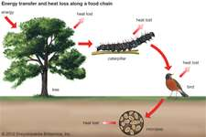
A healthy biodiversity provides a number of natural services for everyone:
- Ecosystem services, such as
  - Protection of water resources
  - Soils formation and protection
  - Nutrient storage and recycling
  - Pollution breakdown and absorption
  - Contribution to climate stability
  - Maintenance of ecosystems
- Biological resources, such as
- Food
- Medicinal resources and pharmaceutical drugs
- Wood products
- Ornamental plants
- Breeding stocks, population reservoirs
- Future resources
- Diversity in genes, species and ecosystems
- Social benefits, such as
  - Research, education and monitoring
  - Recreation and tourism
  - Cultural values

Soil, bacteria, plants; the Nitrogen Cycle
The relationship between soil, plants, bacteria and other life is also referred to as the nitrogen cycle.
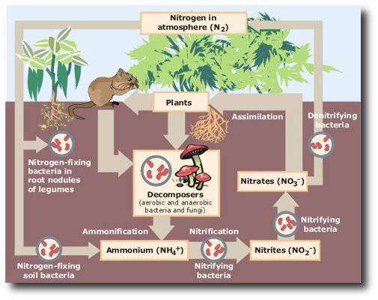
As an example, consider all the species of animals and organisms involved in a simple field used in agriculture.
- Crop by-products feed cattle
- Cattle waste feeds the soil that nourish the crops
- Crops, as well as yielding grain also yield straw
  - Straw provides organic matter and fodder
  - Crops are therefore food sources for humans and animals
- Soil organisms also benefit from crops
  - Bacteria feed on the cellulose fibers of straw that farmers return to the soil
  - Amoebas feed on bacteria making lignite fibers available for uptake by plants
  - Algae provide organic matter and serve as natural nitrogen fixers
  - Rodents that bore under the fields aerate the soil and improve its water-holding capacity
  - Spiders, centipedes and insects grind organic matter from the surface soil and leave behind enriched droppings.
  - Earthworms contribute to soil fertility
- They provide aerage, drainage and maintain soil structure.
- The earthworm is like a natural tractor, fertilizer factory and dam, combined.

Exercise 6
1. Define biodiversity.

2. Define genetic resource conservation.

3. Describe the nature of conservation of Biodiversity and Genetic Resources for sustainable primary production.

4. Explain how biodiversity and genetic resource conservation and sustainable use enhances local primary production.

5. Discuss how food production connected to all the causes of biodiversity loss and recommend ways to minimise it.

6. Discuss and recommend ways to minimise the disadvantages of biodiversity and genetic resource conservation and sustainable use in local primary production.

