AGRICULTURAL SCIENCE
Strand 2: Sustainable Primary Production | Sub-strand 2.2: Husbandry/ Agronomy Practices

LESSON ACTIVITY 2: IMPORTANCE OF MANAGEMENT PRACTICES FOR SUSTAINABLE PRIMARY PRODUCTION

The Specific Learning Outcome (SLO) targeted in this activity are provided below.
SLO# | Specific Learning Outcomes: Students are able to | Skill level | SLO code
6 | Define crop rotation | 1 | agr2.2.1.2
7 | Describe the practice of crop rotation cultivation in long term primary production | 2 | agr2.2.2.3
8 | Explain how crop rotation cultivation ensures the capability of long term primary production | 3 | agr2.2.3.2
9 | Discuss the advantages and disadvantages of crop rotation cultivation and recommend cost-effective ways of ensuring the capability of long term primary production | 4 | agr2.2.4.2

CROP ROTATION
Crop rotation is the practice of growing a series of dissimilar or different types of crops in the same area in sequenced seasons. It is done so that the soilof farms is not used for only one set of nutrients. It helps in reducing soil erosion and increases soil fertility and crop yield.The land is divided into sections, usually between 3 to 6, and each year a different crop is planted on each section.
- Crops with different root depth are grown in different time so all level of top soil are used.
- Different crops take different amounts of minerals from the soil, so a rotation based on nutrient requirements of crops is an important strategy in the total soil management program.
- Crops with high fertility requirements (heavy feeder: tomatoes, cabbages, corn, cucumber, pumpkins) should be followed by a restoring crop (beans, peanuts) which in turn should be followed by a crop which depletes the fertility of the soil only slightly (light feeder: carrots, sweet potatoes, raddish)
- Crop rotation can help reduce the spread of pests and diseases which are destructive to crops. Insects usually prefer to feed on certain crops or families of crops and most diseases are specific to a certain crops or families of crops.
- Separating the pests from its host by growing an alternative crop has long been an important element of pest management, especially for pests such as nematodes which are difficult to control by other methods. Breaking continuous cropping of a single crop (e.g. sweet potato) has been shown to result in fewer pest problems.
Growing the same crop in the same place for many years in a row (monocropping) gradually depletes the soil of certain nutrients. With rotation, a crop that leaches the soil of one kind of nutrient is followed during the next growing season by a dissimilar crop that returns that nutrient to the soil or draws a different ratio of nutrients. In addition, crop rotation mitigates the buildup of pathogens and pests that often occurs when one species is continuously cropped, and can also improve soil structure and fertility by increasing biomass from varied root structures.
Crop rotation increases the nutrients in the soil, thus allows the farmer to plant crops successfully without the need of applying fertilizers. Crop rotation also reduces the constant infestation of crops by pests and diseases, stopping the need of spraying the crops with pesticides.
Plants have different nutrient and mineral requirements and deplete the soil of certain elements while leaving behind other minerals, bacteria, and environments. Crop rotation allows the plants’ effects on the soil to benefit the next crop. Basically, crop rotation capitalizes on what is already happening when plants grow, and prevents the negative consequences that can result from random plantings.

Benefits of crop rotation:
- Improves soil structure
- Controls weeds, diseases, and harmful insects
- Increases microbiology; bacteria and insects
- Preserves the environment
- Decrease cost

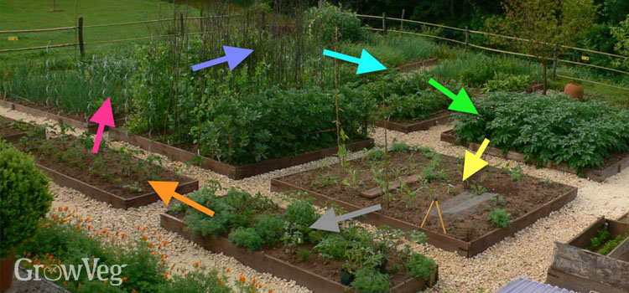 Crop rotation

Exercise 2
1. Define crop rotation. L1 agr2.2.1.2
2. Describe the practice of crop rotation cultivation in long term primary production L2 agr2.2.2.3

3.Explain how crop rotation cultivation ensures the capability of long term primary production. L3 agr2.2.3.2
4. Discuss the advantages and disadvantages of crop rotation cultivation and recommend cost-effective ways of ensuring the capability of long term primary production. L4 agr2.2.4.2

