Central School
Home School Package

Year :12ECO

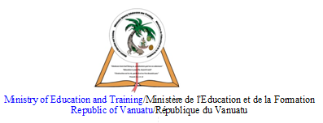

HOME SCHOOL PACKAGE CONTENT

LESSON Plan

Teacher | Name : Charlie Gihiala  Subject : Economics
Date  Date | Week FIVE  TERM TWO
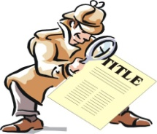 | Topic :  RESOURCE ALLOCATION THROUGH THE STATE SECTOR  Lesson number : 5
Learning outcomes | 12ECO2.1.3.1  Explain the aims of a Government budget.  3
Introduction | Government prepares the budget for fulfilling certain objectives. These objectives are the direct outcome of government’s economic, social and political policies.  http://www.yourarticlelibrary.com/economics/budgeting/6-important-objectives-of-government-budget/30410
Catch phrase for the lesson

The Government's proposed budget of VT57,148,528,185 for the year 2020 received overwhelming support from the Opposition bloc when tabled in Parliament yesterday by the Minister of Finance, Gaetan Pikioune. Dec 17, 2019

https://dailypost.vu/news/vt57-billion-proposed-budget-for-2020/article_0e7677c2-204e-11ea-bff0-5715803c603f.html

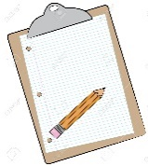  Learners notes | Summary  - The main aims of a government budget is to fund the various activities performed by its economic functions including: Maintaining law and order / national defense. Raising taxes. Providing public services not provided in a free market (e.g. health care, education, street lighting)  Budget is a crucially important activity under governance.  The most important objectives of a government budget are re- ..  Read more at:  https://www.businessinsider.in/budget-what-objectives-does-a-government-budget-serves/articleshow/67699696.cms?utm_source=contentofinterest&utm_medium=text&utm_campaign=cppst  Key Terms  Government Ministries, Department, Central Government, Provincial Government, Municipal Council, Public and Private Sector.
https://www.youtube.com/watch?v=CJ3KA8nddpQ

Also read the script or comments if available.

Take down important points given in this video

- List the main aims of a government budget
- In a paragraph explain each of the government aims
- Which aim of the government is concerned with employing Police officers?
Assignment | Discuss this Daily Post article:  https://dailypost.vu/news/no-families-in-caves/article_a1b26a30-962f-11ea-9b3e-330747340ca7.html  - Bio: Author, dates, webpage description.  - Content: 3 main points with supportive arguments to describe the article  - Context: How does this article relate to 12ECO2.1.3.1  - Conclusion: What you have learnt that will be useful in real life.
Assessment | Answer this question in form of Essay  Education and health should always be the main the priority accounts, in Vanuatu government budget. Explain why?
References | https://dailypost.vu/news/no-families-in-caves/article_a1b26a30-962f-11ea-9b3e-330747340ca7.html  https://www.youtube.com/watch?v=CJ3KA8nddpQ  https://www.businessinsider.in/budget-what-objectives-does-a-government-budget-serves/articleshow/67699696.cms?utm_source=contentofinterest&utm_medium=text&utm_campaign=cppst  https://dailypost.vu/news/vt57-billion-proposed-budget-for-2020/article_0e7677c2-204e-11ea-bff0-5715803c603f.html  http://www.yourarticlelibrary.com/economics/budgeting/6-important-objectives-of-government-budget/30410

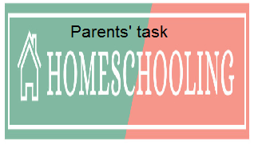

WEEKLY CHECKLIST For Parents:

Term: 2 Week number 1 Date…… to…… Month: …………

Subject | Number of lessons | Days | Tick when activity is complete | Parents comment | Signature
 | 1
 | 2
 | 3
 | 4
 | 5
 | 6

Term: 2 Week number 2 Date…… to…… Month: …………

Subject | Number of lessons | Days | Tick when activity is complete | Parents comment | Signature
 | 1
 | 2
 | 3
 | 4
 | 5
 | 6

Term: 2 Week number 3 Date…… to…… Month: …………

Subject | Number of lessons | Days | Tick when activity is complete | Parents comment | Signature
 | 1
 | 2
 | 3
 | 4
 | 5
 | 6

Term: 2 Week number 4 Date…… to…… Month: …………

Subject | Number of lessons | Days | Tick when activity is complete | Parents comment | Signature
 | 1
 | 2
 | 3
 | 4
 | 5
 | 6

Term: 2 Week number 5 Date…… to…… Month: …………

Subject | Number of lessons | Days | Tick when activity is complete | Parents comment | Signature
 | 1
 | 2
 | 3
 | 4
 | 5
 | 6

Term: 2 Week number 6 Date…… to…… Month: …………

Subject | Number of lessons | Days | Tick when activity is complete | Parents comment | Signature
 | 1
 | 2
 | 3
 | 4
 | 5
 | 6

Term: 2 Week number 7 Date…… to…… Month: …………

Subject | Number of lessons | Days | Tick when activity is complete | Parents comment | Signature
 | 1
 | 2
 | 3
 | 4
 | 5
 | 6

Term: 2 Week number 8 Date…… to…… Month: …………

Subject | Number of lessons | Days | Tick when activity is complete | Parents comment | Signature
 | 1
 | 2
 | 3
 | 4
 | 5
 | 6

Term: 2 Week number 9 Date…… to…… Month: …………

Subject | Number of lessons | Days | Tick when activity is complete | Parents comment | Signature
 | 1
 | 2
 | 3
 | 4
 | 5
 | 6

Term: 2 Week number 10 Date…… to…… Month: …………

Subject | Number of lessons | Days | Tick when activity is complete | Parents comment | Signature
 | 1
 | 2
 | 3
 | 4
 | 5
 | 6

Term: 2 Week number 11 Date…… to…… Month: …………

Subject | Number of lessons | Days | Tick when activity is complete | Parents comment | Signature
 | 1
 | 2
 | 3
 | 4
 | 5
 | 6

Term: 2 Week number 12 Date…… to…… Month: …………

Subject | Number of lessons | Days | Tick when activity is complete | Parents comment | Signature
 | 1
 | 2
 | 3
 | 4
 | 5
 | 6

Term: 2 Week number 13 Date…… to…… Month: …………

Subject | Number of lessons | Days | Tick when activity is complete | Parents comment | Signature
 | 1
 | 2
 | 3
 | 4
 | 5
 | 6

