Central School
Home School Package

Year :12ECO

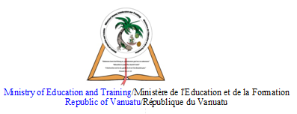

HOME SCHOOL PACKAGE CONTENT

Teacher | Name : Charlie Gihiala  Subject : Economics
Date  Date | Week EIGHT  TERM TWO
Topic :

RESOURCE ALLOCATION THROUGH THE STATE SECTOR

Lesson number : 8

Learning outcomes | 12ECO2.1.2.7  Explain the economic issue of inflation.  2
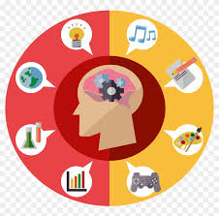  Introduction | Inflation is a quantitative measure of the rate at which the average price level of a basket of selected goods and services in an economy increases over some period of time. It is the rise in the general level of prices where a unit of currency effectively buys less than it did in prior periods. Mar 26, 2020  https://www.investopedia.com/terms/i/inflation.asp
Catch phrase for the lesson

1000vuv bought more goods and services in 1990 than it does in 2020
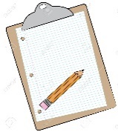  Learners notes | Summary  By MARC DAVIS Updated Feb 9, 2019  When prices for energy, food, commodities, and other goods and services rise, the entire economy is affected. Rising prices, known as inflation, impact the cost of living, the cost of doing business, borrowing money, mortgages, corporate, and government bond yields, and every other facet of the economy.  KEY TAKEAWAYS  - Inflation is the rise in the price of goods and services in an economy over a certain period.  - Inflation that is controlled and low generally helps an economy recover from a recession and results in increases in employment.  - The gross domestic product (GDP), which represents the total value of a nation's finished goods and services produced, measures the health of an economy.  - The Consumer Price Index (CPI) measures an economy's inflation and includes "basket" of basic goods and services, such as food, energy, clothing, and housing.  Follow this link  https://www.investopedia.com/financial-edge/0212/inflation-and-economic-recovery.aspx
https://www.investopedia.com/articles/insights/122016/9-common-effects-inflation.asp

Also read the comments from previous viewers. Show appreciation by commenting on the video

https://www.investopedia.com/articles/insights/122016/9-common-effects-inflation.asp

Reflect on Video

Assignment | Discuss this Daily Post article:  https://dailypost.vu/news/consumer-price-index-increased-in-first-quarter-2018/article_03bd1b79-3f47-51ab-88df-f6143a9db0f0.html  - Bio: Author, dates, webpage description.  - Content: 3 main points with supportive arguments to describe the article  - Context: How does this article relate to 12ECO2.1.2.7  - Conclusion: What you have learnt that will be useful in real life.
Assessment | Answer this question in form of Essay  Open book test.
References | - https://dailypost.vu/news/consumer-price-index-increased-in-first-quarter-2018/article_03bd1b79-3f47-51ab-88df-f6143a9db0f0.html  - https://www.investopedia.com/articles/insights/122016/9-common-effects-inflation.asp  - https://www.investopedia.com/financial-edge/0212/inflation-and-economic-recovery.aspx  - https://www.investopedia.com/terms/i/inflation.asp

LESSON Plan

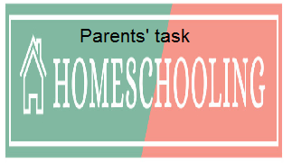

WEEKLY CHECKLIST For Parents:

Term: 2 Week number 1 Date…… to…… Month: …………

Subject | Number of lessons | Days | Tick when activity is complete | Parents comment | Signature
 | 1
 | 2
 | 3
 | 4
 | 5
 | 6

Term: 2 Week number 2 Date…… to…… Month: …………

Subject | Number of lessons | Days | Tick when activity is complete | Parents comment | Signature
 | 1
 | 2
 | 3
 | 4
 | 5
 | 6

Term: 2 Week number 3 Date…… to…… Month: …………

Subject | Number of lessons | Days | Tick when activity is complete | Parents comment | Signature
 | 1
 | 2
 | 3
 | 4
 | 5
 | 6

Term: 2 Week number 4 Date…… to…… Month: …………

Subject | Number of lessons | Days | Tick when activity is complete | Parents comment | Signature
 | 1
 | 2
 | 3
 | 4
 | 5
 | 6

Term: 2 Week number 5 Date…… to…… Month: …………

Subject | Number of lessons | Days | Tick when activity is complete | Parents comment | Signature
 | 1
 | 2
 | 3
 | 4
 | 5
 | 6

Term: 2 Week number 6 Date…… to…… Month: …………

Subject | Number of lessons | Days | Tick when activity is complete | Parents comment | Signature
 | 1
 | 2
 | 3
 | 4
 | 5
 | 6

Term: 2 Week number 7 Date…… to…… Month: …………

Subject | Number of lessons | Days | Tick when activity is complete | Parents comment | Signature
 | 1
 | 2
 | 3
 | 4
 | 5
 | 6

Term: 2 Week number 8 Date…… to…… Month: …………

Subject | Number of lessons | Days | Tick when activity is complete | Parents comment | Signature
 | 1
 | 2
 | 3
 | 4
 | 5
 | 6

Term: 2 Week number 9 Date…… to…… Month: …………

Subject | Number of lessons | Days | Tick when activity is complete | Parents comment | Signature
 | 1
 | 2
 | 3
 | 4
 | 5
 | 6

Term: 2 Week number 10 Date…… to…… Month: …………

Subject | Number of lessons | Days | Tick when activity is complete | Parents comment | Signature
 | 1
 | 2
 | 3
 | 4
 | 5
 | 6

Term: 2 Week number 11 Date…… to…… Month: …………

Subject | Number of lessons | Days | Tick when activity is complete | Parents comment | Signature
 | 1
 | 2
 | 3
 | 4
 | 5
 | 6

Term: 2 Week number 12 Date…… to…… Month: …………

Subject | Number of lessons | Days | Tick when activity is complete | Parents comment | Signature
 | 1
 | 2
 | 3
 | 4
 | 5
 | 6

Term: 2 Week number 13 Date…… to…… Month: …………

Subject | Number of lessons | Days | Tick when activity is complete | Parents comment | Signature
 | 1
 | 2
 | 3
 | 4
 | 5
 | 6

