Central School
Home School Package

Year :12ECO

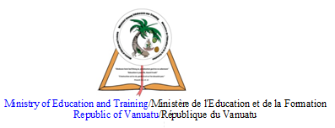

HOME SCHOOL PACKAGE CONTENT

LESSON Plan

Teacher | Name : Charlie Gihiala  Subject : Economics
Date  Date | Week TWO  TERM TWO
Topic :

RESOURCE ALLOCATION THROUGH THE STATE SECTOR

Lesson number : 2

Learning outcomes | 11ECO2.1.2.2  Outline the economic functions of the government  2
Introduction | Economists, however, identify six major functions of governments in market economies. Governments provide the legal and social framework, maintain competition, provide public goods and services, redistribute income, correct for externalities, and stabilize the economy.  https://www.unomaha.edu/college-of-business-administration/center-for-economic-education/teacher-resources/6-8/what-are-the-economic-functions-of-government.pdf
Catch phrase for the lesson

There are six main government economic functions
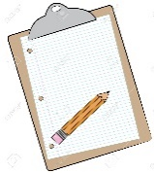  Learners notes | Summary  - The economic functions of a government include: Protection of private property and maintaining law and order / national defense. Raising taxes. Providing public services not provided in a free market (e.g. health care, education, street lighting)  Key Terms  Follow this link  https://www.economicshelp.org/blog/21699/economics/what-are-the-economic-functions-of-a-government/
https://study.com/academy/lesson/what-are-the-economic-functions-of-government.html

Also read the script if available.

Take down important points given in this video

- List the six functions of a government
- In a paragraph explain each of the six functions
- Which of the function is the government using to address COVID19?
Assignment | Discuss this Daily Post article:  https://dailypost.vu/news/opposition-reconsider-employment-stabilisation-plan/article_7db976d0-9631-11ea-8fcb-d74bbb51ca02.html  - Bio: Author, dates, webpage description.  - Content: 3 main points with supportive arguments to describe the article  - Context: How does this article relate to 12ECO2.1.2.2  - Conclusion: What you have learnt that will be useful in real life.
Assessment | https://study.com/academy/practice/quiz-worksheet-economic-functions-of-government.html
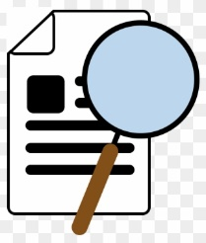  References | - https://study.com/academy/practice/quiz-worksheet-economic-functions-of-government.html  - https://dailypost.vu/news/opposition-reconsider-employment-stabilisation-plan/article_7db976d0-9631-11ea-8fcb-d74bbb51ca02.html  - https://study.com/academy/lesson/what-are-the-economic-functions-of-government.html  - https://www.unomaha.edu/college-of-business-administration/center-for-economic-education/teacher-resources/6-8/what-are-the-economic-functions-of-government.pdf

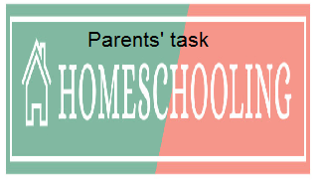

WEEKLY CHECKLIST For Parents:

Term: 2 Week number 1 Date…… to…… Month: …………

Subject | Number of lessons | Days | Tick when activity is complete | Parents comment | Signature
 | 1
 | 2
 | 3
 | 4
 | 5
 | 6

Term: 2 Week number 2 Date…… to…… Month: …………

Subject | Number of lessons | Days | Tick when activity is complete | Parents comment | Signature
 | 1
 | 2
 | 3
 | 4
 | 5
 | 6

Term: 2 Week number 3 Date…… to…… Month: …………

Subject | Number of lessons | Days | Tick when activity is complete | Parents comment | Signature
 | 1
 | 2
 | 3
 | 4
 | 5
 | 6

Term: 2 Week number 4 Date…… to…… Month: …………

Subject | Number of lessons | Days | Tick when activity is complete | Parents comment | Signature
 | 1
 | 2
 | 3
 | 4
 | 5
 | 6

Term: 2 Week number 5 Date…… to…… Month: …………

Subject | Number of lessons | Days | Tick when activity is complete | Parents comment | Signature
 | 1
 | 2
 | 3
 | 4
 | 5
 | 6

Term: 2 Week number 6 Date…… to…… Month: …………

Subject | Number of lessons | Days | Tick when activity is complete | Parents comment | Signature
 | 1
 | 2
 | 3
 | 4
 | 5
 | 6

Term: 2 Week number 7 Date…… to…… Month: …………

Subject | Number of lessons | Days | Tick when activity is complete | Parents comment | Signature
 | 1
 | 2
 | 3
 | 4
 | 5
 | 6

Term: 2 Week number 8 Date…… to…… Month: …………

Subject | Number of lessons | Days | Tick when activity is complete | Parents comment | Signature
 | 1
 | 2
 | 3
 | 4
 | 5
 | 6

Term: 2 Week number 9 Date…… to…… Month: …………

Subject | Number of lessons | Days | Tick when activity is complete | Parents comment | Signature
 | 1
 | 2
 | 3
 | 4
 | 5
 | 6

Term: 2 Week number 10 Date…… to…… Month: …………

Subject | Number of lessons | Days | Tick when activity is complete | Parents comment | Signature
 | 1
 | 2
 | 3
 | 4
 | 5
 | 6

Term: 2 Week number 11 Date…… to…… Month: …………

Subject | Number of lessons | Days | Tick when activity is complete | Parents comment | Signature
 | 1
 | 2
 | 3
 | 4
 | 5
 | 6

Term: 2 Week number 12 Date…… to…… Month: …………

Subject | Number of lessons | Days | Tick when activity is complete | Parents comment | Signature
 | 1
 | 2
 | 3
 | 4
 | 5
 | 6

Term: 2 Week number 13 Date…… to…… Month: …………

Subject | Number of lessons | Days | Tick when activity is complete | Parents comment | Signature
 | 1
 | 2
 | 3
 | 4
 | 5
 | 6

